

**Syrian Private University**

**Faculty of Engineering**

**Department of Software**

**and Information Systems**

**Events and Activities planning platform**

A senior 1 project report- submitted to complete the requirements for obtaining a bachelor's degree in Informatics Engineering - Software Engineering and Information Systems

**Prepared by:**

Helpest Mohamad Mohamad Marwa Ghassan Aljaouni Hiba Ahmad Shawa

**Supervised by:**

Eng. Anas Abdulziz

2025



**الجامعة السورية الخاصة**

**كلية الهندسة**

**قسم البرمجيات و نظم المعلومات**

**منصة لتخطيط الفعاليات**

**والأنشطة**

مشروع تخرج 1 - قدم استكمالاً لمتطلبات الحصول على درجة البكالوريوس في هندسة المعلوماتية

هندسة البرمجيات ونظم المعلومات

**إعداد:**

هبه احمد شاوه مروة غسان الجاعوني هلبست محمد محمد

إ**شراف:**

المهندس أنس عبد العزيز

2025

SUPERVISION CERTIFICATION

Supervisor Certification

I Certify that the preparation of this project entitled

[**Events And Activities Planning Platform**]

Prepared by [Hiba Shawa& Marwa Aljaouni & Helpest Mohamad ] was made under my supervision at Faculty of Informatics Engineering in partial Fulfillment of the Requirements for the Degree of Bachelor of Software and Information system Engineering

Name: Eng.Anas Abdulaziz

Signature:……...…..……….

Date: ….………………………

***Abstract :***

*In a world where we increasingly rely on technology to simplify our daily lives, the need for integrated digital platforms to manage events and activities has become essential. Today, the events sector faces significant challenges due to fragmented operations among multiple parties. Attendees struggle to discover and book events across scattered platforms, organizers face complexities in managing bookings and coordinating with service providers, and suppliers are forced to invest heavily in marketing without guaranteed access to their target customers.*

*This project aims to develop a comprehensive online platform that brings together attendees, organizers, and suppliers in a unified digital marketplace. The platform provides a seamless experience for secure booking with automatic notifications, enables organizers to manage their events through a dashboard that offers real-time analytics, and allows suppliers to connect directly with customers through searchable profiles.*

*Using modern web technologies, the platform seeks to transform the traditional event booking model into a dynamic marketplace that enhances effective collaboration, reduces costs, and improves the overall experience*

***الملخص:***

***في عالم يتزايد فيه الاعتماد على التكنولوجيا لتسهيل حياتنا اليومية، أصبحت الحاجة إلى منصات رقمية متكاملة لإدارة الفعاليات والأنشطة أمرًا ضروريًا. يواجه قطاع الفعاليات اليوم تحديات كبيرة تتمثل في تشتت العمليات بين أطراف متعددة، حيث يجد الحضور صعوبة في اكتشاف وحجز الفعاليات عبر منصات متفرقة، بينما يواجه المنظمون تعقيدات في إدارة الحجوزات والتنسيق مع مزودي الخدمات، ويضطر الموردون للاستثمار بكثافة في التسويق دون ضمان الوصول للعملاء المستهدفين.***

***يهدف هذا المشروع إلى تطوير منصة إلكترونية شاملة تجمع الحضور والمنظمين والموردين في سوق رقمي موحد. توفر المنصة تجربة سلسة للحجز الآمن مع إشعارات تلقائية، وتمكّن المنظمين من إدارة فعالياتهم عبر لوحة تحكم توفر تحليلات فورية، كما تتيح للموردين التواصل المباشر مع العملاء من خلال ملفات تعريفية قابلة للبحث.***

***باستخدام تقنيات الويب الحديثة، تسعى المنصة لتحويل نموذج حجز الفعاليات التقليدي إلى سوق ديناميكي يعزز التعاون الفعال ويقلل التكاليف ويحسن التجربة العامة***

***.***

**List Of Contents:**

Contents

SUPERVISION CERTIFICATION 2

***الملخص:*** 2

**List Of Contents:** 2

**List Of Tables:** 2

**List Of Figures:** 2

**Chapter 1: Introduction** 2

**1.Introduction** 2

**2-problem Definition** **Error! Bookmark not defined.**

**3.project Objectives** **Error! Bookmark not defined.**

**4.Report Organization** 2

**5-Summary** 2

**Chapter 2:Reference Study** 2

**1.Introduction:** 2

**2. Similar Applications:** 2

**1.** **SolarEdge:** 2

**2. Enphase Enlighten:** 2

**3. SMA Sunny Portal:** 2

**4. Tigo Energy:** **Error! Bookmark not defined.**

**5. KACO new energy:** **Error! Bookmark not defined.**

**3. Our System** : 2

**4.Comparison of Systems** 2

**5.Summary** **Error! Bookmark not defined.**

**Chapter 3: Project Management** 2

**1.Project Charter** 2

**2.Methodology:** 2

**3.Statement of work:** 2

**4.Project Timeline** 2

**5.Gantt Chart** 2

**6.Risk management:** 2

**7. Project Development Life Cycle Model:** 2

**8. Hybrid Agile Project Management:** 2

**9.Initial Requirement Trackability Matrix (RTM)(V.1)** 2

**10.Summary:** 2

**Chapter 4:System Analysis** 2

**1.System Initial Analysis** 2

**1. Introduction** 2

**2.Overall Description** **Error! Bookmark not defined.**

**3.High level requirements** 2

**4.Use case diagram:** 2

**4.Activity diagram:** 2

**2.Detailed Analysis** 2

**1.Introduction** 2

**2.purposes** 2

**3.System Requirements:** 2

**3.initial test case:** 2

**4. Requirement Trackability Matrix (RTM) (V.2)** 2

**5.Summary** 2

**Chapter 5: System Design** 2

**1.System Initial Design** 2

**1.Selected Architecture: Layered Architecture with Modularized Services** 2

**2.System Architecture:** 2

**3.Class diagram:** 2

**4.Sequence diagram** 2

**2.Detailed Design** 2

**1.Introduction:** 2

**2.Purpose :** 2

**3.functonal Requirements:** 2

**4.System Class Diagram** 2

**5.** **ERD - Entity-Relationship Diagram** 2

**3.Requirement Trackability Matrix (RTM) (V.3)** 2

**7.Summary** 2

**Chapter6: Implementation** 2

**1.Introduction** 2

**2.Purpose:** 2

**3.User Interfaces** 2

**4. REST API Documentation – Alternative Energy Management System** 2

**4.1.Introduction** 2

**4.2.Purpose** 2

**4.3.API Structure Overview** 2

**4.4.Detailed Table of REST API Endpoints** 2

**5.Execution Test case** 2

**6. Requirement Trackability Matrix (RTM) (V.4)** 2

**7.Summary:** 2

**List Of Tables:**

Table 1:Solar Edge **Error! Bookmark not defined.**

Table 2:Enphase Enlighten **Error! Bookmark not defined.**

Table 3:SMA Sunny Portal **Error! Bookmark not defined.**

Table 4:Tigo Energy **Error! Bookmark not defined.**

Table 5: KACO new energy **Error! Bookmark not defined.**

Table 6: comparison of systems 2

Table 7:project charter info 2

Table 8: roles and responsibilities 2

Table 9:schedules 2

Table 10:timeline 2

Table 11:risk management 2

Table 12:RTM(V.1) 2

Table 13:high level requirements 2

Table 14:UM functional requirements 2

Table 15:use case specification 1 2

Table 16:SPM functional requirements 2

Table 17:use case specification 2 2

Table 18:EDM functional requirements 2

Table 19 :use case specification 3 2

Table 20:SED functional requirements 2

Table 21:use case specification 4 2

Table 22:use case specification 5 2

Table 23:use case specification 6 2

Table 24:use case specification 7 2

Table 25:UPM functional requirements 2

Table 26:use case specification 8 2

Table 27:initial test cases 2

Table 28:RTM V.2 2

Table 29:RTM V.3 2

Table 30:API Structure 2

Table 31:API **Error! Bookmark not defined.**

Table 32:execution test cases 2

Table 33:RTM V.4 2

**List Of Figures:**

Figure 1 :gantt chart 2

Figure 2:project development life cycle model 2

Figure 3:use case diagram for (AEMS) 2

Figure 4:Activity diagram for (AEMS) 2

Figure 5:use case diagram for signup&login 2

Figure 6:activity diagram for Signup&Login **Error! Bookmark not defined.**

Figure 7:use case for solar management system 2

Figure 8:activity diagram for solar management system 2

Figure 9:use case diagram for electrical device management 2

Figure 10:activity diagram for electrical devices management 2

Figure 11:use case diagram for solar energy dashboard 2

Figure 12:activity diagram for solar energy dashboard 2

Figure 13:use case diagram for user profile management 2

Figure 14:activity diagram for user profile management 2

Figure 15:system architecture 2

Figure 16:class diagram in high level 2

Figure 17:sequence diagram in high level 2

Figure 18:sequence diagram for signup&login 2

Figure 19:sequence diagram for solar energy management 2

Figure 20:sequence diagram for electriacl devices management 2

Figure 21:sequence diagram for solar energy dashboard 2

Figure 22:sequence diagram for user proflie management 2

Figure 23 : class diagram 2

Figure 24:ERD diagram 2

Figure 25:login interface<<1>> 2

Figure 26:Reset password interface<<2>> 2

Figure 27 :new register interface<<3>> 2

Figure 28:main dashboard interface<<4>> 2

Figure 29:main dashboard for device analysis interface<5>> 2

Figure 30 :main dashboard for reports interface <<6>> 2

Figure 31:main dashboard for recommendations &insights interface<<7>> **Error! Bookmark not defined.**

Figure 32 :solar panel management interface<<8>> **Error! Bookmark not defined.**

Figure 33:add solar panel interface<<9>> **Error! Bookmark not defined.**

Figure 34:modify solar panel interface<<10>> **Error! Bookmark not defined.**

Figure 35:delete pane interface<<11>> **Error! Bookmark not defined.**

Figure 36:electrical devices management interface<<12>> **Error! Bookmark not defined.**

Figure 37:add device interface<<13>> **Error! Bookmark not defined.**

Figure 38: modify device interface<<14>> **Error! Bookmark not defined.**

Figure 39:delete device interface<<15>> **Error! Bookmark not defined.**

Figure 40:user profile interface<<16>> **Error! Bookmark not defined.**

**Chapter 1: Introduction**

**1.Introduction**

This chapter provides an overview of the Events and Activities planning Platform project by outlining the problems we aim to address, the objectives we hope to achieve, and the structure of the report. It also serves as a guide to help you understand how the project was developed and the content of each section of the report.

**1.1 Problem Definition**

Today, the event industry faces a major challenge where everyone works separately, creating inefficiencies for all involved. Attendees struggle to find and book events across multiple websites with unclear pricing and availability information. Organizers waste time managing bookings manually, juggling different tools to communicate with suppliers, and lacking clear visibility into their event performance. Suppliers spend heavily on advertising just to get noticed by potential clients without a central platform to showcase their services. Our platform solves these problems by creating one unified space where attendees can discover and book events easily, organizers can manage everything through a simple dashboard with real-time insights, and suppliers can create profiles to connect directly with customers, making the entire event experience smoother and more efficient for everyone.

**1.2 Project Objectives**

Our platform is designed to serve three main user groups—attendees, organizers, and suppliers—each with features tailored to their needs. Attendees can securely manage their accounts, browse events using smart filters for date, location, price, and type, book tickets for existing events, or reserve ready-made packages to host their own, while receiving email confirmations and maintaining a full booking history. Organizers can create both public events and customizable host packages, add detailed event information including titles, descriptions, locations, dates, prices, and photos, track bookings in real time, view attendee lists, and control booking availability through a simple dashboard.Suppliers can create detailed profiles showcasing their services, locations, and contact information, making it easy for organizers and users to find them through searchable directories while building trust with clear information and future rating systems .

The platform also ensures smooth operation and organization by providing unique booking references, tracking the status of bookings, sending automated email notifications, and maintaining robust data security. Overall, our goal is to transform the platform from a basic booking system into a full-fledged event marketplace where attendees, organizers, and suppliers can collaborate efficiently and seamlessly.

**4.Report Organization**

The report is structured as follows:

This report is divided into the following chapters:

**Chapter 1: Introduction**

* What the project is about and why it matters

**Chapter 2: Reference Study**

* Looking at other similar platforms
* What's already out there and what we can learn from it

**Chapter 3: Project Management**

* How we planned and organized the work
* Timeline and responsibilities

**Chapter 4: System Analysis and Design**

* What the system needs to do
* How we designed the database and user interface
* Diagrams and mockups

**Chapter 5: Implementation**

* The technology we used
* How we built the main features
* User interfaces and Apis

**5-Summary**

This chapter introduces our Events and Activities planning platform It outlines the challenges people face when planning or attending events, the goals we hope to achieve with the platform, and how this report is structured. The main idea is simple: bring attendees, organizers, and suppliers together on a single platform, making it easy for everyone to find what they need. In the upcoming chapters, we will go deeper into how we researched, planned, designed, and built the system.

**Chapter 2:Reference Study**

**1.Introduction:**

This chapter presents the reference studies we have conducted. The reference study is a process of reviewing, analysing, and summarizing previous sources and studies related to similar applications. This step has helped us identify areas that can be improved and developed.

**2. Similar Applications:**

**1.**  **Eventbrite:**

Description: Eventbrite is a leading global platform for organizing and selling event tickets online. It allows users to create professional event pages, set ticket prices, manage registrations, and track sales through an easy-to-use interface. It is widely used for public events such as conferences, concerts, and workshops.

|  |  |
| --- | --- |
| **Disadvantages** | **Advantages** |
| 1. Charges commissions and fees on every ticket sold, reducing organizer profits. | 1. Simple and user-friendly interface for beginners and small organizers. |
| 2. Limited customization options for event page designs. | 2. Provides integrated tools for ticket booking and instant email confirmations. |
| 3. Limited support for locally based or multi-service events (e.g., vendor collaboration). | 3. Allows integration with social media platforms to boost engagement. |
| 4. Analytical tools are basic compared to large enterprise platforms. | 4. Offers basic marketing tools and statistical reports on attendance and sales. |

**2. Cvent:**

Description: Cvent is a comprehensive professional platform used for managing large-scale events, particularly conferences and exhibitions. It provides tools for registration management, venue coordination, vendor handling, badge printing, and advanced analytical reporting.

|  |  |
| --- | --- |
| **Disadvantages** | **Advantages** |
| 1. The interface is relatively complex and requires training for new users. | 1. A fully integrated system that covers all stages of event management, from booking to evaluation. |
| 2. High cost makes it less suitable for small projects or individuals. | 2. Provides professional tools for managing vendors, budgets, and participant communication. |
| 3. Not ideal for personal or simple events. | 3. Offers precise analytics and interactive dashboards to support decision-making. |
| 4. Requires a longer setup and configuration time initially. | 4. Reliable and trusted by large institutions, universities, and global corporations and Highly customizable to fit different event types (in-person or virtual). |

**3. Bizzabo:**

Description: Bizzabo focuses on enhancing attendee experience and engagement in professional events. It provides solutions for registration management and event marketing (virtual or in-person) while offering detailed reports to measure ROI and event impact.

|  |  |
| --- | --- |
| **Disadvantages** | **Advantages** |
| 1. Subscription plans are relatively expensive compared to traditional platforms. | 1. Modern, flexible, and easily customizable user interface. |
| 2. May not be ideal for small or local events. | 2. Strong reporting and analytics to measure event performance and business impact. |
| 3. Customization of registration designs can be limited. | 3. Excellent support for virtual and hybrid events. |
| 4. Requires some technical experience for efficient management. | 4. Provides marketing tools and personalized content for different attendee types and Emphasis on attendee networking and relationship building. |

**4.Splash:**

Description: Splash is a platform specialized in designing visually appealing event pages and promoting them as part of marketing campaigns. It is used by major companies to organize brand events and manage invitations and marketing analytics.

|  |  |
| --- | --- |
| **Disadvantages** | **Advantages** |
| 1. Not designed for ticket sales or logistical event management. | 1. Professional design interface for creating visually striking event pages. |
| 2. Full features require high-cost paid subscriptions. | 2. Strong focus on marketing aspects and audience data collection. |
| 3. Limited suitability for non-marketing or non-commercial events. | 3. Automated and well-coordinated tools for invitation and attendance management. |
| 4. Analytical tools are less comprehensive than those of professional conference platforms like Cvent. | 4. Integrates with marketing tools like Mailchimp and CRM systems and Ideal for brand-focused corporate events emphasizing visual identity. |

**5.Faaliyeh App_ Syria:**

Description: it is the official platform in Syria for organizing and managing exhibitions, projects, and events

It aims to support economic and cultural activities by bringing together government entities, organizers, and companies on a single digital platform.

It allows users to explore local events, register, and officially participate, while enabling organizers to manage requests and schedule exhibitions electronically, thus contributing to the digitization of the events sector and enhancing communication between participants and visitors.

|  |  |
| --- | --- |
| **Disadvantages** | **Advantages** |
| 1. Lacks ticketing tools or direct electronic payment. | 1. A simple and user-friendly Arabic interface for local users. |
| 2. Lacks interactive features such as event or supplier ratings. | 2. It encompasses various types of events (economic, cultural, social, and educational). |
| 3. Does not allow users to create custom events or hostable packages. | 3. It allows for application and participation in exhibitions through a unified electronic form. |
| 4. Limited analytics and reporting, focusing on administrative rather than marketing aspects. | 4. It helps promote local national projects. |

**3. Our System** :

it offers a comprehensive solution connecting event organizers, attendees, and suppliers within a single, unified digital environment. Our vision is to provide a dynamic marketplace for event management, from discovery to execution. Users can register, edit their profiles, and search for and filter events by date, location, price, and type. For organizers, the platform offers comprehensive management features, including a shared dashboard, the ability to create and manage public events or hostable packages for their own events (such as wedding packages, birthday parties, or private gatherings), and track booking status (active, canceled, completed). We also facilitate collaboration by creating a searchable supplier directory by type and city. Our primary goal is to enhance usability. Each booking generates a unique, trackable reference, and the system is supported by instant automated email notifications for new registrations, ensuring high efficiency and a seamless user experience for both attendees and hosts.

|  |  |  |  |  |  |  |
| --- | --- | --- | --- | --- | --- | --- |
| **Feature** | **Splash** | **Bizzabo** | **Cvent** | **Eventbrite** | **Faaliyeh** | **Our system** |
| **User-Friendly Interface** |  |  |  |  |  |  |
| **Ticket sales & automated confirmations** |  |  |  |  |  |  |
| **Hostable/custom packages** |  |  |  |  |  |  |
| **Creating Special Events** |  |  |  |  |  |  |
| **Affordable for small/local events** |  |  |  |  |  |  |
| **Supporting Commercial Events** |  |  |  |  |  |  |
| **Collaborative**  **Dashboard** |  |  |  |  |  |  |

**4.Comparison of Systems**

**5.Summary**

We compared our system with popular event management platforms such as Eventbrite, Cvent, Bizzabo, Splash, and Faaliyeh App, focusing on key features like a user-friendly interface, ticket sales with automated confirmations, hostable or customizable event packages, the ability to create special events, suitability for small or local projects, support for commercial events, collaboration among users, and an event management dashboard. These platforms are effective in managing events and providing essential tools for users, but they face challenges such as high costs, limited customization, complex setup, and limited support for local events.

Table 1: comparison of systems

**Chapter 3: Project Management**

**1.Project Charter**

|  |
| --- |
| **Project tittle:** Alternative Energy Management System. |
| **Project start date:** October_ 1 _2025 |
| **Project finish date:** January _ 21 _ 2026 |
| **Project manager**: Eng. Anas Abdulaziz. |

Table 2:project charter info

**Project objectives:**

* Develop a unified event management platform that integrates attendees, organizers, and suppliers.
* Provide seamless event discovery with advanced filtering capabilities (date, location, price, event type).
* Enable dual booking functionality: booking tickets for public events and booking packages to host private events.
* Implement a comprehensive organizer dashboard with real-time analytics (bookings, revenue, available seats).
* Allow organizers to create and manage both public events and customizable host packages with full event details.
* Enable organizers to tag basic supplier notes for each event or package for internal reference.
* Create a supplier directory that connects service providers with organizers and users through searchable profiles.
* Manage bookings with unique reference numbers, status tracking (confirmed, canceled), and email notifications.
* Build a scalable foundation for future marketplace features including ratings, reviews, and direct supplier integrations.
* Create a supplier directory that connects service providers with organizers and users through searchable profiles.

**Approach:**

* Define the project scope and requirements.
* Conduct system analysis and design for all user roles (attendees, organizers, suppliers).
* Design system architecture including user authentication, event management, and booking systems.
* Develop user interface for event discovery, filtering, and dual booking options (public events and host packages).
* Implement a real-time notification system for booking confirmations and updates.
* Create a supplier directory with search and filter functionality.
* Deploy the platform and provide user documentation.

**Roles and Responsibilities:**

|  |  |  |
| --- | --- | --- |
| **Name** | **Role** | **Responsibility** |
| Eng. Anas Abdulaziz | Project Supervisor | Provides guidance and evaluates project progress. |
| Helpest Mohamad | Project Member | Responsibility for Project Management and overseeing all SDLC phases. |
| Hiba Shawa | Project Member | Responsibility for Project Management and overseeing all SDLC phases. |
| Marwa Aljaouni | Project Member | Responsibility for Project Management and overseeing all SDLC phases. |

Table 3: roles and responsibilities

**2.Methodology:**

**1.Introduction**

This section aims to explain and justify the chosen methodology for developing the events and activities planning platform. Based on the project's nature and requirements, this document proposes adopting a hybrid Agile methodology combining the Scrum and Kanban frameworks to achieve the optimal balance between the necessary structure and flexibility.

**2.Description of the Selected Methodology**

Detailed description of the selected methodology: Hybrid Agile (Scrum and Kanban): Core Principles and Values: This methodology is based on Agile principles, such as focusing on the customer and their needs, early and continuous delivery of functional value, welcoming changes in requirements, close collaboration between stakeholders and developers, motivating individuals and trusting them to accomplish their tasks, sustainable work that maintains a constant development pace, attention to technical details and quality, simplifying processes, encouraging team self-organization, and regular reflection on ways to continuously improve.

**2.1 Framework and Key Processes:**

Scrum: Scrum will be used to organize development cycles into short, fixed-duration time units called "Sprints." Scrum events will include Sprint Planning meetings, the Daily Scrum, the Sprint Review meeting, and the Sprint Retrospective meeting. System requirements will be documented and managed in the "Product Backlog" and prioritized by the "Product Owner."

Kanban: Kanban principles will be applied to visualize the workflow within each Sprint and across different development stages. A "Kanban board" will be used to track the status of different tasks and limit "Work in Progress" (WIP) to ensure a smooth flow of work and reduce potential bottlenecks.

**2.2 Key Roles and Responsibilities:**

* **Product Owner:** Responsible for defining the product vision and managing and prioritizing the Product Backlog: Eng. Anas Abdulaziz
* **Scrum Master**: Responsible for facilitating the Scrum process and ensuring the team understands and applies Scrum and Kanban principles and practices correctly: Hiba Shawa
* **Development Team:** A multidisciplinary team responsible for analyzing, designing, developing, testing, and delivering the solar energy management system: Marwa AlJaouni, Helpest Mohamad, Hiba Shawa

**2.3 Expected Deliverables:** There will be shippable software increments at the end of each Sprint, in addition to a visible Kanban board to track work progress, and a managed and continuously updated Product Backlog.

**3.Justifications for Choosing the Methodology**:

Adopting a hybrid Agile methodology combining Scrum and Kanban is considered the most suitable option for developing the solar energy management system for the following reasons:

**3.1 Project Nature and Requirements:**

**Complexity and Flexibility:** The solar energy management system may involve integration with various devices, analysis of complex data, and different user interfaces. These complexities require a high degree of flexibility in dealing with requirements that may become fully apparent during the development process.

**Expected Changes:** Changes in system requirements are likely to occur based on continuous developments in solar energy technology or based on user feedback.

**Gradual Delivery of Value:** Using Scrum allows for the frequent delivery of functional parts of the system at the end of each Sprint, allowing stakeholders to provide early feedback and obtain tangible value early in the project lifecycle.

**Risk Mitigation**: Through frequent delivery and regular reviews, potential problems and risks can be identified early and addressed effectively.

**Team Characteristics:** Given that the team size is only 3 people, Scrum promotes effective collaboration and communication within small and cross-functional teams.

**3.2 Project Constraints:**

Timeline and Early Delivery: Frequent delivery in Scrum allows for providing basic parts of the system early, which may meet some urgent stakeholder needs.

**3.3 Stakeholder Requirements:**

Active Participation: Scrum events such as Sprint Review meetings encourage stakeholders to participate and provide their feedback regularly, ensuring that the system is developed in accordance with their needs and expectations.

Clear Vision of Progress: Shippable software increments and the Kanban board provide a clear view of the progress made in developing the system.

**4. Specific Application of the Methodology to This Project:**

**4.1.Methodology Customization:**

The Scrum framework will be applied with the integration of a Kanban board to visualize the flow of Sprint tasks. The Sprint length will initially be set at two weeks, and this duration can be adjusted based on the team's experience and project needs. The focus will be on applying Work in Progress (WIP) limits to specific development stages within the Sprint to improve workflow and reduce task accumulation.

**4.2 Tools and Technologies:**

An Agile project management tool (such as Jira) will be used to support the management of the Product Backlog, Sprint Backlog, and visualization of the Kanban board. Online communication and collaboration tools will also be used to ensure effective communication between team members and stakeholders.

**4.3 Communication Processes:**

Communication processes will include the Daily Scrum for the development team, Sprint Planning, Review, and Retrospective meetings, as well as periodic meetings with stakeholders to present progress and gather feedback and guidance. Digital communication channels (such as email and instant messaging platforms) will be used for asynchronous communication.

**5.Change Management Processes within the Selected Methodology**:

Changes in requirements or unforeseen circumstances will be handled through the following mechanisms:

**Daily Scrum:** The team can use the Daily Scrum to discuss any emerging changes or new challenges and how they affect the current work, and to plan how to respond to these changes effectively.

**Sprint Review:** The Sprint Review will be an important opportunity for stakeholders to provide feedback on the work done and suggest changes or new priorities that can be added to the Product Backlog to be addressed in the next Sprint.

**Product Backlog Refinement:** Regular Product Backlog Refinement sessions will be held to review, clarify, and estimate requirements, allowing for the integration of new changes or modification of existing requirements based on new priorities set by the Product Owner.

**6.Summary:**

Based on the analysis of the nature of the solar energy management system project and its requirements, team characteristics, project constraints, and stakeholder requirements, we confirm that adopting a hybrid Agile methodology combining the Scrum and Kanban frameworks is the optimal choice for this project. This methodology provides the necessary flexibility to deal with complexities and potential changes, promotes effective collaboration and communication, allows for the gradual delivery of functional value, and helps mitigate potential risks.

**3.Statement of work:**

**1.Project title:** Events And Activities Planning platform.

**2.project description and objectives:**

This document specifies the software requirements and design for the Event Management Platform, a unified solution designed to connect event attendees, organizers, and suppliers in one seamless ecosystem. The system enables users to discover and book tickets for existing events or host their own events using pre-configured packages, organizers to create and manage events efficiently with real-time analytics, and suppliers to showcase their services, ultimately creating a dynamic event marketplace.

**3.Project Scope**

**Scope:** The Event Management Platform is a web-based application that brings together three key stakeholders in the event industry. The system allows attendees to browse and book events or host their own using pre-configured packages, provides organizers with comprehensive management tools and analytics dashboards, and offers suppliers a platform to connect directly with potential clients through searchable profiles.

**4. project goals:**

- Develop a user-friendly platform that simplifies event discovery, booking, and hosting for attendees.

- Create powerful management tools for organizers to handle multiple event types with real-time tracking and insights.

- Build a supplier directory that connects service providers with organizers and users transparently.

- Implement secure authentication and booking management systems.

- Provide users with:

* Advanced event filtering and search capabilities
* Automated booking confirmations and notifications
* Real-time dashboards showing bookings, revenue, and performance metrics
* Booking history and status tracking

**5.Deliverables:**

▪ Project plan and charter

▪ SRS (Software Requirements Specification) documentation

▪ System design documents (database schema, architecture diagrams)

▪ Final project report

▪ Backend and frontend system components – the complete platform

**6. Project Requirements:**

**Technology and Tools:**

**Frontend:** React.js – For user interfaces, dashboards, and interactive components

**Backend:** Spring Boot )java)– For API management and business logic

**Database:** PostgreSQL / Firebase Firestore – For storing users, events, bookings, and supplier data

**Authentication:** Firebase Auth – For secure user login and session management

**Email Service:** SendGrid or Nodemailer – For booking confirmations and notifications

**Hosting:** AWS, Heroku, or Vercel – For deployment

**7. Assumptions:**

Organizers will provide accurate event information (dates, locations, pricing).

Suppliers will maintain updated profile information.

Email addresses provided by users are valid for receiving notifications.

Continuous availability of project team members throughout development.

Regular supervision and feedback from the project supervisor.

**8. Project Resources:**

**Human Resources:**

Eng. Anas Abdulaziz : Project Manager

Hiba Shawa : SE Developer

Marwa Aljaouni : SE Developer

Helpest Mohamad : SE Developer

**9. Schedules:**

|  |
| --- |
| **Project Start Date:** 25\10\2025 |
| **First project Seminar:** 16\11\2025 |
| **Second project Seminar:** 20\12\2025 |
| **Project Finish Date**: 21\01\2026 |

Table 4:schedules

**4.Project Timeline**

**1. Basic Project Information**

* **Project Name:** Events And Activities Planning Platform
* **Project Manager**: Eng.Anas Abdulaziz
* **Start Date:** 25/10/2025
* **Expected End Date:** 21/01/2026
* **Total Duration :** Approximately 3 months

|  |  |  |  |  |
| --- | --- | --- | --- | --- |
| **Main phase** | **sub-task** | **approximate start date** | **approximate end date** | **approximate** |
| **sprint 1:** | 1.1 Requirements Analysis | 25/10/2025 | 31/10/2025 | 1 wk |
| 1.2 System Architecture Design | 01/11/2025 | 07/11/2025 | 1 wk |
| 1.3 Database Schema Design | 08/11/2025 | 15/11/2015 | 1 wk |
| **sprint 2:** | 2.1 Actors Authentication | 16/11/2015 | 29/11/2025 | 2 wks |
| 2.2 User Module (Event Browsing & Booking) | 21/11/2025 | 05/12/2025 | 2 wks |
| **sprint 3:** | 3.1 Organizer Module (Dashboard & Event Management) | 06/12/2025 | 20/12/2025 | 2 wks |
| 3.2 Provider Module (Directory & Profile Management) | 12/12/2025 | 24/12/2025 | 1.5 wks |
| **sprint 4:** | 4.1 Dashboard Implementation | 25/12/2025 | 08/01/2026 | 2 wks |
| 4.2 Booking Management | 31/12/2025 | 13/01/2026 | 2 wks |
| 4.3 Notification System | 25/12/2025 | 10/01/2026 | 3 wks |
| **sprint 5:** | 5.2 Testing | 03/01/2026 | 15/01/2026 | 2 wks |
| 5.3 Submission | 10/01/2026 | 20/01/2026 | 1.5 wks |
| **Project Completion** |  |  | **21/01/2026** |  |

Table 5:timeline

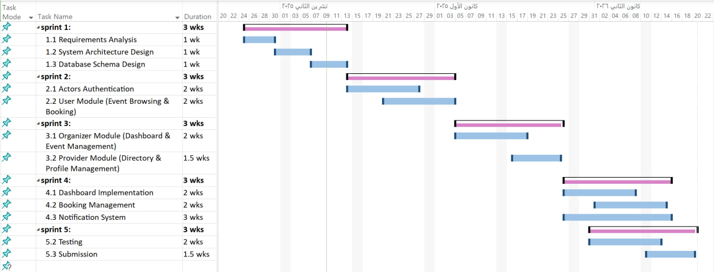**5.Gantt Chart**

Figure 1 :gantt chart

**6.Risk management:**





Table 6:risk management

**7. Project Development Life Cycle Model:**

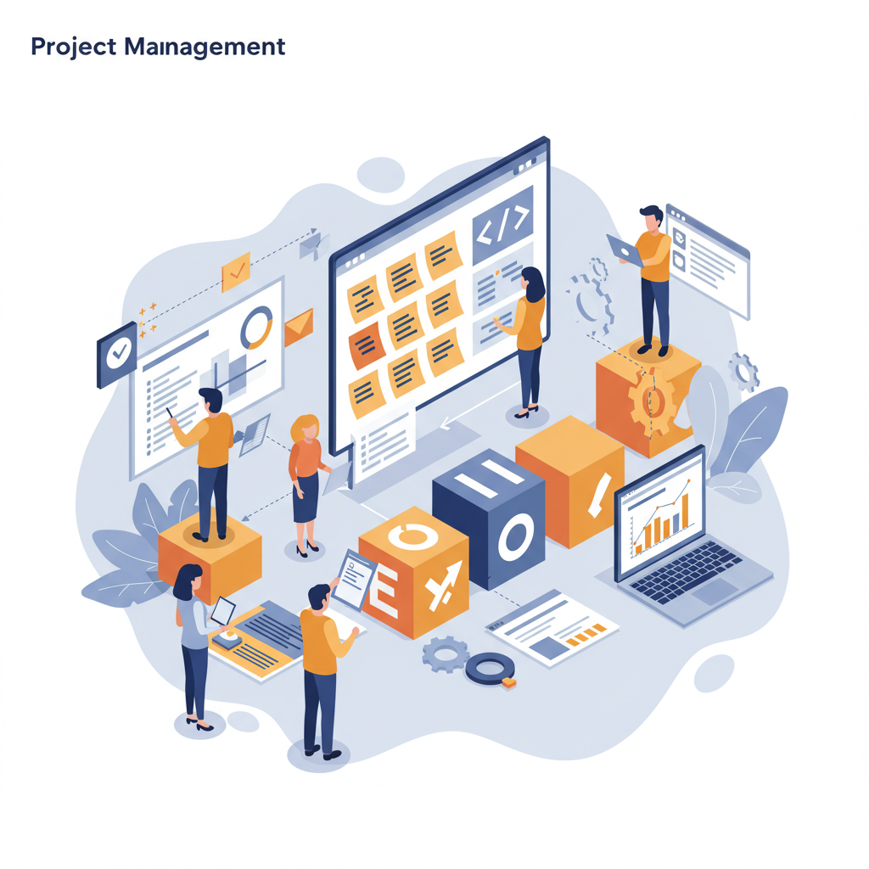5.1 Determine development model based on system requirements and structure: This section explains the process of selecting the appropriate software development model for the project. After conducting a thorough analysis and extracting the system requirements, as well as breaking down the system into its core components, the next step is to choose the most suitable software development process for our system. Given the nature of the system and its requirements, which necessitate flexibility and continuous adaptation, a Hybrid Agile methodology that combines Agile principles with specific frameworks, namely Scrum and Kanban, has been adopted as the best approach for development

Figure 2:project development life cycle model

Software development model

**8. Hybrid Agile Project Management:**

This section adopts a flexible approach to project management that differs from traditional models requiring comprehensive and detailed upfront planning. Hybrid Agile project management relies on adaptive and iterative planning and execution, integrating elements from Scrum and Kanban to achieve maximum efficiency and effectiveness. This approach focuses on delivering business value and providing benefits to clients through: Iterative and Incremental Planning ,Visualize Workflow and Limit Work in Progress ,Regular Meetings and Continuous Communication ,Regular and Transparent Reporting and Sending alerts.

**9.Initial Requirement Trackability Matrix (RTM)(V.1)**

|  |  |  |  |  |  |  |  |
| --- | --- | --- | --- | --- | --- | --- | --- |
| **Requirement id** | **Title** | **Use case** | **System Design** | **Analysis** | **Detaied Design** | **Coding** | **Test Cases** |
| PM-01 | Assign roles and responsibilities to team members |  |  |  |  |  |  |
| PM-02 | Prepare and monitor a detailed project schedule |  |  |  |  |  |  |
| PM-03 | Hold weekly meetings to review project progress |  |  |  |  |  |  |
| PM-04 | Conduct risk assessments and develop mitigation plans |  |  |  |  |  |  |
| PM-05 | Keep track of resources (team time, skills, tools) to use them well and finish the project on time |  |  |  |  |  |  |
| PM-06 | Ensure quality assurance checkpoints are in place |  |  |  |  |  |  |
| PM-07 | Perform final project closure and evaluation |  |  |  |  |  |  |
| PM-08 | Document and approve the chosen project methodology |  |  |  |  |  |  |
| PM-09 | Periodically review the application of the project methodology |  |  |  |  |  |  |
| PM-10 | Document all project changes and approvals |  |  |  |  |  |  |

Table 7:RTM(V.1)

**10.Summary:**

This chapter outlined the project management plan for the **"Events and activities planning platform"** It began with the project charter, which defined the main objectives, team roles, and responsibilities. The chosen methodology  **)Hybrid Agile, combining Scrum and Kanban**( was selected for its flexibility and suitability to the project's evolving requirements. The development process was broken down into clearly defined stages, from requirements analysis to final delivery, all organize within a detailed project timeline. The chapter also covered the project scope, required resources, and selected development tools, along with the apprpriate software development life cycle model. Overall, the plan emphasizes that flexible management and effective organization are key to delivering a high-quality system on time.

**Chapter 4:System Analysis**

**1.System Initial Analysis**

This section presents the initial analysis and key features identified during the

early stages of project planning and development.

**1. Introduction**

**1.1 Purpose**

This document specifies the software requirements and design for the Event Management Platform, a comprehensive solution designed to facilitate event discovery, booking, and management. The platform connects three key stakeholders: attendees seeking events to join or host, organizers managing events and packages, and suppliers offering event-related services. The system provides an intuitive marketplace that simplifies event participation, creation, and collaboration.

**1.2 Project Scope**

This system is an effective and user-friendly platform for managing the complete event lifecycle—from discovery and booking to hosting and supplier collaboration. It relies on organizer-created events and supplier services to provide a seamless experience for all stakeholders, enabling efficient event operations and enhanced user satisfaction.

**Key Features:**

- Unified platform for attending and hosting events

- Comprehensive organizer dashboard with analytics

- Integrated supplier directory for service discovery

- Real-time booking management and notifications

- Scalable architecture supporting multiple user roles

**1.2.1 High-Level Requirements:**

**1.2.1 User Management & Authentication**

- User registration and login

- Profile management

- Password recovery

- Account deletion

**1.2.2 Event Discovery & Browsing**

- Browse available events

- Search and filter events

- View event details

- Display event availability

**1.2.3 Booking Management**

- Book tickets for public events (Attend)

- Book host packages (Host)

- View booking history

- Cancel bookings

- Receive booking confirmations

**1.2.4 Organizer Management**

- Create and manage public events

- Create and manage host packages

- Enable/disable bookings

- Track event status

**1.2.5 Organizer Dashboard & Analytics**

- View booking statistics

- Monitor revenue

- Track event performance

- Access recent bookings

**1.2.6 providers Directory**

-provider registration

- provider categorization

- Display provider profiles

**1.2.7 Notification System**

- Registration notifications

- Password recovery notifications

- Booking confirmations and cancellations

- Event update notifications

- Event reminders

- Organizer alerts

**1.2.8 Visitor Access**

- Browse events without registration

- Search and filter functionality

- View event and provider information

- Access registration when attempting to book

**1.2.9 Security & Validation**

- Data validation

- Secure authentication

- Password encryption

- Input sanitization

**1.2.2 Actors:**

**1.3.1 Visitor (Non-registered User)**

**Responsibilities:**

* Browse available events
* Search and filter events
* View event details
* View supplier directory
* Explore platform features before registration

**Privileges:**

* Read-only access to public content
* No booking capabilities
* No profile management

**1.3.2 User / Attendee (Registered User)**

**Responsibilities:**

* Register and maintain profile
* Browse and search events
* Book tickets for public events (Attend)
* Book host packages for personalized events (Host)
* Manage personal bookings
* Cancel bookings when needed
* Receive notifications

**Privileges:**

* Access to personal dashboard
* View booking history
* Modify personal profile data
* Receive booking confirmations
* Access full event details
* Cancel own bookings

**1.3.3 Organizer**

**Responsibilities:**

* Create and manage public events
* Create and manage host packages
* Define event details and pricing
* Enable/disable bookings per event
* Monitor event performance
* Tag suppliers to events
* Respond to booking notifications
* Manage event capacity

**Privileges:**

* Access to organizer dashboard
* Create/edit/delete events
* View detailed analytics and revenue reports
* Access to all booking information
* Filter and search own events
* Receive organizer-specific notifications
* Tag providers to events

**1.3.4 provider**

**Responsibilities:**

* Register and maintain business profile
* Provide service information
* Update contact details
* Maintain service quality for visibility

**Privileges:**

* Create public supplier profile
* Display business information
* Be discoverable by users and organizers
* Static presence in directory

**2.Overall Description**

**2.1 Product Perspective**

**Product Perspective**

The Event Management Platform is a standalone web-based product designed to revolutionize event discovery, participation, and management. It is not part of an existing product family nor a replacement for any current system. The platform serves as a comprehensive marketplace connecting three distinct user groups: attendees seeking engaging events, organizers creating memorable experiences, and suppliers providing essential event services.

The system operates as a centralized hub where:

- Users discover events that match their interests and location

- Organizers manage event logistics and track performance

- Suppliers gain visibility and connect with potential clients

The platform is designed with scalability in mind, allowing for future enhancements such as payment gateway integration and advanced supplier interactions.

**2.2 Product Features**

**1. Event Management**

- Create and manage public events and host packages

- Enable/disable bookings

- Track event status and performance

**2. Booking System**

- Book tickets for public events

- Book host packages

- Manage bookings and cancellations

**3. Organizer Dashboard**

- View bookings and revenue analytics

- Monitor event performance

- View booking statistics

**4. Provider Directory**

- Browse service providers

- Search by category and location

- Tag providers to events

**5. Notification System**

- Automated email notifications

- Booking confirmations and reminders

- Event updates and alerts

**6. User Management**

- Registration and authentication

- Profile management

- Role-based access

**2.3 User Categories and Their Characteristics**

**2.3.1 Visitor (Non-registered User)**

**Responsibilities:**

- Browse events

- Search and filter events

- View event and supplier details

**Privileges:**

- Read-only access to public content

- Cannot make bookings

**2.3.2 User/Attendee (Registered User)**

**Responsibilities:**

- Manage profile

- Book events (Attend or Host)

- Manage bookings

- Cancel bookings

**Privileges:**

- Access personal dashboard

- View booking history

- Modify profile

- Receive email notifications

**2.3.3 Organizer**

**Responsibilities:**

- Create and manage events

- Create and manage host packages

- Enable/disable bookings

- Monitor event performance

- Tag suppliers to events

**Privileges:**

- Access organizer dashboard

- Create/edit/delete events

- View booking details and analytics

- Filter and search events

- Receive organizer notifications

**2.3.4 Provider**

**Responsibilities:**

- Register and maintain business profile

- Provide service information

- Update contact details

**Privileges:**

- Create and edit business profile

- Public directory listing

- Display contact information

**High-Level Requirements Table**

|  |  |  |  |
| --- | --- | --- | --- |
| **HLR ID** | **High-Level Requirement** | **Description** | **Priority** |
| **HLR-1** | User Management | System shall provide complete user account management including registration, authentication, profile management, and session handling | High |
| **HLR-2** | Event Discovery & Browsing | System shall allow users and visitors to discover, search, filter, and view event details | High |
| **HLR-3** | Event Booking System | System shall enable users to book events and host packages with capacity management and booking confirmation | High |
| **HLR-4** | Booking Management | System shall allow users to view booking history and cancel bookings with automatic capacity restoration | High |
| **HLR-5** | Event Management (Organizer) | System shall allow organizers to create, edit, delete, and manage public events and host packages | High |
| **HLR-6** | Organizer Dashboard & Analytics | System shall provide organizers with dashboard displaying event management tools, statistics, and revenue tracking | High |
| **HLR-7** | Supplier Directory | System shall provide supplier registration, directory browsing, and search functionality | Medium |
| **HLR-8** | Notification System | System shall send email notifications for registration, booking actions, event updates, reminders, and organizer alerts | High |
| **HLR-9** | Visitor Access | System shall allow non-registered visitors to browse events and suppliers with restricted booking access | High |
| **HLR-10** | Security & Validation | System shall enforce data validation, password security, session management, and access control | High |

**Use case diagram:**

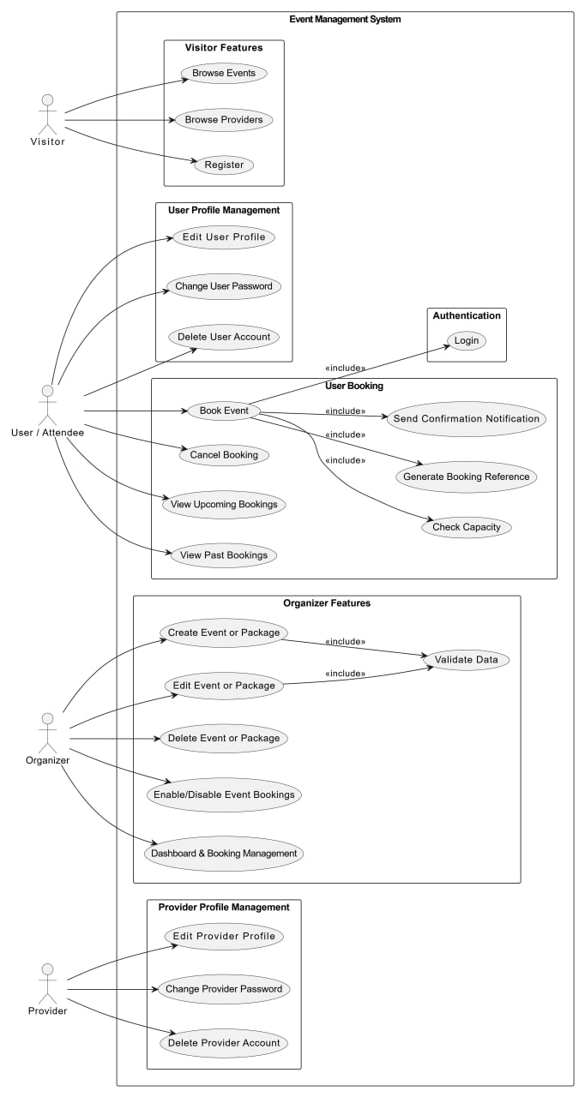

Figure 14: use case diagram

**2.Detailed Analysis**

**1.Introduction**

This chapter aims to transform the functional requirements identified during the preliminary analysis phase into precise engineering designs. Utilizing UML modeling to illustrate system interactions, this section will establish the technical framework to be adopted by the development team in subsequent stages

**2.purposes**

we will:

* Formalize system behavior through state diagrams capturing entity lifecycles
* Map operational workflows via activity diagrams
* Define interaction patterns using sequence diagrams
* Establish validation protocols for data integrity
* Model the static structure of the system using class diagrams, defining key entities (classes), their attributes, operations, and the relationships between them. This will provide a blueprint for the system's architecture and data
* organization.

**3.system requirements:**

**3.1.** **Visitor Management Functional Requirements**

|  |  |  |  |  |
| --- | --- | --- | --- | --- |
| **Requirements ID** | **Description** | **Module** | **Priority** | **Detailed Specification** |
| REQ-FR-VM-01 | Visitor browse events | Visitor Management | High | • Allows visitors to view all available events without logging in |
| REQ-FR-VM-02 | Visitor search & filter | Visitor Management | High | • Allows visitors to search events by title or keywords  • Allows filtering events by date, location, price, and type |
| REQ-FR-VM-03 | Visitor view event details | Visitor Management | High | • Displays full event details including description, images, date, time, location, and availability |
| REQ-FR-VM-04 | Prevent visitor booking | Visitor Management | High | • Restricts booking functionality to logged-in users only |
| REQ-FR-VM-05 | Redirect to login for booking | Visitor Management | High | • Redirects visitors to registration/login page when attempting to book |
| REQ-FR-VM-06 | Visitor browse suppliers | Visitor Management | Medium | • Allows visitors to view provider directory  • Displays provider name, service type, city, and description |

**3.1.2.use case diagram for visitor**

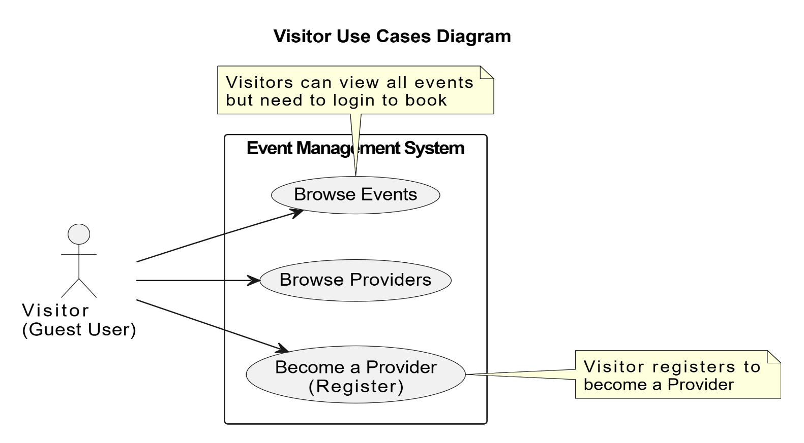

Figure 15 : <<use case 1 (for visitor) >>

**3.1.3.activity diagram for visitor management:**

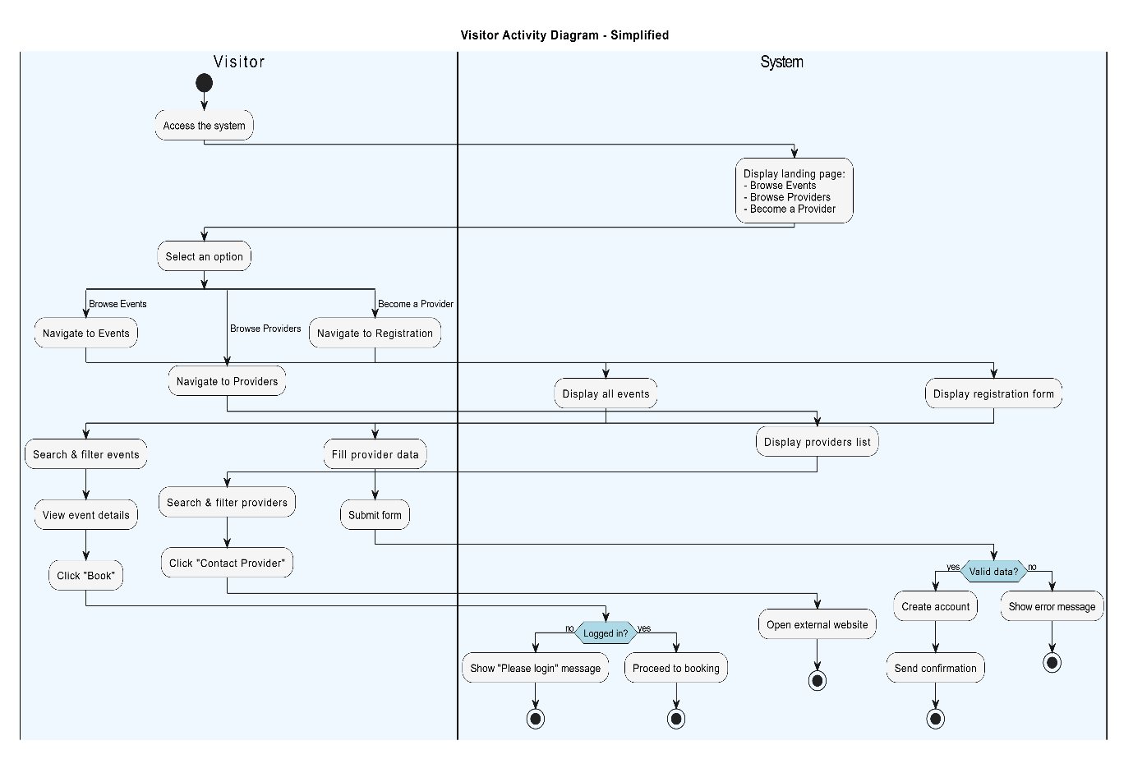

Figure 16:activity diagram for visitor management

**3.1.4 use case specification:**

**Use Case 1: Browse Events as Visitor**

|  |  |
| --- | --- |
| **Use case name:** | Browse and View Events Without Registration |
| **Participating Actors:** | Visitor (Guest User) |
| **The flow of events:** | 1. Visitor accesses the system 2. System displays landing page with three options:    * Browse Events    * Browse Providers    * Become a Provider 3. Visitor selects "Browse Events" 4. System displays all available events without requiring login 5. Visitor uses search & filter functionality (date, location, price, type) 6. System displays filtered results 7. Visitor clicks on "View Event Details" 8. System displays full event details (description, images, capacity, price, supplier info) 9. Visitor clicks on "Book Event" 10. System checks if user is logged in 11. System displays message: "You don't have an account ID. Please login or register to book" 12. System redirects to login/register page |
| **Alternative flows:** | A1. Visitor doesn't attempt to book:   * Visitor continues browsing events * No login required   A2. Visitor is already logged in:   * System proceeds to booking flow * No login prompt displayed   A3. No events match filter:   * System displays "No events found" message |
| **Entry condition** | 1. System is operational 2. Visitor has internet access |
| **Exit conditions** | **Success:**   * Visitor can browse all events freely * Full event details displayed * Search and filter work correctly * Login prompt shown when attempting to book   **Failure:**   * No events available * System unable to load event data |

**Use Case 2: Browse Providers as Visitor**

|  |  |
| --- | --- |
| **Use case name:** | Browse Supplier Directory Without Registration |
| **Participating Actors:** | Visitor (Guest User) |
| **The flow of events:** | 1. Visitor accesses the system 2. System displays landing page with three options 3. Visitor selects "Browse Providers" 4. System displays supplier directory without requiring login 5. Visitor browses and filters supplier listings 6. Visitor clicks on "Contact Provider" 7. System navigates to provider's external website |
| **Alternative flows:** | A1. No providers match filter:   * System displays "No providers found" message   A2. External website unavailable:   * System shows error message |
| **Entry condition** | 1.System is operational  2.Providers are registered in system |
| **Exit conditions** | **Success:**   * Visitor can browse all providers freely * Filter functionality works * External website opens successfully   **Failure:**   * No providers available * External link broken |

**Use Case 3: Become a Provider (Register as Provider)**

|  |  |
| --- | --- |
| **Use case name:** | Provider Registration by Visitor |
| **Participating Actors:** | Visitor (Guest User becoming Provider) |
| **The flow of events:** | 1. Visitor accesses the system 2. System displays landing page with three options 3. Visitor selects "Become a Provider" 4. System displays Provider Registration Form 5. Visitor fills registration data:    * Business Name    * Contact Information (email, phone)    * Services Offered    * Business Description    * Other required details 6. Visitor clicks "Submit" 7. System validates registration data 8. If valid:    * System creates provider account    * System sends confirmation email    * System displays success message |
| **Alternative flows:** | A1. Invalid or missing data:   * System displays validation error message * Visitor must correct errors * Visitor remains on registration form   A2. Email already registered:   * System displays "Email already exists" error * Visitor must use different email   A3. Visitor cancels registration:   * Visitor clicks "Cancel" * System returns to landing page * No account created |
| **Entry condition** | 1.System is operational  2.Visitor wants to become a provider |
| **Exit conditions** | **Success:**   * Provider account created successfully * Confirmation email sent * Visitor can now login as provider   **Failure:**   * Validation errors displayed * Missing required fields * Email already exists * No account created |

**3.2. User Functional Requirements**

|  |  |  |  |  |
| --- | --- | --- | --- | --- |
| **Requirements ID** | **Description** | **Module** | **Priority** | **Detailed Specification** |
| REQ-FR-UM-01 | Create Account | Account Creation | High | • Collect user name, email, phone, and password  • Validate email format  • Enforce strong password policy (min 8 chars, 1 uppercase, 1 number)  • Show registration success/failure notifications |
| REQ-FR-UM-02 | User Login | Authentication | High | • Verify email and password  • Authenticate against stored data  • Maintain session securely  • Show error message if credentials invalid |
| REQ-FR-UM-03 | User Logout | Authentication | Medium | • Terminate user session  • Redirect to home page or login page after logout |
| REQ-FR-UM-04 | Profile Management | Profile Management | Medium | • View profile information (name, email, phone, profile picture)  • Edit profile details  • Change password  • Delete account with password confirmation  • Prevent unauthorized access to other users’ profiles |
| REQ-FR-UM-05 | Browse & Search Events | Event Browsing / User | High | • View all available events in list or card format  • Filter by date, location, price, type• Search by title or keywords |
| REQ-FR-UM-06 | View Event Details | Event Details / User | High | • Display full event details (description, images, date/time, location, capacity, ticket price, total bookings,  display provider info if linked)  • Show booking availability  • Display provider info if linked |
| REQ-FR-UM-07 | Book Event | Booking / User | High | • Book an event (requires login)  • Generate unique booking reference  • Update capacity immediately  • Prevent overbooking  • Send confirmation email |
| REQ-FR-UM-08 | Manage Bookings | Booking / User | High | • Display upcoming and past bookings  • Cancel bookings and restore capacity  • Send cancellation notification  • Filter/sort bookings |

**Use case diagram for Authentication system**

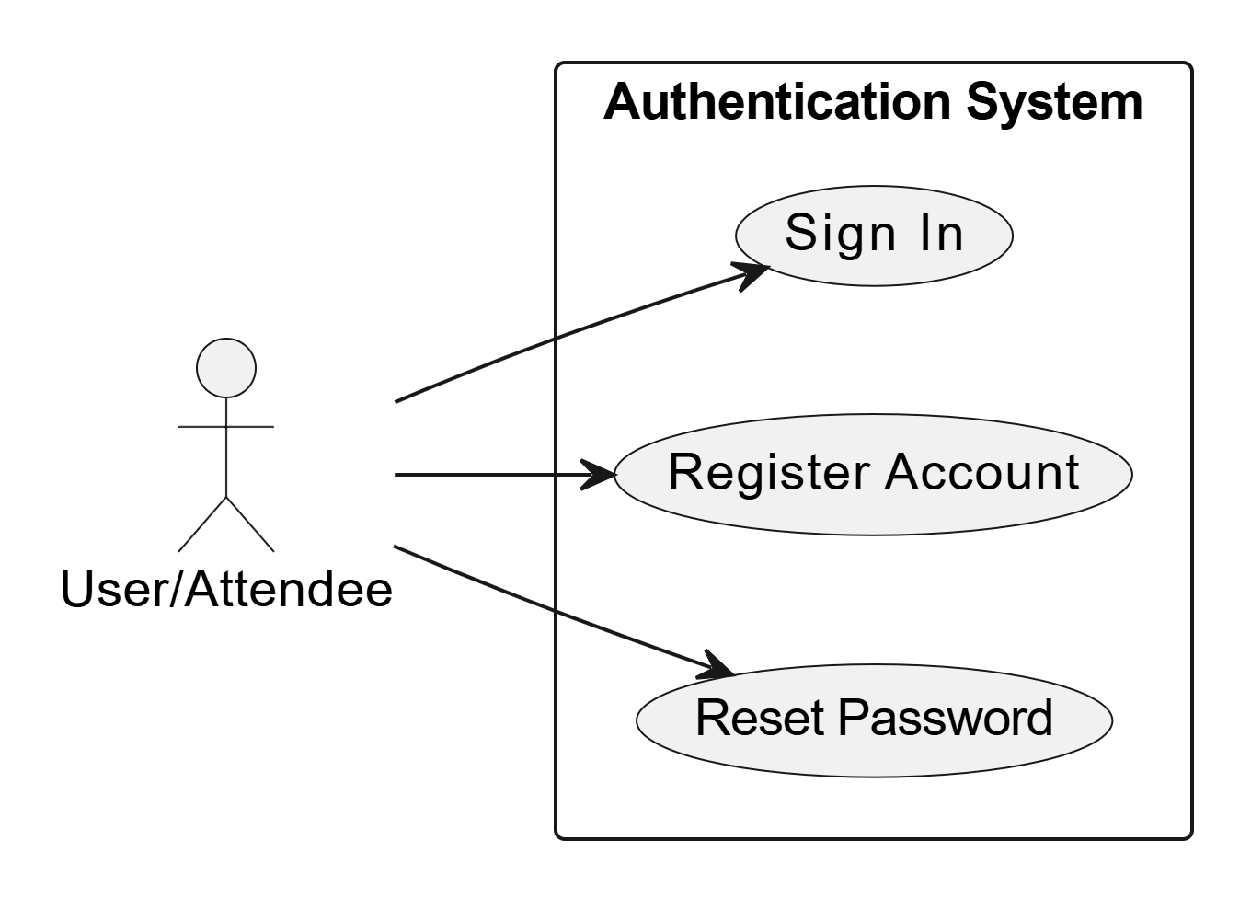

Figure 17:Use case 2 :( for Authentication system )

**Activity diagram for registration account**

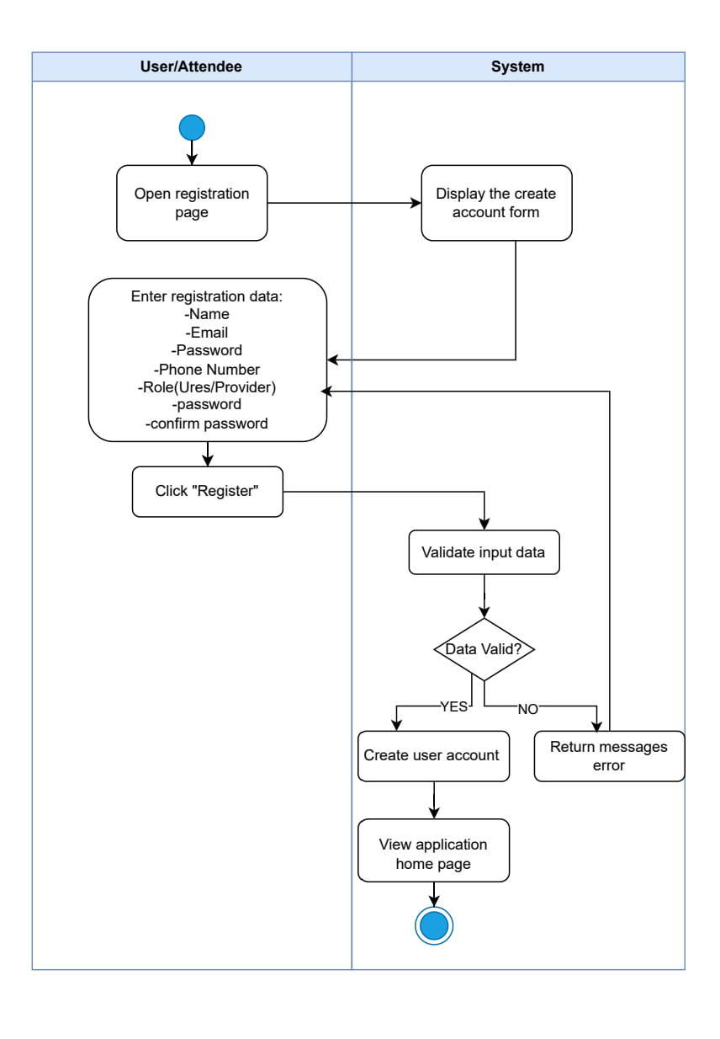

Figure 18:activity diagram for registration new account

**Use case specification:**

|  |  |
| --- | --- |
| **Use case name:** | Register New Account |
| **Participating Actors:** | User/Attendee |
| **The flow of events:** | 1. User/Attendee opens the registration page 2. System displays the create account form 3. User/Attendee enters registration data:    * Name    * Email    * Password    * Phone Number    * Role (User/Provider)    * Confirm password 4. User/Attendee clicks "Register" 5. System validates input data 6. System checks if data is valid    * If valid:      + System creates user account      + System displays the application home page      + Use case ends successfully    * If invalid:      + System returns error messages      + System redisplays the registration form      + User/Attendee can re-enter data |
| **Alternative flows:** | A1. Invalid data format:   * System displays specific validation errors (e.g., "Invalid email format") * User/Attendee remains on registration form * User/Attendee corrects the data   A2. Password mismatch:   * System displays "Passwords do not match" error * User/Attendee re-enters passwords   A3. Email already exists:   * System displays "Email already registered" error * User/Attendee redirected to sign-in page or uses different email   A4. Weak password:   * System displays password strength requirements * User/Attendee enters stronger password   Entry condition:   1. User/Attendee does not have an existing account 2. System is operational 3. Registration page is accessible |
| **Entry condition** | 1. User/Attendee does not have an existing account 2. System is operational 3. Registration page is accessible |
| **Exit conditions** | **Success:**   * User account created successfully * User/Attendee authenticated automatically * Application home page displayed * Welcome notification sent   **Failure:**   * Validation errors displayed * User/Attendee remains on registration form * No account created in database * Error messages guide user to correct inputs |

Activity diagram for login

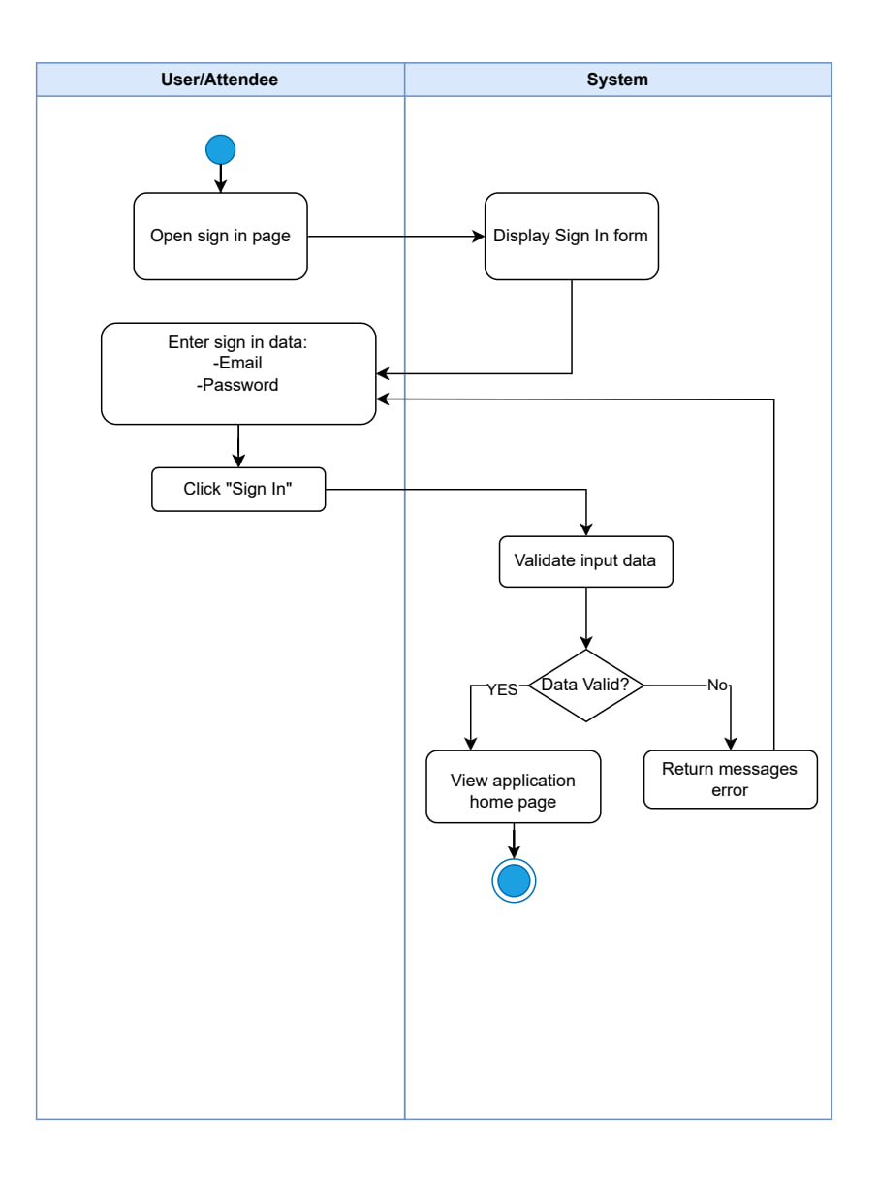

|  |  |
| --- | --- |
| **Use case name:** | Sign In to System |
| **Participating Actors:** | User/Attendee |
| **The flow of events:** | 1. User/Attendee opens the sign-in page 2. System displays the Sign In form 3. User/Attendee enters sign-in data:    * Email    * Password 4. User/Attendee clicks "Sign In" 5. System validates input data 6. System checks if data is valid    * If valid:      + System authenticates the user      + System displays the application home page      + Use case ends successfully    * If invalid:      + System returns error messages      + System redisplays the Sign In form      + User/Attendee can re-enter credentials |
| **Alternative flows:** | A1. Invalid credentials:   * System displays "Invalid email or password" error * User/Attendee remains on sign-in page * User/Attendee can retry or reset password   A2. Empty fields:   * System displays "Required fields missing" error * User/Attendee prompted to fill all fields   A3. Account locked/suspended:   * System displays appropriate error message * User/Attendee cannot proceed to home page |
| **Entry condition** | 1. User/Attendee has internet connection 2. System is operational 3. Sign-in page is accessible |
| **Exit conditions** | **Success:**   * User/Attendee authenticated successfully * Application home page displayed * User session initiated   **Failure:**   * Validation errors displayed * User/Attendee remains on sign-in page * No session created * Error messages shown to user |

**Activity diagram for forget password**

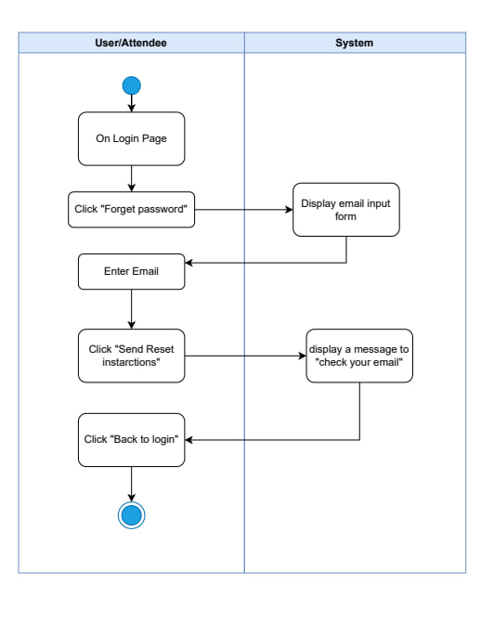

|  |  |
| --- | --- |
| **Use case name:** | **Reset Forgotten Password** |
| **Participating Actors:** | User/Attendee |
| **The flow of events:** | 1.User/Attendee is on the login page  2.User/Attendee clicks "Forget password"  3.System displays email input form  4.User/Attendee enters email address  5.User/Attendee clicks "Send Reset Instructions"  6.System displays message "check your email"   1. System sends password reset email to the user 2. User/Attendee clicks "Back to login" 3. Use case ends |
| **Alternative flows:** | A1. Email not found:   * System displays "Email not registered" error * User/Attendee can retry with different email or register new account   A2. Invalid email format:   * System displays "Invalid email format" error * User/Attendee corrects email address   A3. Email delivery failure:   * System logs the error * User/Attendee may not receive email * User/Attendee can request resend   A4. User cancels operation:   * User/Attendee clicks "Back to login" before submitting * No email sent * Returns to login page |
| **Entry condition** | 1. User/Attendee has forgotten their password   1. User/Attendee is on the login page 2. System is operational 3. Email service is available |
| **Exit conditions** | **Success:**   * Password reset email sent successfully * User/Attendee receives instructions in email * User/Attendee returns to login page * System logs the reset request   **Failure:**   * Email not sent due to invalid address * Error message displayed to user * User/Attendee remains on password reset form * No reset email delivered |

**Use case diagram : for user profile management**

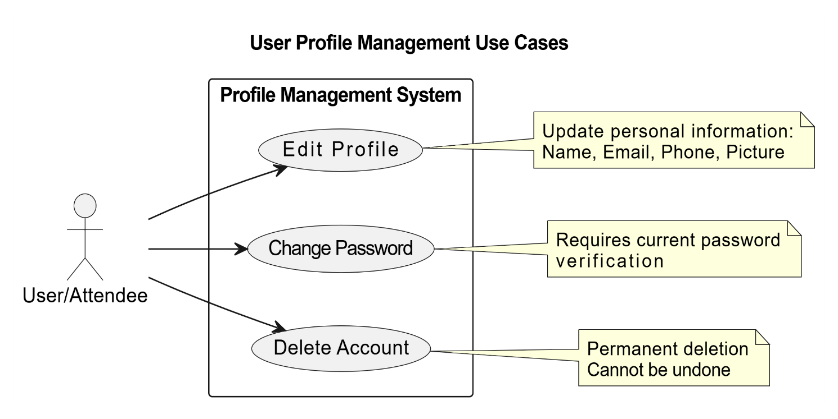

Figure 19:use case 2: user profile

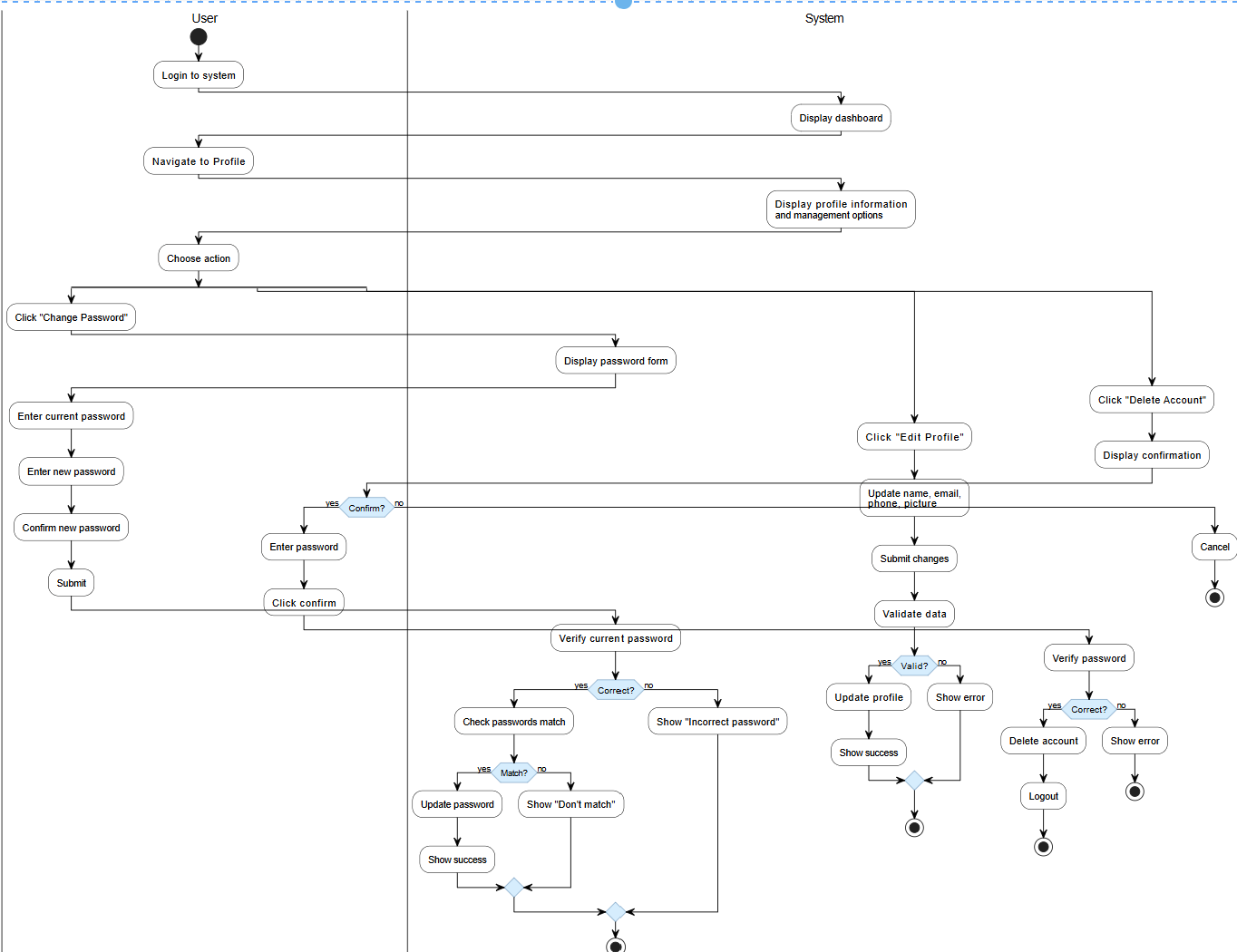**3.13 activity diagram for user profile management**

Figure 20:activity diagram for user profile management

**Use Case Specification: Profile Management**

**Use Case 1: Edit Profile**

|  |  |
| --- | --- |
| **Use case name:** | Edit User Profile Information |
| **Participating Actors:** | User/Attendee |
| **The flow of events:** | 1. User logs into the system 2. System displays dashboard 3. User navigates to Profile 4. System displays profile information and management options 5. User clicks "Edit Profile" 6. System displays edit form with current information 7. User updates information:    * Name    * Email    * Phone number    * Profile picture 8. User submits changes 9. System validates data 10. System updates profile information 11. System displays success message |
| **Alternative flows:** | A1. Invalid data entered:   * System displays validation error * User must correct errors * User remains on edit form   A2. Email already exists:   * System displays "Email already in use" error * User must use different email   A3. User cancels edit:   * System returns to profile page * No changes saved |
| **Entry condition** | 1. User is authenticated and logged in 2. System is operational |
| **Exit conditions** | **Success:**   * Profile information updated successfully * Success message displayed * Updated information visible in profile   **Failure:**   * Validation errors displayed * Invalid data entered * No changes saved to database |

**Use Case 2: Change Password**

|  |  |
| --- | --- |
| **Use case name:** | Edit User Profile Information |
| **Participating Actors:** | User/Attendee |
| **The flow of events:** | 1. User logs into the system 2. System displays dashboard 3. User navigates to Profile 4. System displays profile information and management options 5. User clicks "Change Password" 6. System displays password change form 7. User enters current password 8. User enters new password 9. User confirms new password 10. User clicks "Submit" 11. System verifies current password is correct 12. System checks if new passwords match 13. System updates password in database 14. System displays success message |
| **Alternative flows:** | A1. Current password incorrect:   * System displays error: "Incorrect current password" * User must enter correct current password * User remains on password form   A2. New passwords don't match:   * System displays error: "Passwords don't match" * User must re-enter matching passwords * User remains on password form   A3. New password doesn't meet requirements:   * System displays validation error * User must enter valid password   A4. User cancels:   * System returns to profile page * Password remains unchanged |
| **Entry condition** | 1. User is authenticated and logged in 2. System is operational |
| **Exit conditions** | **Success:**   * Password updated successfully * Success message displayed * User can login with new password   **Failure:**   * Current password incorrect * New passwords don't match * Validation errors displayed * Password remains unchanged |

|  |  |
| --- | --- |
| **Use case name:** | Delete User Account |
| **Participating Actors:** | User/Attendee |
| **The flow of events:** | 1. User logs into the system 2. System displays dashboard 3. User navigates to Profile 4. System displays profile information and management options 5. User clicks "Delete Account" 6. System displays confirmation dialog with warning message 7. User confirms deletion 8. System prompts user to enter password for confirmation 9. User enters password 10. User clicks "Confirm Delete" 11. System verifies password is correct 12. System deletes user account 13. System deletes all associated user data 14. System logs out user 15. System displays success message or redirects to homepage |
| **Alternative flows:** | A1. User cancels deletion:   * User clicks "Cancel" on confirmation dialog * System returns to profile page * No account deletion occurs   A2. Incorrect password entered:   * System displays error: "Incorrect password" * User must enter correct password * Account not deleted   A3. User has active bookings:   * System displays warning about active bookings * User can still proceed or cancel (business rule dependent) |
| **Entry condition** | 1. User is authenticated and logged in  2. System is operational   1. User has valid account |
| **Exit conditions** | **Success:**   * User account deleted successfully * All user data removed from database * User logged out automatically * Success message displayed   **Failure:**   * Incorrect password entered * User cancels deletion * Account remains active * User remains logged in |

Use case for event

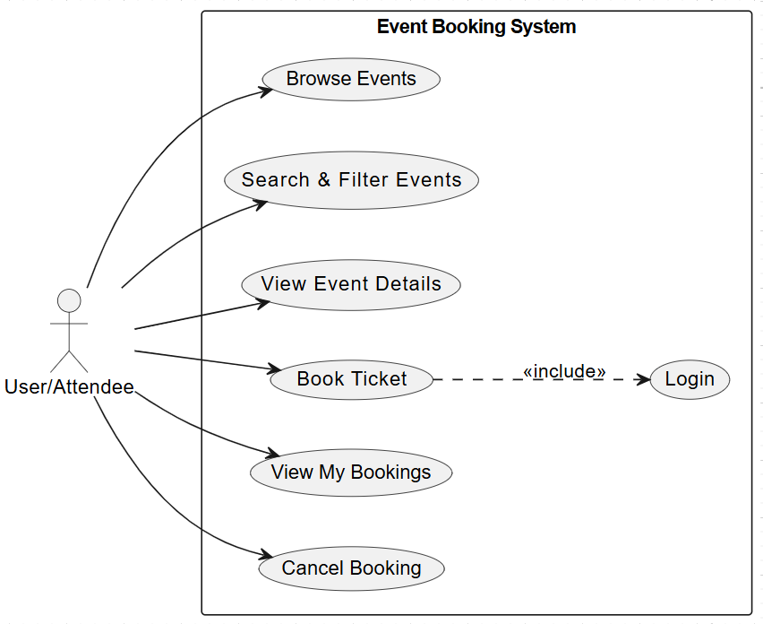

Figure 21:use case 3 (for events)

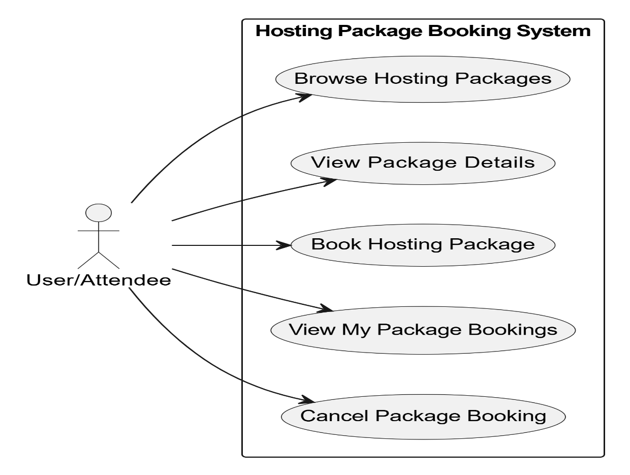

Figure 22: UC-06

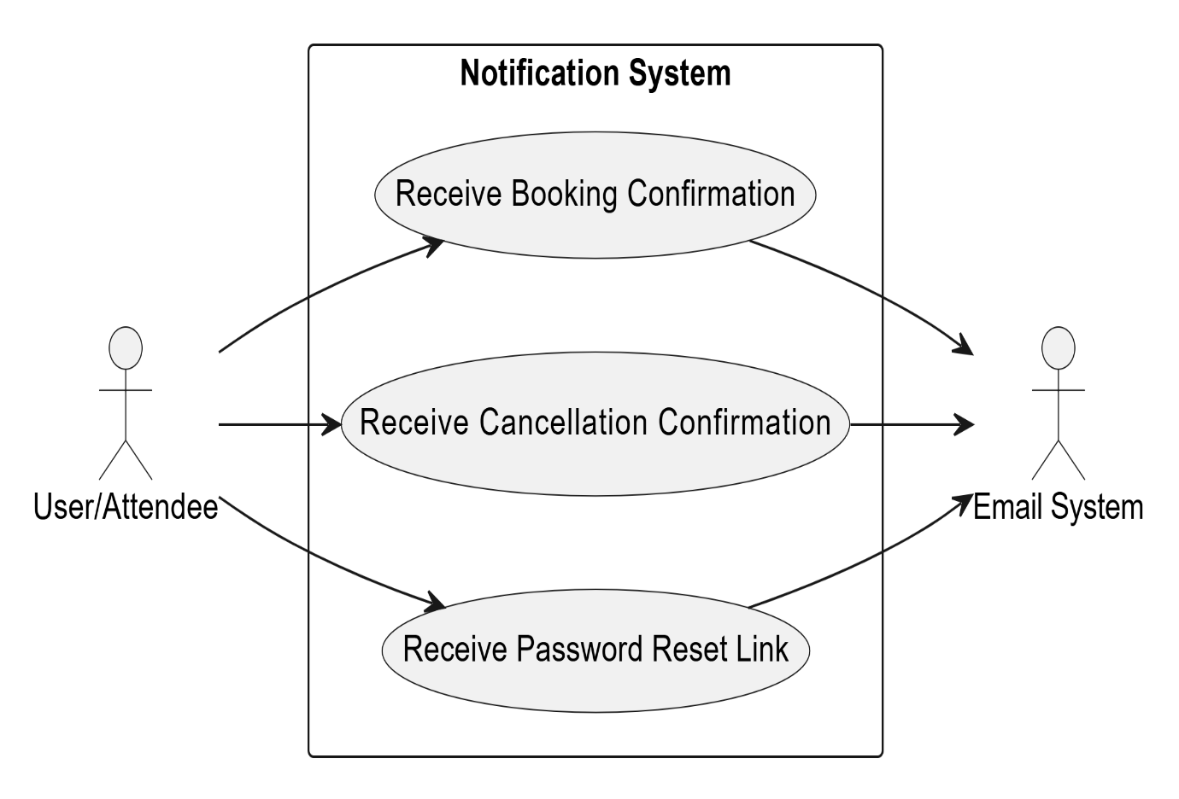

Figure 23:USE CASE 7

Activity diagram for event discovery & booking activity diagram

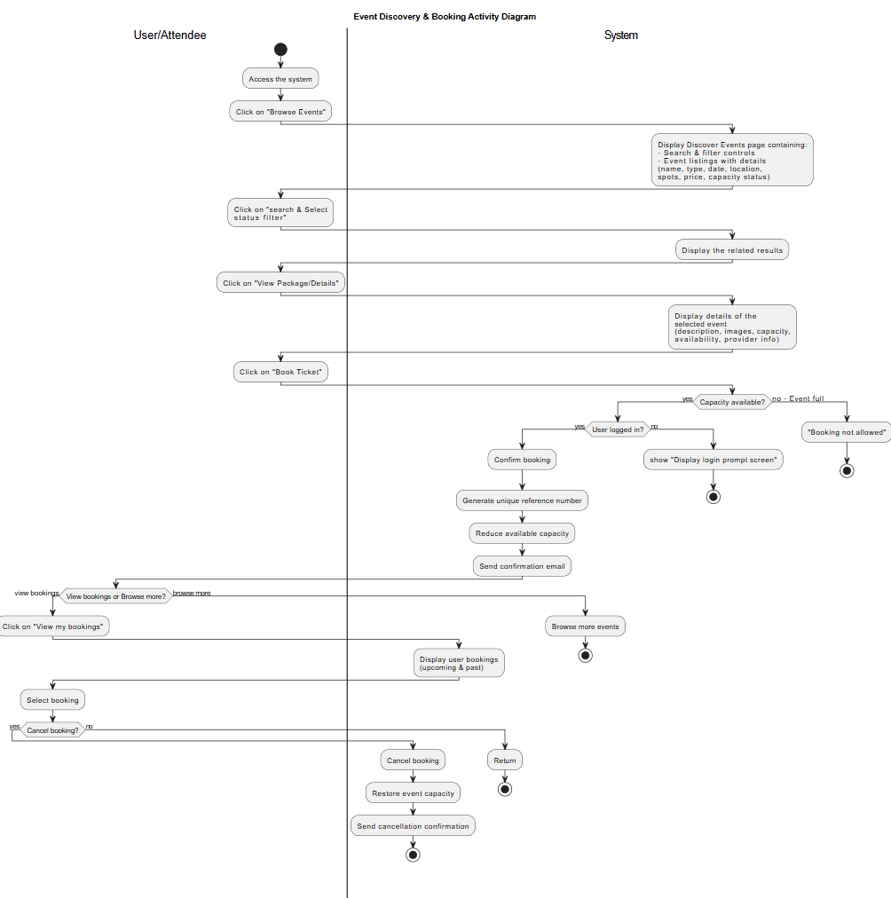

Figure 24: Activity diagram for event discovery & booking activity diagram

**3.3.2.2Use Case specification**

|  |  |
| --- | --- |
| **Use case name:** | Event Discovery and Booking |
| **Participating Actors:** | End User |
| **The flow of events:** | **Main Flow:**   1. User accesses the system 2. User clicks on "Browse Events" 3. System displays Discover Events page containing:    * Search & filter controls (search field, city, type, date, price)    * Event listings (event name, type, date, location, spots, price, capacity status) 4. User clicks on "search & Select status filter" 5. System displays the related results 6. User clicks on "View Package/Event" 7. System displays details of the selected event:    * Description, images, capacity, availability    * Ticket price, supplier information (if tagged) 8. User clicks on "Book package/event" 9. System checks if capacity is available 10. System checks if user is logged in 11. System confirms booking 12. System generates unique booking reference number 13. System reduces available capacity immediately 14. System sends booking confirmation email with reference number 15. User chooses to view bookings or browse more events   **Alternative Flow A (View My Bookings):**   1. User clicks on "View my bookings" 2. System displays user bookings with details (upcoming & past bookings) 3. User selects a booking 4. User decides to cancel or return 5. If cancel:    * System cancels booking    * System restores event capacity    * System sends cancellation confirmation message   **Alternative Flow B (Browse More Events):**   1. System returns to browse more events page |
| **Alternative flows:** | A1. Event capacity exceeded:   * System shows error message: "Event capacity exceeded" * User cannot proceed with booking   A2. User not logged in:   * System shows error message: "Please login first" * User redirected to login page   A3. Empty search/filter:   * System displays all available events   A4. No events match filter criteria:   * System displays "No events found" message   A5. Booking cancellation:   * User cancels booking from "My Bookings" * System restores event capacity * System sends cancellation confirmation |
| **Entry condition** | 1- System is operational  2-Events are available in the system  3- User has access to the system |
| **Exit conditions** | **Success:**   * Event booking confirmed successfully * Unique reference number generated * Confirmation email sent * Event capacity updated * User can view booking in "My Bookings"   **Success (Cancel Booking):**   * Booking canceled successfully * Event capacity restored * Cancellation confirmation sent   **Failure:**   * Error message displayed (capacity exceeded / not logged in) * User remains on current page * No changes to event capacity or booking status |

|  |  |  |  |  |
| --- | --- | --- | --- | --- |
| **Requirements ID** | **Description** | **Module** | **Priority** | **Detailed Specification** |
| REQ-FR-OR-01 | Create Public Event | Event Management | High | •Allows organizer to create a new public event • Mandatory fields: title, description, location, future date, time, capacity, ticket price • Validate all inputs before saving |
| REQ-FR-OR-02 | Edit Event | Event Management | High | • Allows organizer to edit existing events • Update title, description, location, date/time, capacity, price |
| REQ-FR-OR-03 | Delete Event | Event Management | Medium | • Allows organizer to delete events • Requires confirmation before deletion • Notify participants via email if deleted |
| REQ-FR-OR-04 | Create Host Package | Event Management | Medium | • Allows organizer to open or close event booking (Open/Close) |
| REQ-FR-OR-05 | Edit Host Package | Host Package Management | Medium | • Allows organizer to create a new host package• Mandatory fields: title, description, base setup details, location options, package price |
| REQ-FR-OR-06 | Delete Host Package | Host Package Management | Medium | • Allows organizer to edit host packages after creation |
| REQ-FR-OR-07 | Enable/Disable Host Package Booking | Host Package Management | Medium | • Allows organizer to delete host packages• Requires confirmation |
| REQ-FR-OR-08 | Manage Bookings | Host Package Management | Medium | • Allows organizer to open or close booking for host packages |
| REQ-FR-OR-09 | Display Event Dashboard | Event Dashboard | High | • Show all events created by the organizer• Display type, city, date, status, bookings, statistics, revenue, available actions |
| REQ-FR-OR-10 | Display Per-Event Statistics | Analytics | High | • Show statistics per event: total bookings, remaining seats, total revenue |
| REQ-FR-OR-11 | Display General Statistics | Analytics | High | • Show general statistics: total events created, active events, total overall revenue |
| REQ-FR-OR-12 | Booking Notifications | Notifications | High | • Notify organizer for new bookings• Notify when event capacity reaches 80% or 100% |
| REQ-FR-OR-13 | Event Update Notifications | Notifications | High | • Notify attendees if event is canceled, date changed, or location changed |
| REQ-FR-OR-14 | Filter Events by Status | Event Dashboard | Medium | • Filter events by status: All, Active, Canceled, Completed |
| REQ-FR-OR-15 | Search Events | Event Dashboard | Medium | • Search events by title or keywords |

**Use case for organizer**

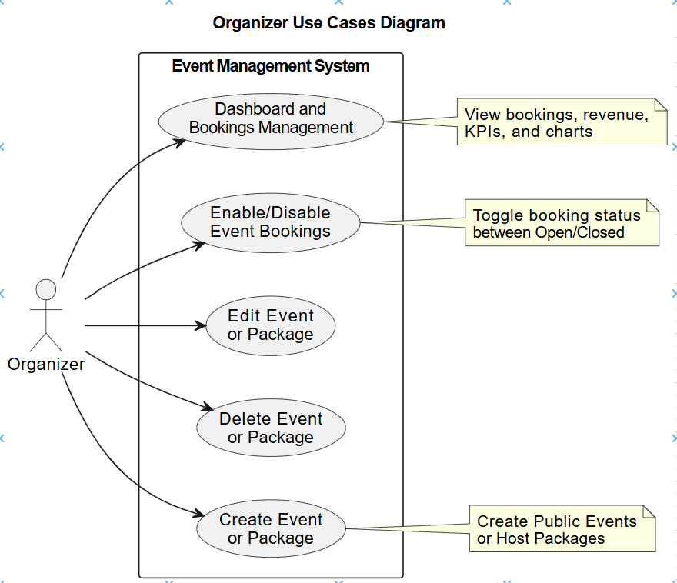

Figure 25:use case 5 : (for organizer)

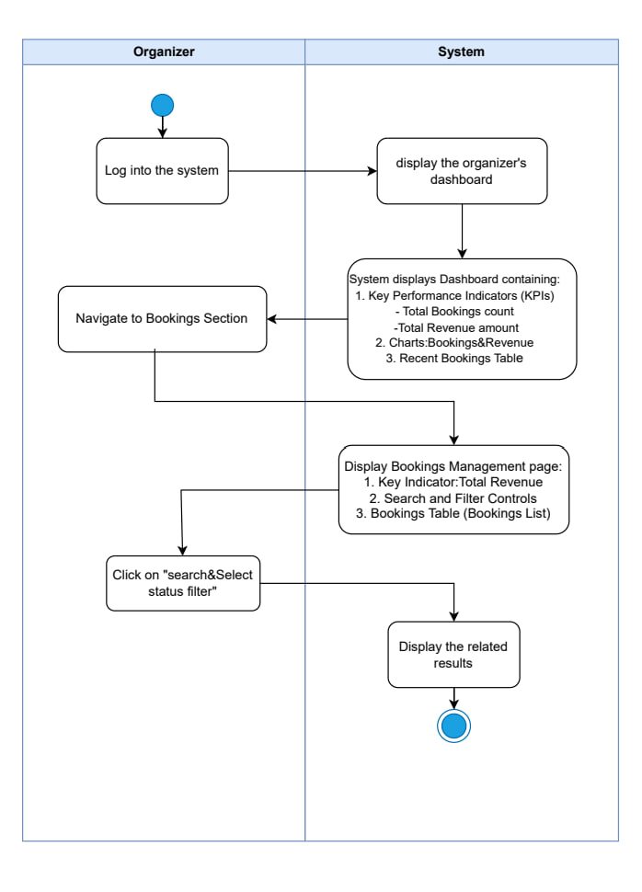

Figure 26:activity diagram for organizer

|  |  |
| --- | --- |
| **Use case name:** | Organizer Dashboard and Bookings Management |
| **Participating Actors:** | Organizer |
| **The flow of events:** | 1. Organizer logs into the system 2. System displays the organizer's dashboard containing:    * Key Performance Indicators (KPIs):      + Total Bookings count      + Total Revenue amount    * Charts: Bookings & Revenue    * Recent Bookings Table 3. Organizer navigates to Bookings Section 4. System displays Bookings Management page containing:    * Key Indicator: Total Revenue    * Search and Filter Controls    * Bookings Table (Bookings List) 5. Organizer clicks on "search & Select status filter" 6. System displays the related results |
| **Alternative flows:** | A1. No bookings available:   * System displays "No bookings found" message   A2. Empty search/filter:   * System displays all bookings |
| **Entry condition** | 1. Organizer is authenticated 2. System is operational |
| **Exit conditions** | **Success:**   * Dashboard data displayed successfully * Bookings list filtered and displayed * Statistics and charts visible   **Failure:**   * Error loading dashboard data * No results match filter criteria |

**Disable/Enable Bookings**

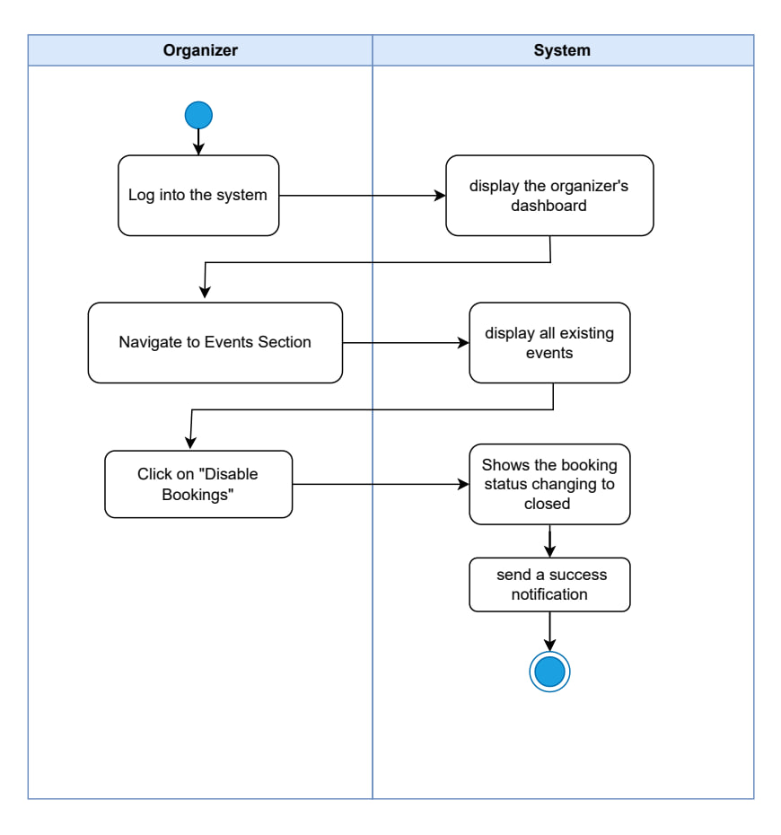

|  |  |
| --- | --- |
| **Use case name:** | Enable or Disable Event Bookings |
| **Participating Actors:** | Organizer |
| **The flow of events:** | 1. Organizer logs into the system 2. System displays the organizer's dashboard 3. Organizer navigates to Events Section 4. System displays all existing events 5. Organizer clicks on "Disable Bookings" button 6. System shows the booking status changing to "closed" 7. System sends a success notification 8. Event booking status updated |
| **Alternative flows:** | A1. Enable Bookings:   * Organizer clicks "Enable Bookings" * System changes status to "open" * Success notification sent   A2. No events available:   * System displays "No events found" message |
| **Entry condition** | 1. Organizer is authenticated 2. Event exists in the system 3. System is operational |
| **Exit conditions** | **Success:**   * Booking status changed successfully (Open/Closed) * Success notification displayed * Event updated in database   **Failure:**   * Error updating booking status * System displays error message |

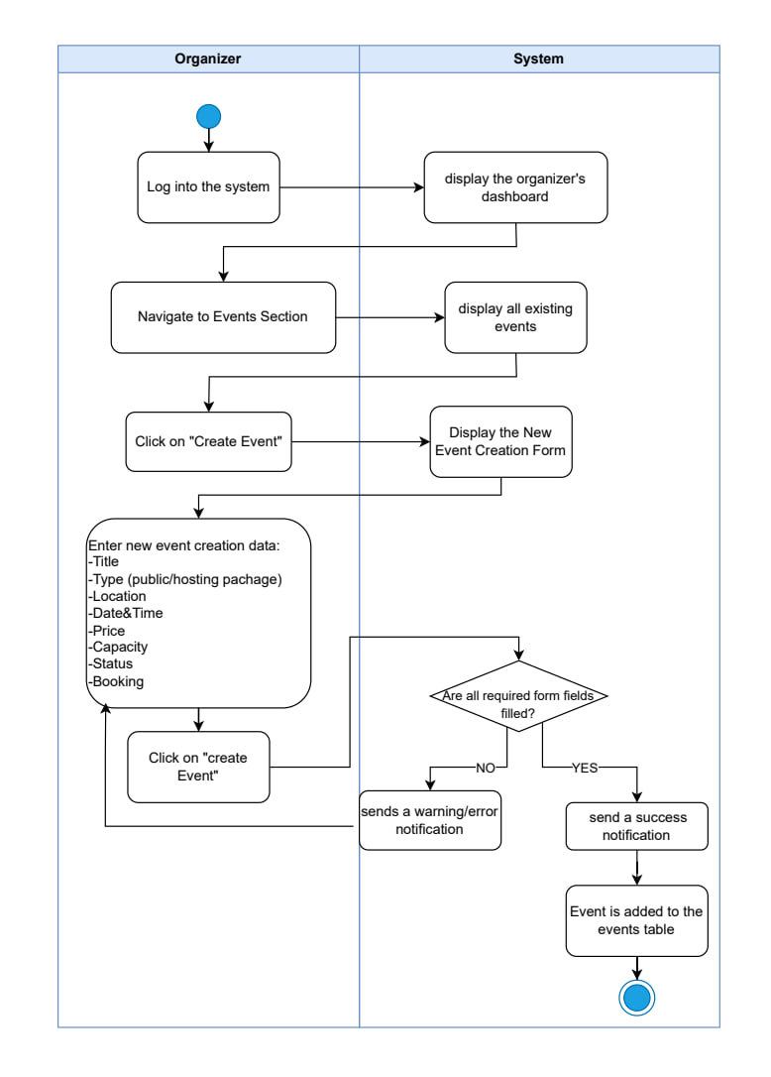

|  |  |
| --- | --- |
| **Use case name:** | Create New Public Event or Host Package |
| **Participating Actors:** | Organizer |
| **The flow of events:** | 1. Organizer logs into the system 2. System displays the organizer's dashboard 3. Organizer navigates to Events Section 4. System displays all existing events 5. Organizer clicks on "Create New Event" 6. System displays Create Event Form 7. Organizer selects Event Type (Public Event or Host Package) 8. If Public Event:    * Organizer enters: Title, Description, Location, Date (future), Time, Capacity, Ticket Price    * Optional: Image, Supplier information 9. If Host Package:    * Organizer enters: Title, Description, Base setup details, Location options, Package Price, Customizable elements    * Optional: Image, Supplier information 10. Organizer clicks "Create Event" or "Cancel" 11. If submitted:     * System validates all required fields are filled     * System checks if date is in the future     * System saves event to database     * System sends success notification     * System displays event in events list |
| **Alternative flows:** | A1. Missing required fields:   * System displays error: "Please fill all required fields" * Organizer remains on create form   A2. Past date entered:   * System displays error: "Date must be in the future" * Organizer must correct the date   A3. Cancel creation:   * Organizer clicks "Cancel" * System returns to events list * No event created |
| **Entry condition** | 1. Organizer is authenticated 2. System is operational |
| **Exit conditions** | **Success:**   * Event/Package created successfully * Success notification displayed * New event visible in events list * Event available for users to browse and book   **Failure:**   * Validation errors displayed * Required fields missing * Invalid date (past date) * Organizer remains on create form * No event created in database |

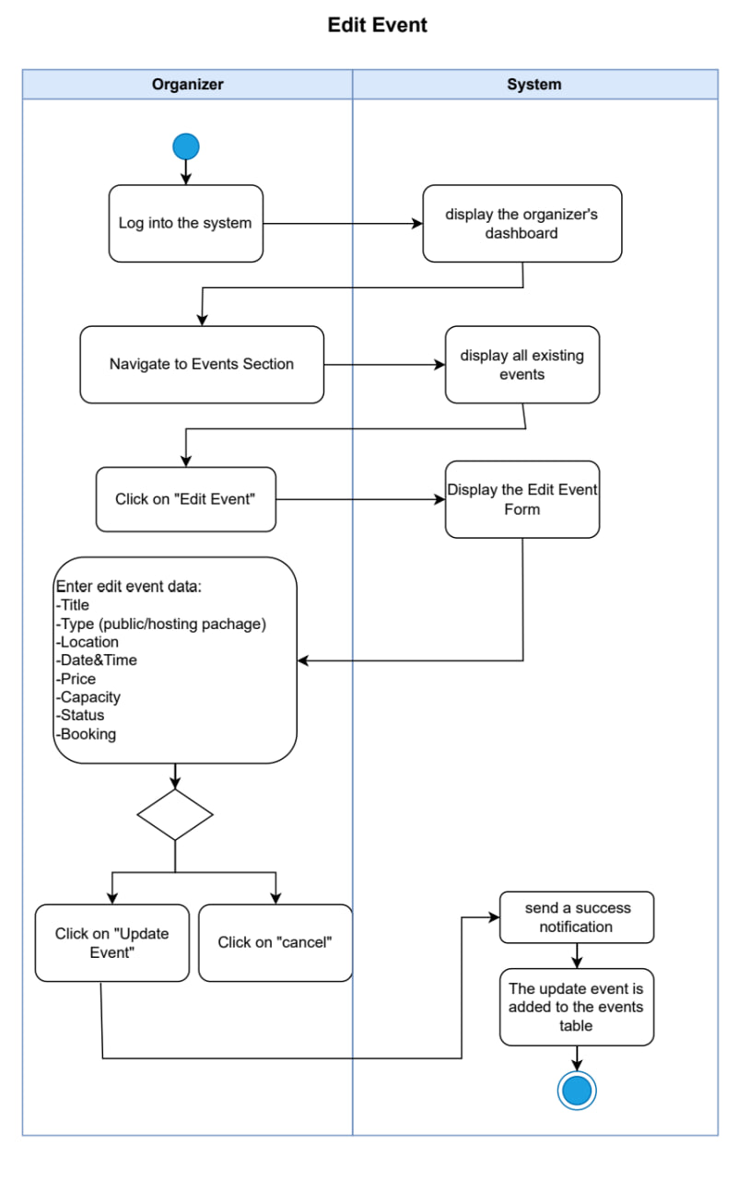

|  |  |
| --- | --- |
| **Use case name:** | Edit Existing Event or Package |
| **Participating Actors:** | Organizer |
| **The flow of events:** | **The flow of events:**  1.Organizer logs into the system  2.System displays the organizer's dashboard  3.Organizer navigates to Events Section  4.System displays all existing events  5.Organizer clicks on "Edit Event"  6.System displays the Edit Event Form with current data  7.Organizer enters edit event data:   * 1. Title   2. Type (public/hosting package)   3. Location   4. Date & Time   5. Price   6. Capacity   7. Status   8. Booking settings   8.Organizer makes a decision to update or cancel   1. If update:    1. Organizer clicks "Update Event"    2. System validates inputs    3. System sends a success notification    4. The updated event is reflected in the events table |
| **Alternative flows:** | A1. Cancel edit:   * Organizer clicks "cancel" * System returns to events list * No changes saved   A2. Invalid data:   * System displays validation error * Organizer remains on edit form   A3. Missing required fields:   * System prompts to fill required fields |
| **Entry condition** | 1.Organizer is authenticated  2.Event exists in the system  3.System is operational |
| **Exit conditions** | **Success:**   * Event updated successfully * Success notification displayed * Changes reflected in events table   **Failure:**   * Validation errors displayed * Organizer remains on edit form * No changes saved to database * System displays error message |

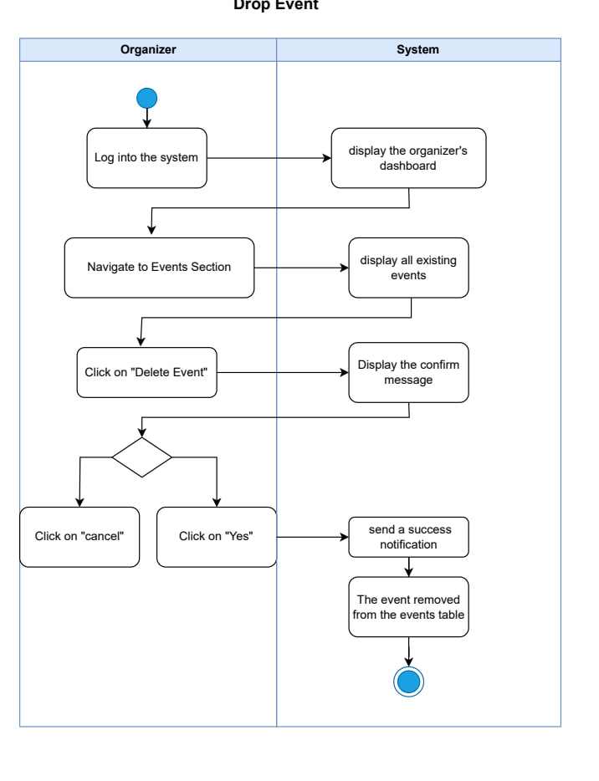

|  |  |
| --- | --- |
| **Use case name:** | Delete Event or Package |
| **Participating Actors:** | Organizer |
| **The flow of events:** | 1. Organizer logs into the system 2. System displays the organizer's dashboard 3. Organizer navigates to Events Section 4. System displays all existing events 5. Organizer clicks on "Delete Event" 6. System displays the confirm message: "Are you sure you want to delete this event?" 7. Organizer makes a decision:    * Click "cancel" to abort    * Click "Yes" to confirm deletion 8. If confirmed:    * System sends a success notification    * The event is removed from the events table |
| **Alternative flows:** | A1. Cancel deletion:   * Organizer clicks "cancel" * System returns to events list * Event remains unchanged   A2. Event has active bookings:   * System displays warning message * Organizer can still proceed with deletion (optional business rule) |
| **Entry condition** | 1. Organizer is authenticated 2. Event exists in the system 3. System is operational |
| **Exit conditions** | **Success:**   * Event deleted successfully * Success notification displayed * Event removed from database and events table   **Failure:**   * Deletion canceled by organizer * Event remains in system |

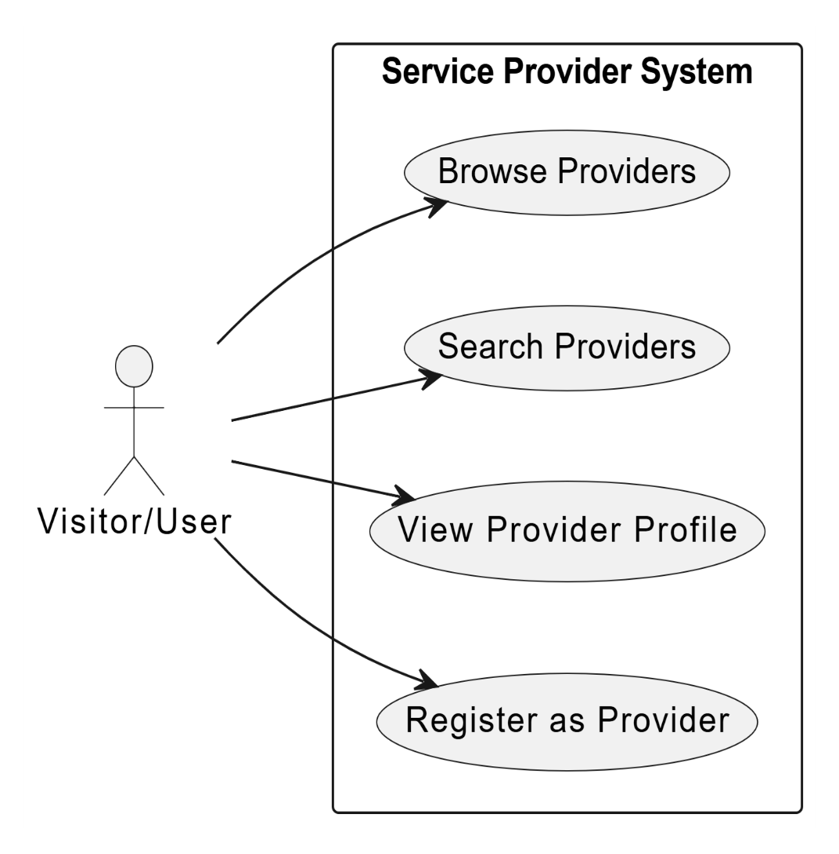

Figure 27:use case 6 (for provider)

**3.initial test case:**

|  |  |  |  |  |
| --- | --- | --- | --- | --- |
| **TC ID** | **Title** | **Preconditions** | **Test Steps** | **Expected Result** |
| TC-01 | User Registration | User is on the registration page | Enter valid data and submit the form | Account is created and confirmation email is received |
| TC-02 | Registration Validation | User is on the registration page | Enter invalid email, phone, or password and submit | Validation error messages are displayed |
| TC-03 | Login & Logout | User account exists | Log in with valid credentials then log out | User logs in and logs out successfully |
| TC-04 | Password Recovery | Email is registered in the system | Click “Forgot Password” and enter email | Password reset email is sent |
| TC-05 | Change Password | User is logged in | Enter old password and new password | Password is changed successfully |
| TC-06 | View & Edit Profile | User is logged in | Open profile, edit information, and save | Profile information is updated |
| TC-07 | Delete User Account | User is logged in | Confirm account deletion | User account is deleted |
| TC-08 | View Events | Published events exist | Open events page as guest or user | Events list is displayed |
| TC-09 | Search & Filter Events | Published events exist | Search events or apply filters | Correct events are displayed |
| TC-10 | Event Details & Capacity | Event is published | Open event details page | Event details, capacity, and booking status are shown |
| TC-11 | View Vendor Information | Event is linked to a vendor | Open event details page | Vendor information is displayed |
| TC-12 | Book Event | User is logged in, seats available | Complete booking process | Booking is confirmed and capacity is updated |
| TC-13 | Booking Restrictions | Event is full or user not logged in | Attempt to book event | Booking is blocked or user redirected to login |
| TC-14 | Cancel Booking | User has a confirmed booking | Cancel the booking | Booking is canceled and seat is restored |
| TC-15 | Booking Notifications | Booking action occurs | Create or cancel booking | Notification email is received |
| TC-16 | View Bookings | User has bookings | Open bookings page | Upcoming and past bookings are displayed |
| TC-17 | View & Book Packages | Packages are available | Open packages and complete booking | Packages are displayed and booking is successful |
| TC-18 | Event Management | Organizer is logged in | Create, edit, or delete an event | Event is saved or removed correctly |
| TC-19 | Package Management | Organizer is logged in | Create, edit, or delete a package | Package is saved or removed correctly |
| TC-20 | Dashboard & Statistics | Organizer has events | Open dashboard | Dashboard data and statistics are displayed |
| TC-21 | Vendor Registration | Vendor not registered | Complete vendor registration | Vendor account is created |
| TC-22 | System Basic Quality | System is running | Use system on different browsers | System works correctly with acceptable performance |

Table 24:initial test cases

* 1. **Requirement Trackability Matrix (RTM) (V.2)**

|  |  |  |  |  |  |  |  |
| --- | --- | --- | --- | --- | --- | --- | --- |
| **Requirements Id** | **Title** | **Use case** | **System Design** | **Analysis** | **Detailed Design** | **Coding** | **Test Cases** |
| REQ-FR-01 | The system should allow users and service providers to register with basic information | Uc-02 |  |  |  |  | TC-01 |
| REQ-FR-02 | The system should validate email, phone, and password | UC-02 |  |  |  |  | TC-02 |
| REQ-FR-03 | The system should allow users, service providers, and admins to log in and log out | UC-02 |  |  |  |  | TC-03 |
| REQ-FR-04 | The system should allow users to reset their password via an email link | UC-02 |  |  |  |  | TC-04 |
| REQ-FR-05 | The system should display user profile information | US-03 |  |  |  |  | TC-06 |
| REQ-FR-06 | The system should allow users to edit personal details | US-03 |  |  |  |  | TC-06 |
| REQ-FR-07 | The system should allow users to change their password | UC-03 |  |  |  |  | TC-05 |
| REQ-FR-08 | The system should allow users to delete their account | US-03 |  |  |  |  | TC-07 |
| REQ-FR-09 | The system should display all available events on the homepage | US-04 |  |  |  |  | TC-08 |
| REQ-FR-10 | The system should allow users to filter events by date, location, price, and event type | UC-04 |  |  |  |  | TC-09 |
| REQ-FR-11 | The system should display event cards with key information | UC-04 |  |  |  |  | TC-08, TC-09 |
| REQ-FR-12 | The system should allow users to search events by title or keywords | UC-04 |  |  |  |  | TC-09, TC-12 |
| REQ-FR-13 | The system should display available seats for each event | UC-04 |  |  |  |  | TC-10 |
| REQ-FR-14 | The system should display full event details, including description, images, capacity, and ticket price | UC-05 |  |  |  |  | TC-10 |
| REQ-FR-15 | The system should display booking availability status for each event | UC-04 |  |  |  |  | TC-10 |
| REQ-FR-16 | The system should display vendor information associated with the event | UC-05 |  |  |  |  | TC-11 |
| REQ-FR-17 | The system should prevent booking when event capacity is full | UC-06 |  |  |  |  | TC-13 |
| REQ-FR-18 | The system should require users to log in before completing a booking | UC-06 |  |  |  |  | TC-12, TC-13 |
| REQ-FR-19 | The system should generate a unique booking reference number upon confirmation | UC-05 |  |  |  |  | TC-12 |
| REQ-FR-20 | The system should immediately reduce available capacity after booking | UC-05 |  |  |  |  | TC-12 |
| REQ-FR-21 | The system should send a booking confirmation email with the reference number | UC-07 |  |  |  |  | TC-15 |
| REQ-FR-22 | The system should display hosting packages with setup details | UC-05 |  |  |  |  | TC-17 |
| REQ-FR-23 | The system should allow users to book a hosting package for a specific date or location | UC-05 |  |  |  |  | TC-17 |
| REQ-FR-24 | The system should display upcoming bookings for the user | UC-04 |  |  |  |  | TC-16 |
| REQ-FR-25 | The system should display completed bookings | UC-06 |  |  |  |  | TC-16 |
| REQ-FR-26 | The system should allow cancellation of confirmed bookings | UC-07 |  |  |  |  | TC-14 |
| REQ-FR-27 | The system should restore event capacity when a booking is canceled | UC-02 |  |  |  |  | TC-14 |
| REQ-FR-28 | The system should allow organizers to create new public events | UC-03 |  |  |  |  | TC-18 |
| REQ-FR-29 | The system should require mandatory fields for events | UC-04 |  |  |  |  | – |
| REQ-FR-30 | The system should allow organizers to edit existing event details | UC-03 |  |  |  |  | TC-18 |
| REQ-FR-31 | The system should allow organizers to delete events | US-04 |  |  |  |  | TC-18 |
| REQ-FR-32 | The system should allow organizers to enable or disable booking for an event | UC-05 |  |  |  |  | – |
| REQ-FR-33 | The system should allow organizers to create new hosting packages | UC-06 |  |  |  |  | TC-19 |
| REQ-FR-34 | The system should require mandatory fields for hosting packages | UC-07 |  |  |  |  | – |
| REQ-FR-35 | The system should allow defining customizable elements within packages | UC-06 |  |  |  |  | – |
| REQ-FR-36 | The system should allow organizers to edit hosting package details | UC-05 |  |  |  |  | TC-19 |
| REQ-FR-37 | The system should allow organizers to delete hosting packages | UC-05 |  |  |  |  | TC-19 |
| REQ-FR-38 | The system should allow organizers to filter events by status | UC-05 |  |  |  |  | – |
| REQ-FR-39 | The system should allow organizers to search events within the dashboard | UC-05 |  |  |  |  | – |
| REQ-FR-40 | The system should display event type, city, date, status, bookings, statistics, and revenue in the dashboard | UC-06 |  |  |  |  | TC-20 |
| REQ-NFR-01 | The system should be easy to use |  |  |  |  |  | TC-20 |
| REQ-NFR-02 | The system should load main pages in <3 seconds |  |  |  |  |  | TC-20 |
| REQ-NFR-03 | The system should protect user data |  |  |  |  |  | – |
| REQ-NFR-04 | The system should work on modern browsers |  |  |  |  |  | – |
| REQ-NFR-05 | Notifications should be delivered on time |  |  |  |  |  | – |

Table 25:RTM V.2

**5.Summary**

In this chapter, we thoroughly analyzed the Events and activities planning platform , starting from the initial phase of understanding the general requirements to identifying the main functions the system needs to fulfill. We focused on the key points that matter to the end user,

We clarified the most important use cases where users interact with the system, including login, device management, displaying data on the dashboard, and updating user profiles. Activity diagrams were also created to visualize how processes flow within each part of the system.

Next, we specified the functional requirements for each system module, detailing the operations involved. We also prepared initial test cases to ensure these requirements are properly met.

Finally, we developed a Requirements Traceability Matrix (RTM) to link each requirement with the corresponding analysis, design, and implementation stages. This helps ensure the work covers all aspects and nothing important is overlooked in the upcoming development phases.

**Chapter 5: System Design**

**1.System Initial Design**

In order to design the backend architecture of a robust and scalable web application like the Event and activities planning platform , developed using Java Spring Boot, Firebase, and ReactJS, a properly designed architectural pattern needs to be applied. The applied architecture for the backend is the Layered (N-Tier) Architecture with Modularized Microservice Principles.

**1.Selected Architecture: Layered Architecture with Modularized Services**

**Definition:** The Layered Architecture, or N-Tier Architecture, structures the backend into tiers where each tier is intended to address a given concern. Shared tiers are:

1. **Presentation Layer (Controller)** – Takes care of processing HTTP requests and forwarding them to service layer actions.
2. **Service Layer (Business Logic)** – Stores intrinsic logic, verifications, and rules that rule the application.
3. **Data Access Layer (Repository)** – Manages database interaction (Firebase in our case here).
4. **Model Layer (Entities/DTOs)** – Made up of data structures that are passed between layers.

Modularization in spirit of microservice architecture is performed in this pattern to maintain the core domains such as EventService, BookingService, UserService, etc., decoupled, even when there is a monolithic Spring Boot application.

**Why This Architecture?**

1. **Separation of Concerns**

* Clean decoupling between web processing (controllers), business logic (services), and database operations (repositories) results in better maintainability and testability.
* Each module (e.g., user, Event, Booking) can evolve independently with minimal side effects.

1. **Scalability**

* Even though the system begins as a monolith, services are designed to be modular and can then scale out into individual microservices if needed (e.g., running BookingService independently).
* Firebase enables easy real-time data updates and scalability for some data types (alerts, user preferences, etc.).

1. **Spring Boot Compatibility**

* Spring Boot inherently supports layer-based architecture and dependency injection and is therefore an ideal choice.
* Developers like Spring Security, Bean Validation, and integration with Firebase using Spring Cloud GCP libraries are supported easily.

1. **Security and Validation**

* Input validation (e.g., email address, number of seats, price, event date, booking status) is implemented at two levels:
* DTO Layer using annotations such as @Valid, @Data@NoArgsConstructor,@AllArgsConstructor
* Service Layer to validate business logic such as:
  + - Ensuring seat availability before booking
    - Verifying event validity (not canceled or expired)
* Authentication and role-based access control are managed using:
  + - Spring Security to protect APIs
    - Firebase Authentication to verify user identities
    - Clear permissions are defined, such as:

Event Organizer (create/edit/delete events)

Regular User (view events/book/pay)

Provider (edit your profile,service)

1. **Maintainability and Extensibility**
2. **Firebase Integration**

* Firebase Firestore (NoSQL) integrates nicely with Spring Boot using Firebase Admin SDK.
* Services can have custom DAOs or Firebase utility classes to encapsulate Firebase's query and update data logic.
* Firebase's capabilities of real-time can be utilized to refresh dashboards in real time.

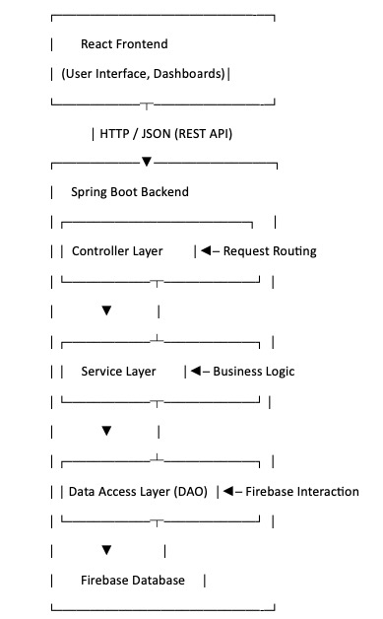**2.System Architecture:**

Figure 28:system architecture

**3.Class diagram:**

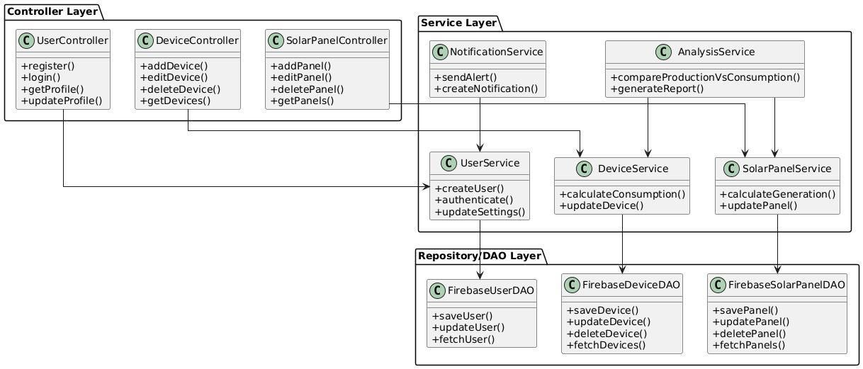

Figure 29:class diagram in high level

**2.Detailed Design**

**1.Introduction:**

This section presents the detailed design of the system by providing an in-depth representation of its internal components. It focuses on outlining the software structure and database architecture using diagrams that describe the relationships and interactions among different elements of the system.

**2.Purpose :**

The purpose of the Detailed Design section is to translate the system’s functional requirements into clear, technical structures that guide the development process. This section defines how each part of the system will be implemented and how different components interact with each other. The included diagrams help organize the codebase. This level of design is essential for building a robust, scalable, and maintainable application.

**3.functonal Requirements:**

**1. visitor management Functional Requirements:**

|  |  |  |  |  |
| --- | --- | --- | --- | --- |
| **Requirements ID** | **Description** | **Module** | **Priority** | **Detailed Specification** |
| **REQ-FR-VM-01** | System Navigation | landing page | High | system shall display the main landing page and allow the visitor to select between: Browse Events, Browse Providers, or Become a Provider. |
| **RQ-FR-VM-02** | Event Discovery & Booking | Event Management | High | The system shall allow users to browse, search, and filter events. Upon clicking 'Book', the system must verify login status and either proceed to booking or prompt a login message. |
| **RQ-FR-VM-03** | Provider Exploration | Provider Directory | Medium | The system shall display a list of providers with search/filter capabilities and provide a link to the provider's external website upon clicking 'Contact Provider'. |
| **RQ-FR-VM-04** | Provider Onboarding | Registration | High | The system shall provide a registration form for new providers, validate the submitted data, and upon success, create an account and send a confirmation to the user. |
| **RQ-FR-VM-05** | Error & Validation Handling | System Logic | High | The system shall handle validation logic for both user authentication (during booking) and data integrity (during registration), displaying appropriate error or success messages. |

**3.3.1.4 Sequence Diagram for visitor management:**

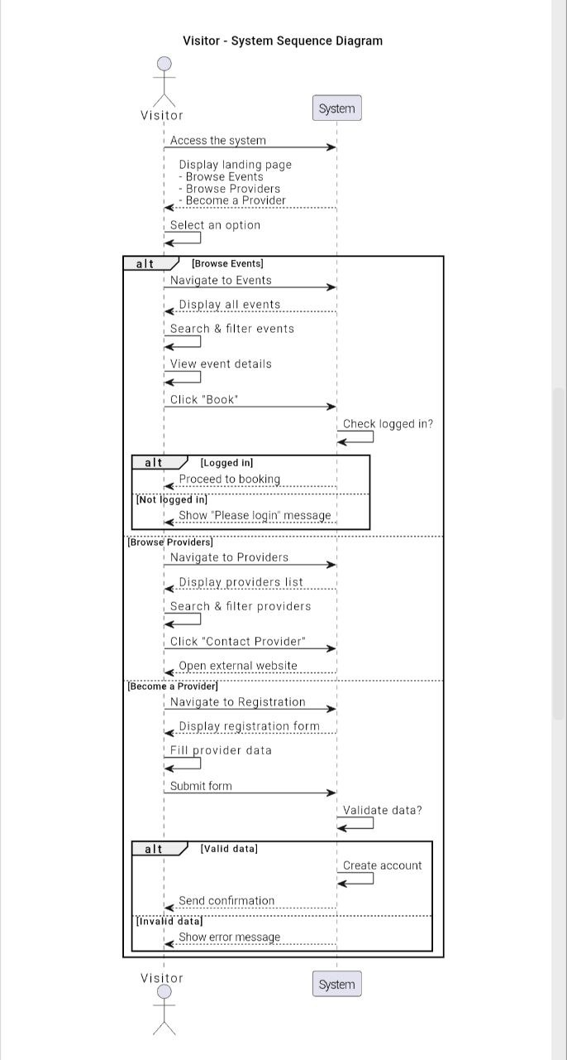

Figure 30:sequence diagram for visitor management

**2. user profile management Functional Requirements:**

|  |  |  |  |  |
| --- | --- | --- | --- | --- |
| **Requirements ID** | **Description** | **Module** | **Priority** | **Detailed Specification** |
| **REQ-FR-UPM-01** | User Login | Authentication | High | The system shall allow users to log in and, upon successful authentication, display the dashboard. |
| **REQ-FR-UPM-02** | Access Profile | Navigation | Medium | The system shall provide navigation to the Profile section and display user information and management options. |
| **REQ-FR-UPM-03** | Change Password | Profile Management | High | The system shall allow users to change their password by verifying the current password and ensuring the new passwords match. |
| **REQ-FR-UPM-04** | Edit Profile | Profile Management | Medium | The system shall allow users to update their name, email, phone, and profile picture after validating the provided data. |
| **REQ-FR-UPM-05** | Delete Account | Profile Management | Low | The system shall allow users to permanently delete their account after a confirmation step and password verification. |
| **REQ-FR-UPM-06** | Error Handling | Profile Management | Medium | The system must provide specific feedback/error messages for "Incorrect password", "Passwords don't match", and "Invalid data". |

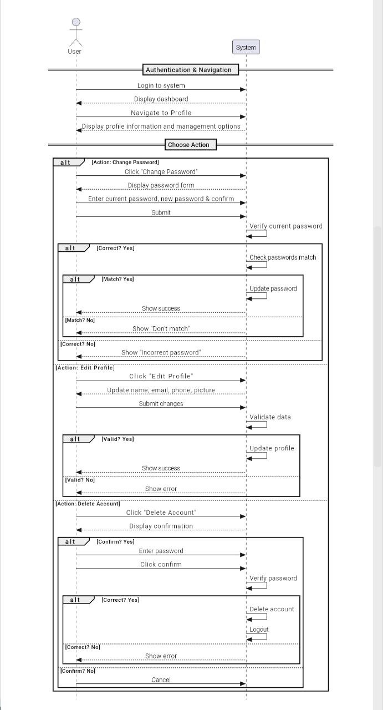**3.3.2.4 Sequence Diagram** **for user profile management:**

Figure 31:sequence diagram for user profile management

**3. Event discovery & booking Functional Requirements:**

|  |  |  |  |  |
| --- | --- | --- | --- | --- |
| **Requirements ID** | **Description** | **Module** | **Priority** | **Detailed Specification** |
| **REQ-FR-UPM-01** | Search & Browse Events | Event Discovery | High | The system shall allow users to browse event listings and apply filters (like status) to view specific results. |
| **REQ-FR-UPM-02** | View Event Details | Event Discovery | High | The system shall display comprehensive details for a selected event, including description, images, and capacity. |
| **REQ-FR-UPM-03** | Capacity Validation | Booking | High | The system must check seat availability; if the event is full, it must prevent booking and notify the user. |
| **REQ-FR-UPM-04** | User Authentication Check | Booking | High | The system shall verify if the user is logged in before proceeding with the booking; if not, a login prompt is displayed. |
| **REQ-FR-UPM-05** | Process Booking | Booking | Critical | Upon successful validation, the system shall confirm the booking and generate a unique reference number. |
| **REQ-FR-UPM-06** | Inventory Management | Booking | High | The system shall automatically reduce the available capacity of the event once a booking is confirmed. |
| **REQ-FR-UPM-07** | Booking Confirmation | Booking | Medium | The system shall send an automated confirmation email to the attendee and display a success message on the screen. |
| **REQ-FR-UPM-08** | View My Bookings | Post-Booking | Medium | The system shall allow users to view a list of their upcoming and past event bookings. |
| **REQ-FR-UPM-09** | Cancel Booking | Post-Booking | Medium | The system shall allow users to request a cancellation, update the booking status, and restore the event capacity. |
| **REQ-FR-UPM-10** | Cancellation Notify | Post-Booking | Low | The system shall send a cancellation confirmation to the user and confirm completion on the interface. |

**3.3.2.4 Sequence diagram for event discovery & booking** :

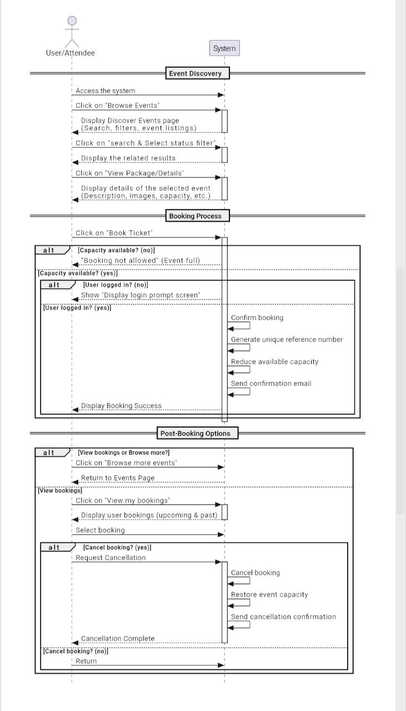

Figure 32:sequence diagram for event discovery & booking

**4. Organizer Dashboard and Bookings Management- Functional Requirement:**

|  |  |  |  |  |
| --- | --- | --- | --- | --- |
| **Requirements ID** | **Description** | **Module** | **Priority** | **Detailed Specification** |
| **REQ-FR-DDBM-01** | User Login | Authentication | High | The system shall allow the Organizer to log in and access their specific dashboard. |
| **REQ-FR-DDBM-02** | Dashboard Visualization | Dashboard | High | he system must display KPIs (Total Bookings, Total Revenue), performance charts, and a table of recent bookings. |
| **REQ-FR-DDBM-03** | Navigation & Management | Bookings | Medium | The system shall provide a dedicated section to manage bookings, displaying total revenue and a comprehensive bookings list. |
| **REQ-FR-DDBM-04** | Search & Filtering | Bookings | Medium | The system shall allow the user to filter and search bookings based on specific status criteria and display related results. |

**4.3.2.4Sequence diagram for Organizer Dashboard and Bookings Management:**

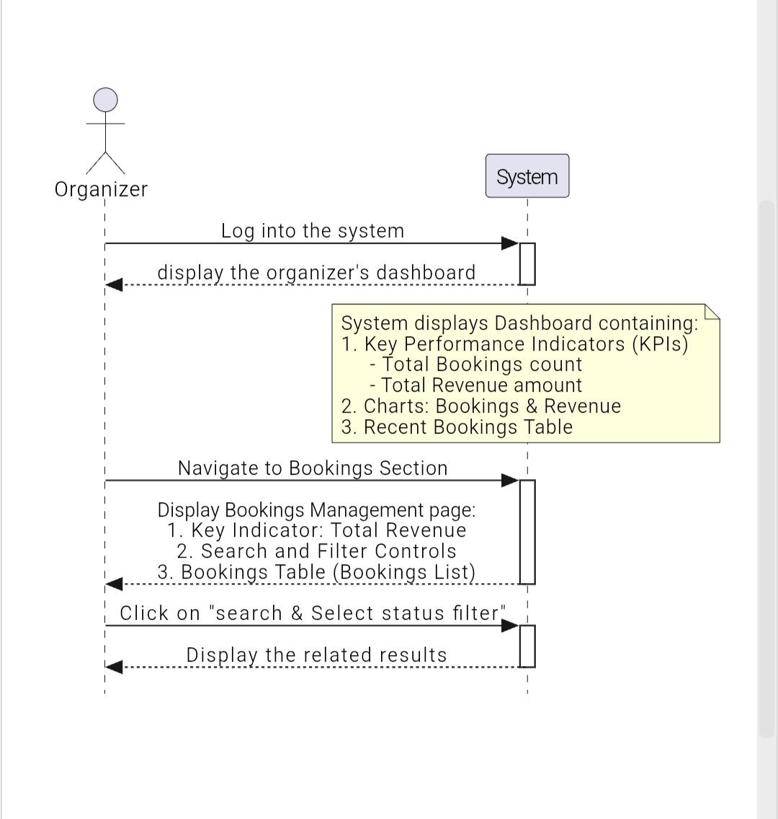

Figure 33:sequence diagram for Organizer Dashboard and Bookings Management

**5. Disable/Enable Bookings Functional Requirement:**

|  |  |  |  |  |
| --- | --- | --- | --- | --- |
| **Requirements ID** | **Description** | **Module** | **Priority** | **Detailed Specification** |
| **REQ-FR-DEB-01** | User Login | Authentication | High | The system shall allow the Organizer to log in and access their personal dashboard. |
| **REQ-FR-DEB-02** | View Events | Event Management | High | The system shall provide a navigation path to the Events Section and display a list of all existing events. |
| **REQ-FR-DEB-03** | Disable Bookings | Booking Control | High | The system shall allow the Organizer to disable bookings for a specific event. |
| **REQ-FR-DEB-04** | Update Status | Status Management | Medium | The system shall automatically update and display the booking status as "Closed" upon disabling. |
| **REQ-FR-DEB-05** | Success Feedback | Notification | Medium | The system shall send a success notification to the Organizer confirming the change in booking status. |

**5.3.2.4 Sequence diagram for Disable/Enable Bookings**

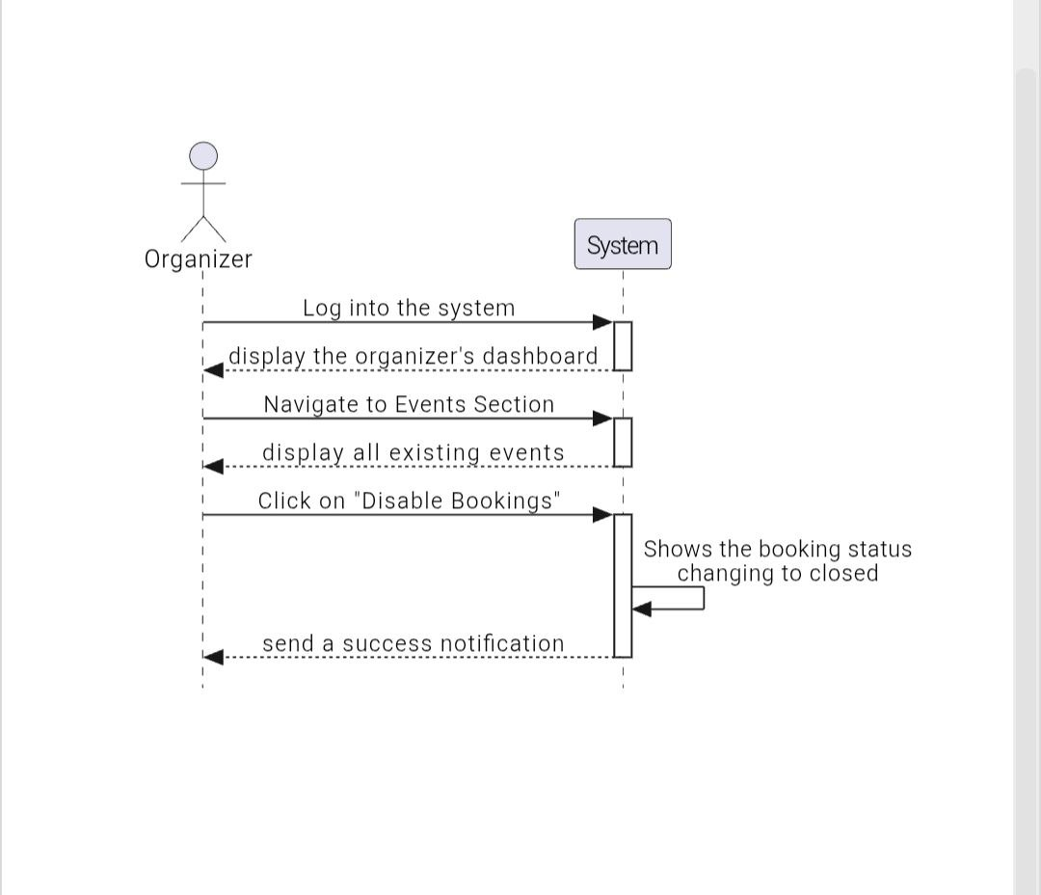

Figure 34:sequence diagram for Disable/Enable Bookings

**6. Create New Public Event or Host Package** **Functional Requirements:**

|  |  |  |  |  |
| --- | --- | --- | --- | --- |
| **Requirements ID** | **Description** | **Module** | **Priority** | **Detailed Specification** |
| **REQ-FR-CNPEHP-01** | User Login | Authentication | High | The system shall allow the Organizer to log in and access the dashboard. |
| **REQ-FR-CNPEHP-02** | View Events | Event Management | Medium | The system shall display a list of all existing events upon navigating to the Events Section. |
| **REQ-FR-CNPEHP-03** | Form Access | Event Management | High | The system shall provide a "Create Event" form to the Organizer. |
| **REQ-FR-CNPEHP-04** | Data Entry | Event Management | High | The system shall allow inputting Title, Type, Location, DateTime, Price, Capacity, Status, and Booking. |
| **REQ-FR-CNPEHP-05** | Form Validation | Validation | High | The system shall validate that all required fields are filled before processing the creation. |
| **REQ-FR-CNPEHP-06** | Error Handling | Notification | Medium | The system shall display a warning/error notification if any required fields are missing. |
| **REQ-FR-CNPEHP-07** | Event Storage | Database / Storage | High | The system shall add the new event to the events table upon successful validation. |
| **REQ-FR-CNPEHP-08** | Success Confirmation | Notification | Medium | The system shall send a success notification to the Organizer after the event is successfully created. |

**5.3.2.5 Sequence diagram for Create New Public Event or Host Package**:

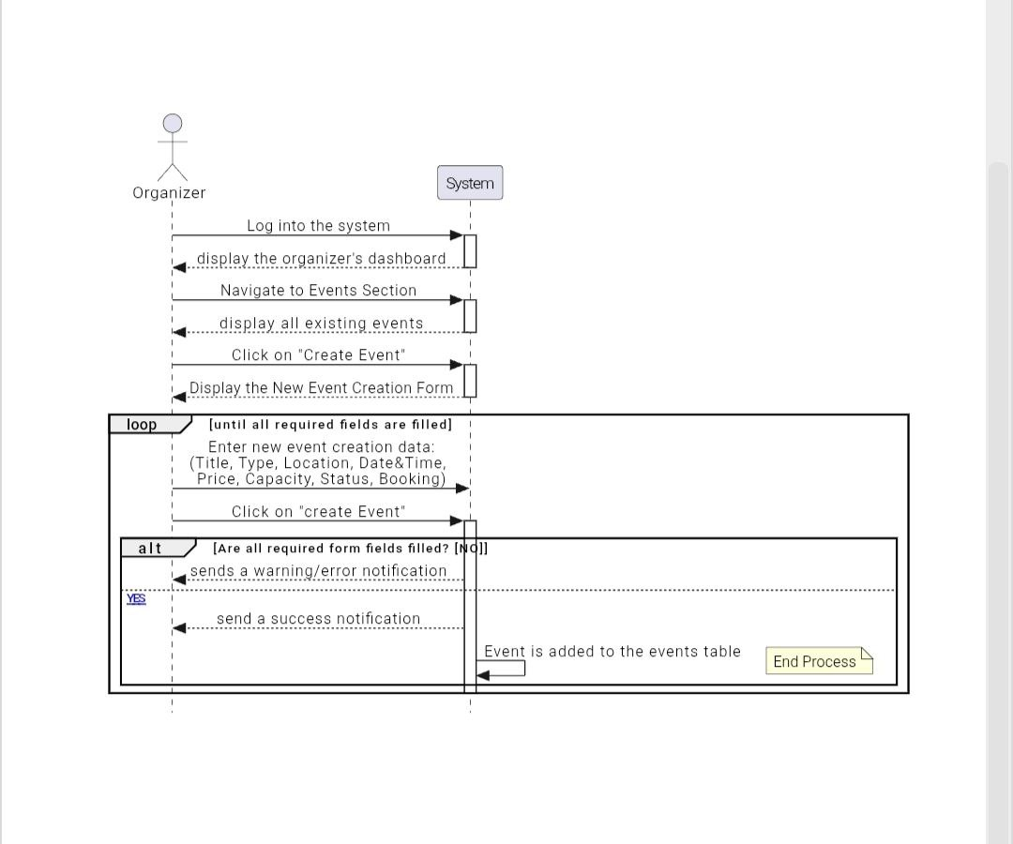

**7. Edit Existing Event or Package Functional Requirements:**

|  |  |  |  |  |
| --- | --- | --- | --- | --- |
| **Requirements ID** | **Description** | **Module** | **Priority** | **Detailed Specification** |
| **REQ-FR-EEP-01** | User Login | Authentication | High | The system shall allow the Organizer to log in and access the dashboard. |
| **REQ-FR-EEP-02** | View Events | Event Management | High | The system shall display a list of all existing events created by the organizer. |
| **REQ-FR-EEP-03** | Access Edit Form | Event Management | Medium | The system shall provide an "Edit" option and display a form populated with current event data. |
| **REQ-FR-EEP-04** | Update Event | Event Management | High | The system shall allow editing of: Title, Type, Location, Date & Time, Price, Capacity, Status, and Booking. |
| **REQ-FR-EEP-05** | Save Changes | Event Management | High | Upon clicking "Update", the system shall save the new data to the database and show a success notification. |
| **REQ-FR-EEP-06** | Cancel Operation | Event Management | Low | The system shall allow the user to cancel the edit process and return to the events list without saving. |

**5.3.2.5 Sequence diagram for** **Edit Existing Event or Package:**

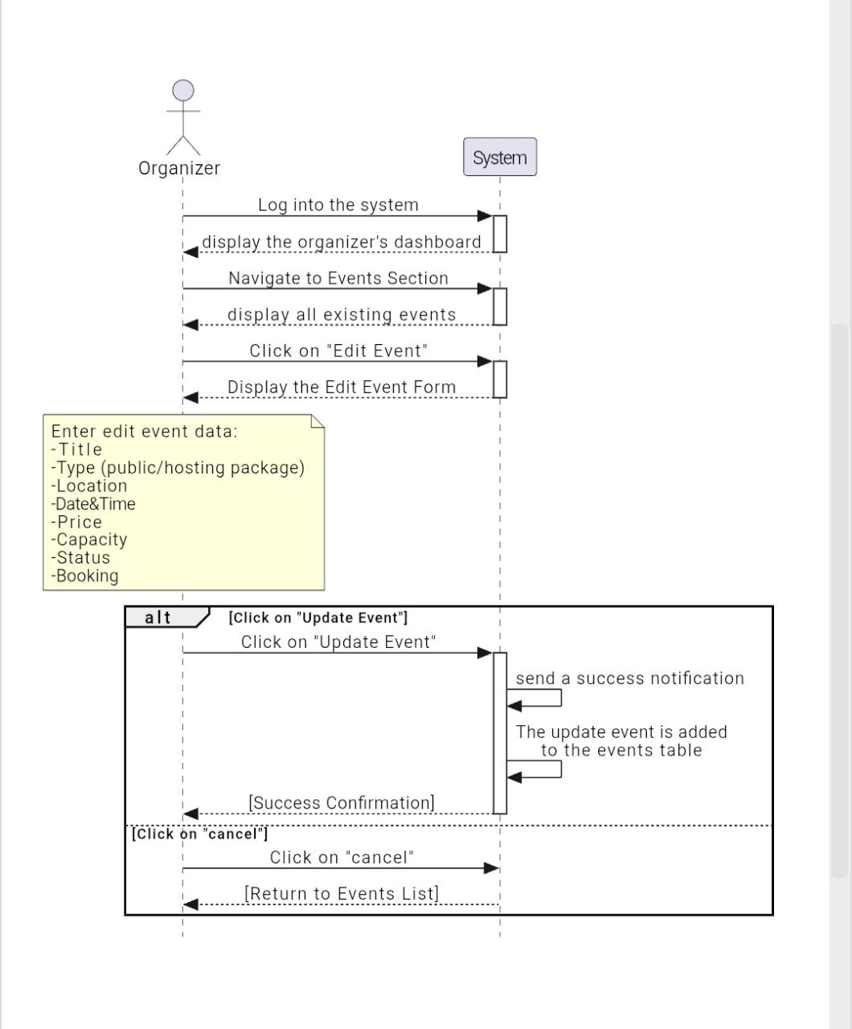

**8. Delete Event or Package Functional Requirements:**

|  |  |  |  |  |
| --- | --- | --- | --- | --- |
| **Requirements ID** | **Description** | **Module** | **Priority** | **Detailed Specification** |
| **REQ-FR-DEP-01** | User Login | Authentication | High | The system shall allow the Organizer to log in and access the dashboard. |
| **REQ-FR-DEP-02** | View Events | Event Management | High | The system shall display a list of all existing events in the Events Section. |
| **REQ-FR-DEP-03** | Delete Event Initiation | Event Management | Medium | The system shall provide a "Delete" option and prompt for confirmation before removal. |
| **REQ-FR-DEP-04** | Confirm Deletion | Event Management | High | Upon clicking "Yes", the system shall permanently remove the event from the database. |
| **REQ-FR-DEP-05** | Success Feedback | Notification | Medium | The system shall send a success notification to the Organizer after a successful deletion. |
| **REQ-FR-DEP-06** | Cancel Deletion | Event Management | Low | If the user clicks "Cancel", the system shall stop the process and return to the previous state. |

**5.3.2.5 Sequence diagram for Delete Event or Package:**

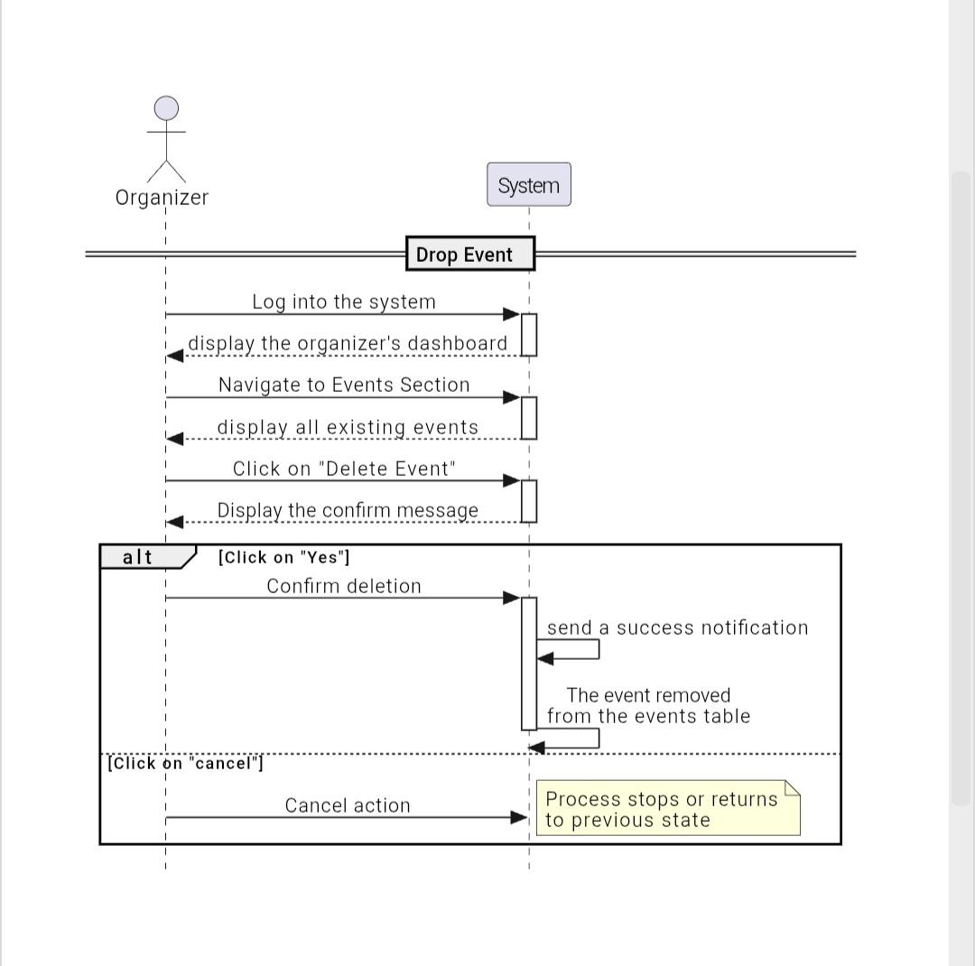

**4.System Class Diagram**

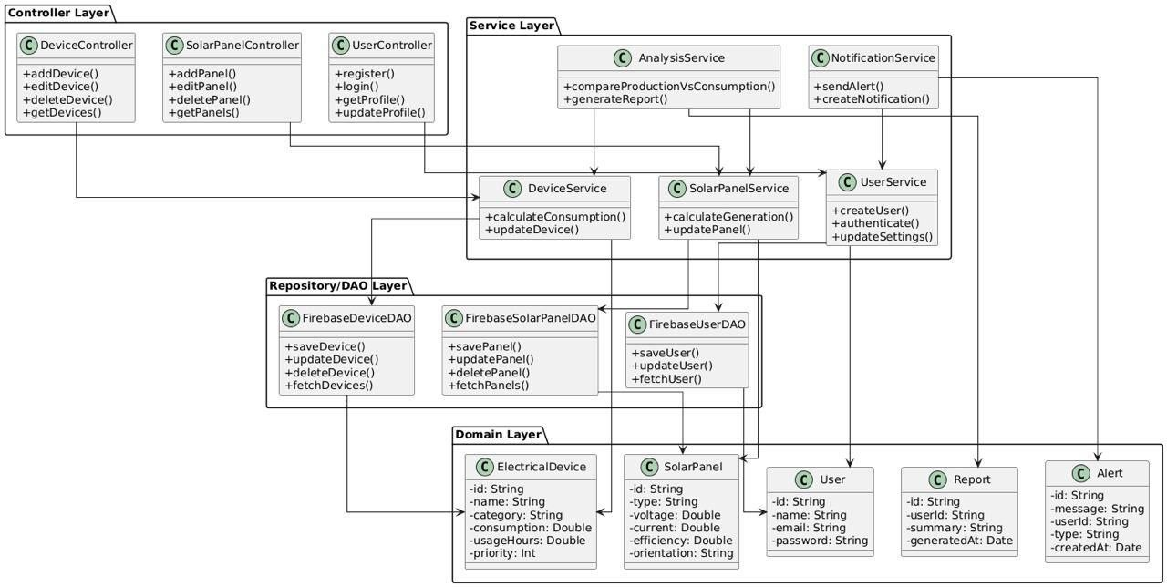

Figure 35 : class diagram

**5.Data Model Diagram**

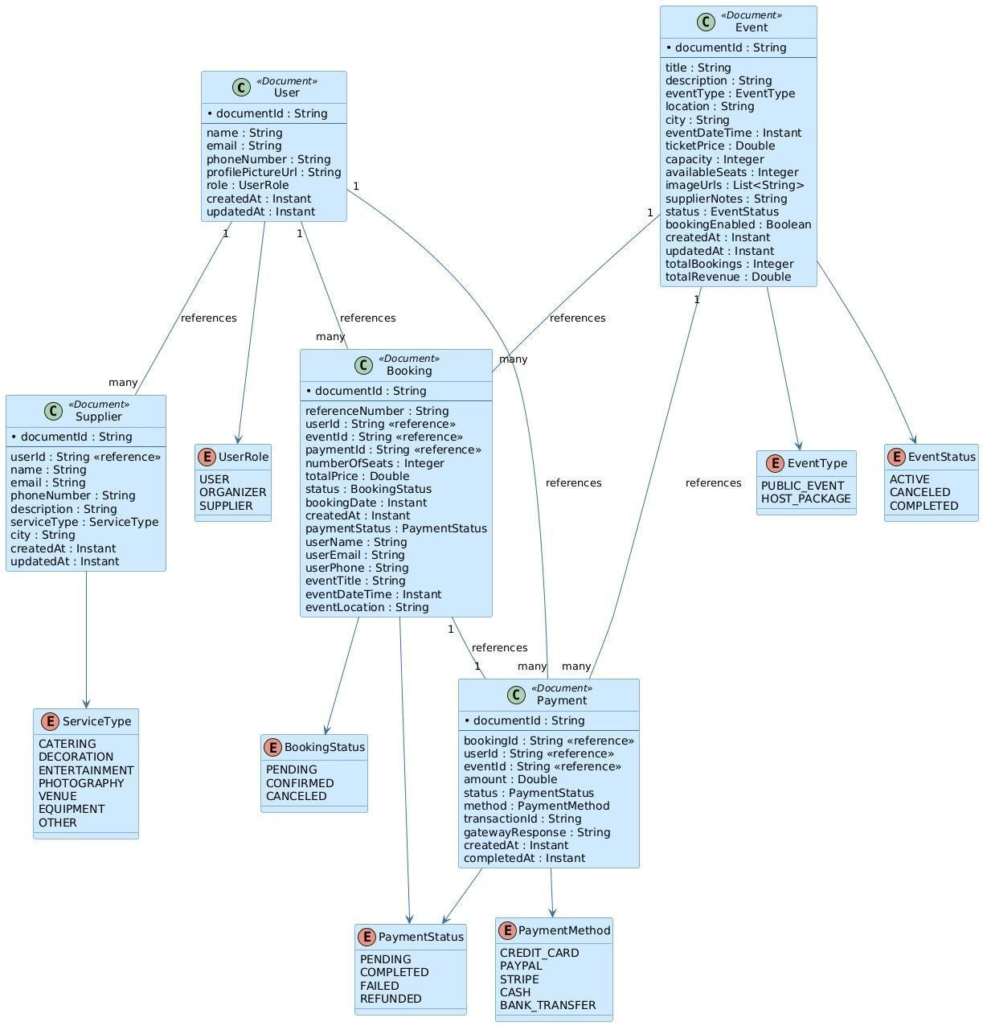

Figure 36:Data Model Diagram

**3.Requirement Trackability Matrix (RTM) (V.3)**

|  |  |  |  |  |  |  |  |  |
| --- | --- | --- | --- | --- | --- | --- | --- | --- |
| **Requirements Id** | **Title** | **Use case** | **System Design** | **Analysis** | **Detailed Design** | **Coding** | **Test Cases** | **change log** |
| REQ-FR-01 | The system should allow users and service providers to register with basic information. |  |  |  |  |  |  |  |
| REQ-FR-02 | The system should validate email format, phone number, and password strength. |  |  |  |  |  |  |  |
| REQ-FR-03 | The system should allow users, service providers, and admins to log in and log out. |  |  |  |  |  |  |  |
| REQ-FR-04 | The system should allow users to reset their password via an email link. |  |  |  |  |  |  |  |
| REQ-FR-05 | The system should display the user profile information. |  |  |  |  |  |  |  |
| REQ-FR-06 | The system should allow users to edit their name, email, phone number, and profile picture. |  |  |  |  |  |  |  |
| REQ-FR-07 | The system should allow users to change their password. |  |  |  |  |  |  |  |
| REQ-FR-08 | The system should allow users to delete their account after password confirmation. |  |  |  |  |  |  |  |
| REQ-FR-09 | The system should display all available events on the homepage. |  |  |  |  |  |  |  |
| REQ-FR-10 | The system should allow users to filter events by date, location, price, and event type. |  |  |  |  |  |  |  |
| REQ-FR-11 | The system should display event cards containing title, description, image, date, time, location, and availability. |  |  |  |  |  |  |  |
| REQ-FR-12 | The system should allow users to search events by title or keywords. |  |  |  |  |  |  |  |
| REQ-FR-13 | The system should display available seats for each event. |  |  |  |  |  |  |  |
| REQ-FR-14 | The system should display full event details, including description, images, capacity, and ticket price. |  |  |  |  |  |  |  |
| REQ-FR-15 | The system should display booking availability status for each event. |  |  |  |  |  |  |  |
| REQ-FR-16 | The system should display vendor information associated with the event. |  |  |  |  |  |  |  |
| REQ-FR-17 | The system should prevent booking when event capacity is full. |  |  |  |  |  |  |  |
| REQ-FR-18 | The system should require users to log in before completing a booking. |  |  |  |  |  |  |  |
| REQ-FR-19 | The system should generate a unique booking reference number upon confirmation. |  |  |  |  |  |  | This requirement has been added |
| REQ-FR-20 | The system should immediately reduce available capacity after booking. |  |  |  |  |  |  | This requirement has been added |
| REQ-FR-21 | The system should send a booking confirmation email with the reference number. |  |  |  |  |  |  |  |
| REQ-FR-22 | The system should display hosting packages with setup details. |  |  |  |  |  |  |  |
| REQ-FR-23 | The system should allow users to book a hosting package for a specific date or location. |  |  |  |  |  |  |  |
| REQ-FR-24 | The system should display upcoming bookings for the user. |  |  |  |  |  |  |  |
| REQ-FR-25 | The system should display completed bookings. |  |  |  |  |  |  |  |
| REQ-FR-26 | The system should allow cancellation of confirmed bookings. |  |  |  |  |  |  |  |
| REQ-FR-27 | The system should restore event capacity when a booking is canceled. |  |  |  |  |  |  |  |
| REQ-FR-28 | The system should allow organizers to create new public events. |  |  |  |  |  |  |  |
| REQ-FR-29 | The system should require mandatory fields for events: title, description, location, date, time, capacity, and ticket price. |  |  |  |  |  |  | This requirement has been added |
| REQ-FR-30 | The system should allow organizers to edit existing event details. |  |  |  |  |  |  |  |
| REQ-FR-31 | The system should allow organizers to delete events. |  |  |  |  |  |  | This requirement has been added |
| REQ-FR-32 | The system should allow organizers to enable or disable booking for an event. |  |  |  |  |  |  | This requirement has been added |
| REQ-FR-33 | The system should allow organizers to create new hosting packages. |  |  |  |  |  |  |  |
| REQ-FR-34 | The system should require mandatory fields for hosting packages: title, description, setup details, location options, and price. |  |  |  |  |  |  | This requirement has been added |
| REQ-FR-35 | The system should allow defining customizable elements within packages. |  |  |  |  |  |  | This requirement has been added |
| REQ-FR-36 | The system should allow organizers to edit hosting package details. |  |  |  |  |  |  |  |
| REQ-FR-37 | The system should allow organizers to delete hosting packages. |  |  |  |  |  |  |  |
| REQ-FR-38 | The system should allow organizers to filter events by status: all, active, canceled, or completed. |  |  |  |  |  |  | This requirement has been added |
| REQ-FR-39 | The system should allow organizers to search events within the dashboard. |  |  |  |  |  |  | This requirement has been added |
| REQ-FR-40 | The system should display event type, city, date, status, bookings, statistics, and revenue in the dashboard. |  |  |  |  |  |  | This requirement has been modified |
| REQ-FR-41 | The system should display total bookings, remaining seats, and total revenue per event. |  |  |  |  |  |  | This requirement has been added |
| REQ-FR-42 | The system should display total created events, active events, and total revenue. |  |  |  |  |  |  | This requirement has been added |
| REQ-FR-43 | The system should allow registering vendors with business name, service type, city, description, and contact information. |  |  |  |  |  |  |  |
| REQ-FR-44 | The system should allow searching vendors by service type or city. |  |  |  |  |  |  |  |
| REQ-FR-45 | The system should support vendor service categories such as catering, photography, venues, entertainment, decoration, audio/visual, and transportation. |  |  |  |  |  |  |  |
| REQ-FR-46 | The system should send email notifications upon registration (success or failure). |  |  |  |  |  |  |  |
| REQ-FR-47 | The system should send password reset links and confirmation emails. |  |  |  |  |  |  |  |
| REQ-FR-48 | The system should send booking notifications for confirmation and cancellation. |  |  |  |  |  |  | This requirement has been added |
| REQ-FR-49 | The system should notify attendees of event cancellations or changes in date or location. |  |  |  |  |  |  |  |
| REQ-FR-50 | The system should allow guests to browse all events without registration. |  |  |  |  |  |  |  |
| REQ-FR-51 | The system should allow guests to search and filter events. |  |  |  |  |  |  | This requirement has been added |
| REQ-FR-52 | The system should display full event details to guests. |  |  |  |  |  |  |  |
| REQ-FR-53 | The system should prevent guests from booking without logging in. |  |  |  |  |  |  | This requirement has been added |
| REQ-FR-54 | The system should redirect guests to the registration page when attempting to book. |  |  |  |  |  |  |  |
| REQ-FR-55 | The system should allow guests to browse the vendor directory. |  |  |  |  |  |  | This requirement has been added |
| REQ-FR-56 | The system shall send reminder email 24 hours before event |  |  |  |  |  |  | This requirement has been removed |
| REQ-NFR-01 | The system should be easy to use and clear, even for non-technical users. |  |  |  |  |  |  |  |
| REQ-NFR-02 | The system should load main pages (Home, Events, Booking) within less than 3 seconds. |  |  |  |  |  |  |  |
| REQ-NFR-03 | The system should be available at least 99% of the time. |  |  |  |  |  |  |  |
| REQ-NFR-04 | The system should protect user data and not share it with any external party. |  |  |  |  |  |  |  |
| REQ-NFR-05 | The system should work correctly on modern browsers (Chrome, Firefox, Edge). |  |  |  |  |  |  |  |
| REQ-NFR-06 | The system should handle an increasing number of users and events without issues. |  |  |  |  |  |  | This requirement has been modified |
| REQ-NFR-07 | Any successful booking cannot be lost or duplicated. |  |  |  |  |  |  |  |
| REQ-NFR-08 | Notifications should be delivered on time without noticeable delay. |  |  |  |  |  |  | This requirement has been modified |

Table 26:RTM V.3

**7.Summary**

In this chapter, we focused on designing the system in a clear and organized way. We chose a layered architecture where each layer handles specific tasks like handling requests, business logic, and database interaction. This separation makes the system easier to maintain and extend.

We divided the system into smaller modules such as EventService, BookingService, UserService analysis, each working independently but connected within the system.

We used modern technologies like Java Spring Boot with Firebase and React to build a secure, responsive, and scalable system.

We created diagrams showing how different components interact, which helps developers understand and build the system efficiently.

Finally, we clearly defined the requirements for each part and linked them to design, implementation, and testing processes to ensure the system’s quality and completeness.

**Chapter6: Implementation**

**1.Introduction**

This section provides a visual overview of the system's core interfaces through a series of detailed screenshots. These screenshots help illustrate the overall design of key interactive elements and explain how different user groups, including regular users, event organizers, and service providers, interact with the system. This contributes to enhanced usability and a seamless, efficient user experience.

**2.Purpose:**

This section aims to visually review the core interfaces of the Events and Activities Planning Platform System, explaining the principles upon which their design is based. By presenting screenshots with brief descriptions of each interface, the expected user experience is clarified, the most important interactive elements are highlighted, and how these interfaces support interaction between users, organizers, and service providers with the system's various functions are explained. This also allows stakeholders to understand the system's visual design and provide constructive feedback for its improvement.

**3.User Interfaces**

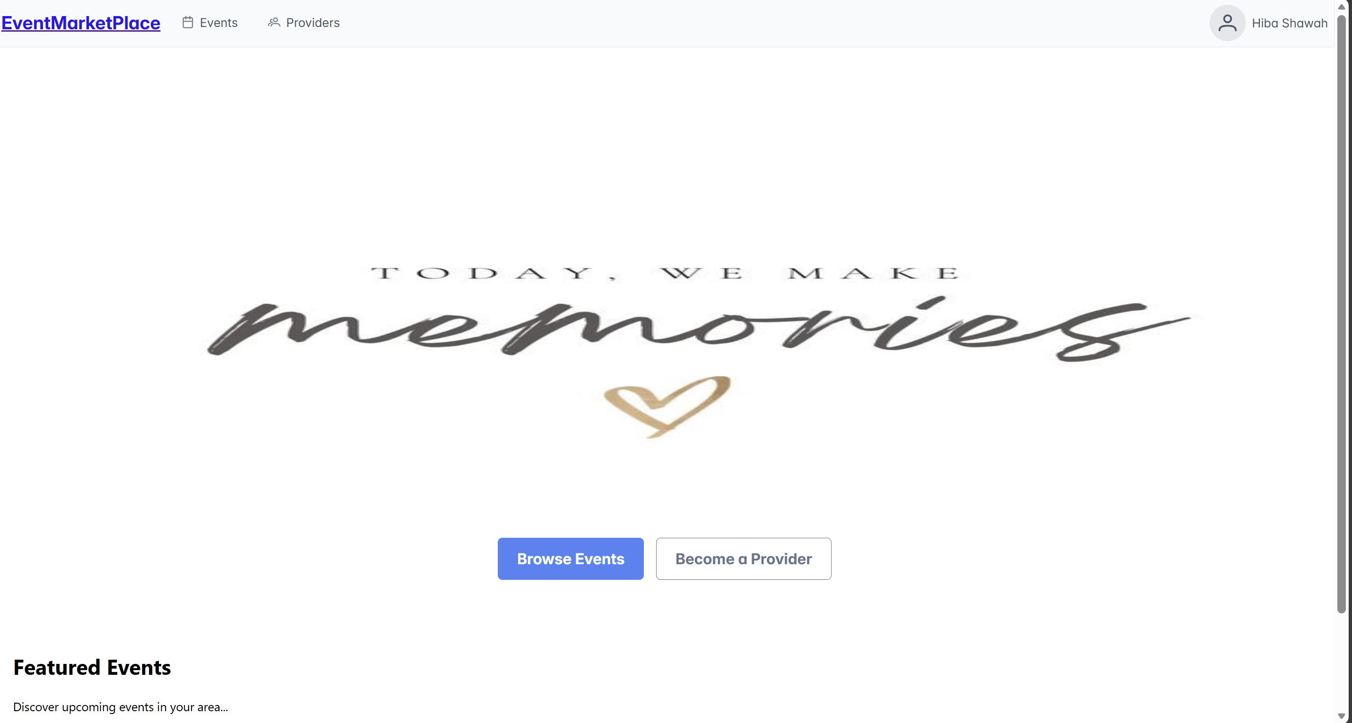

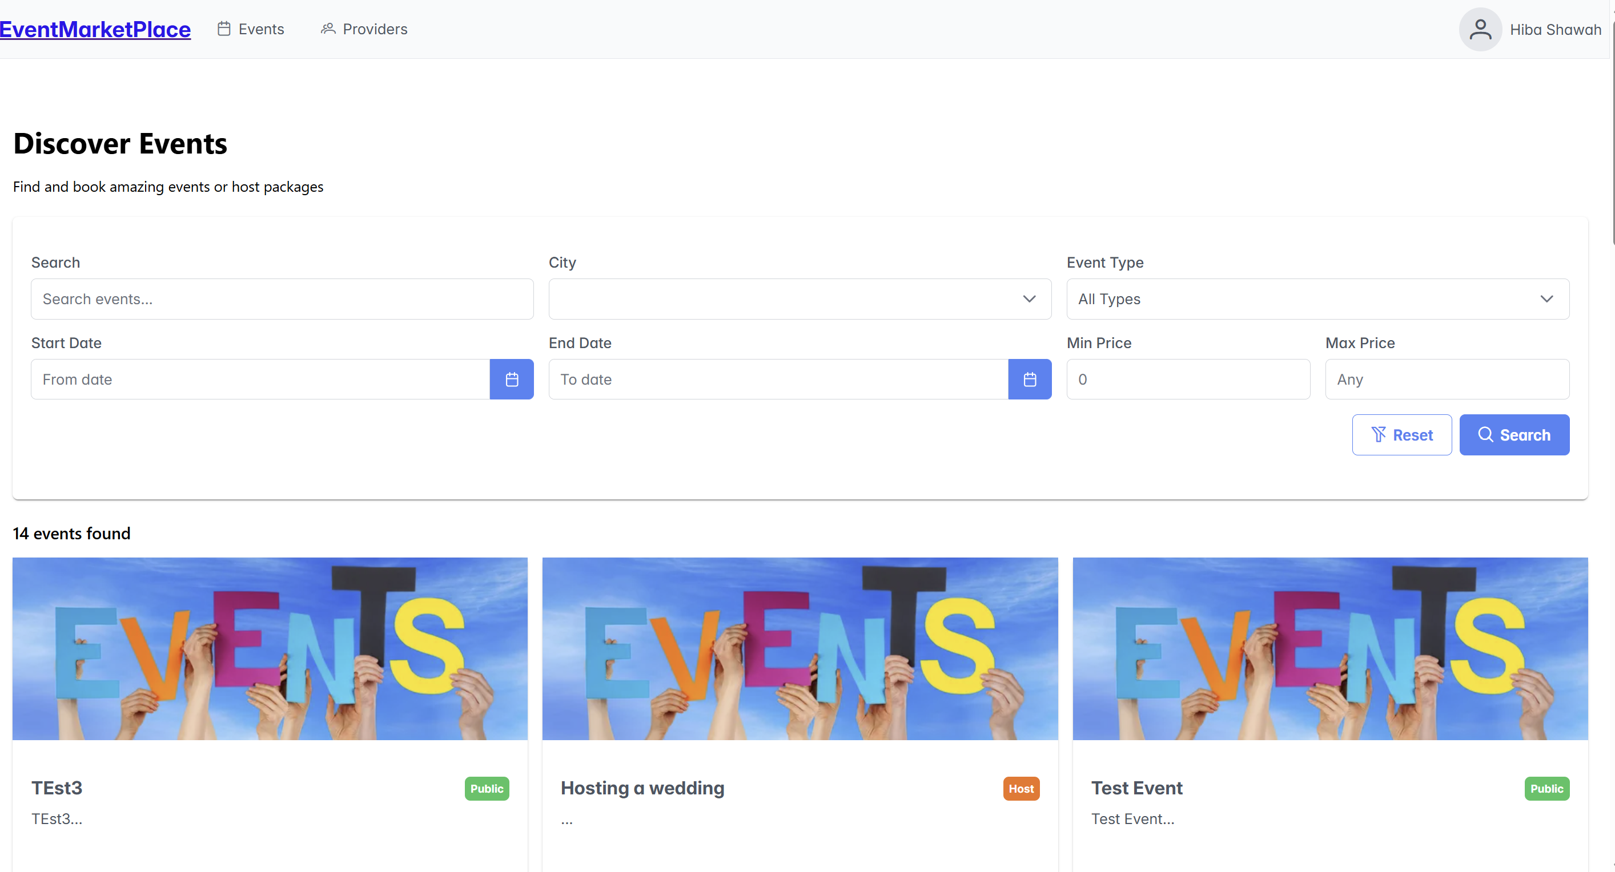

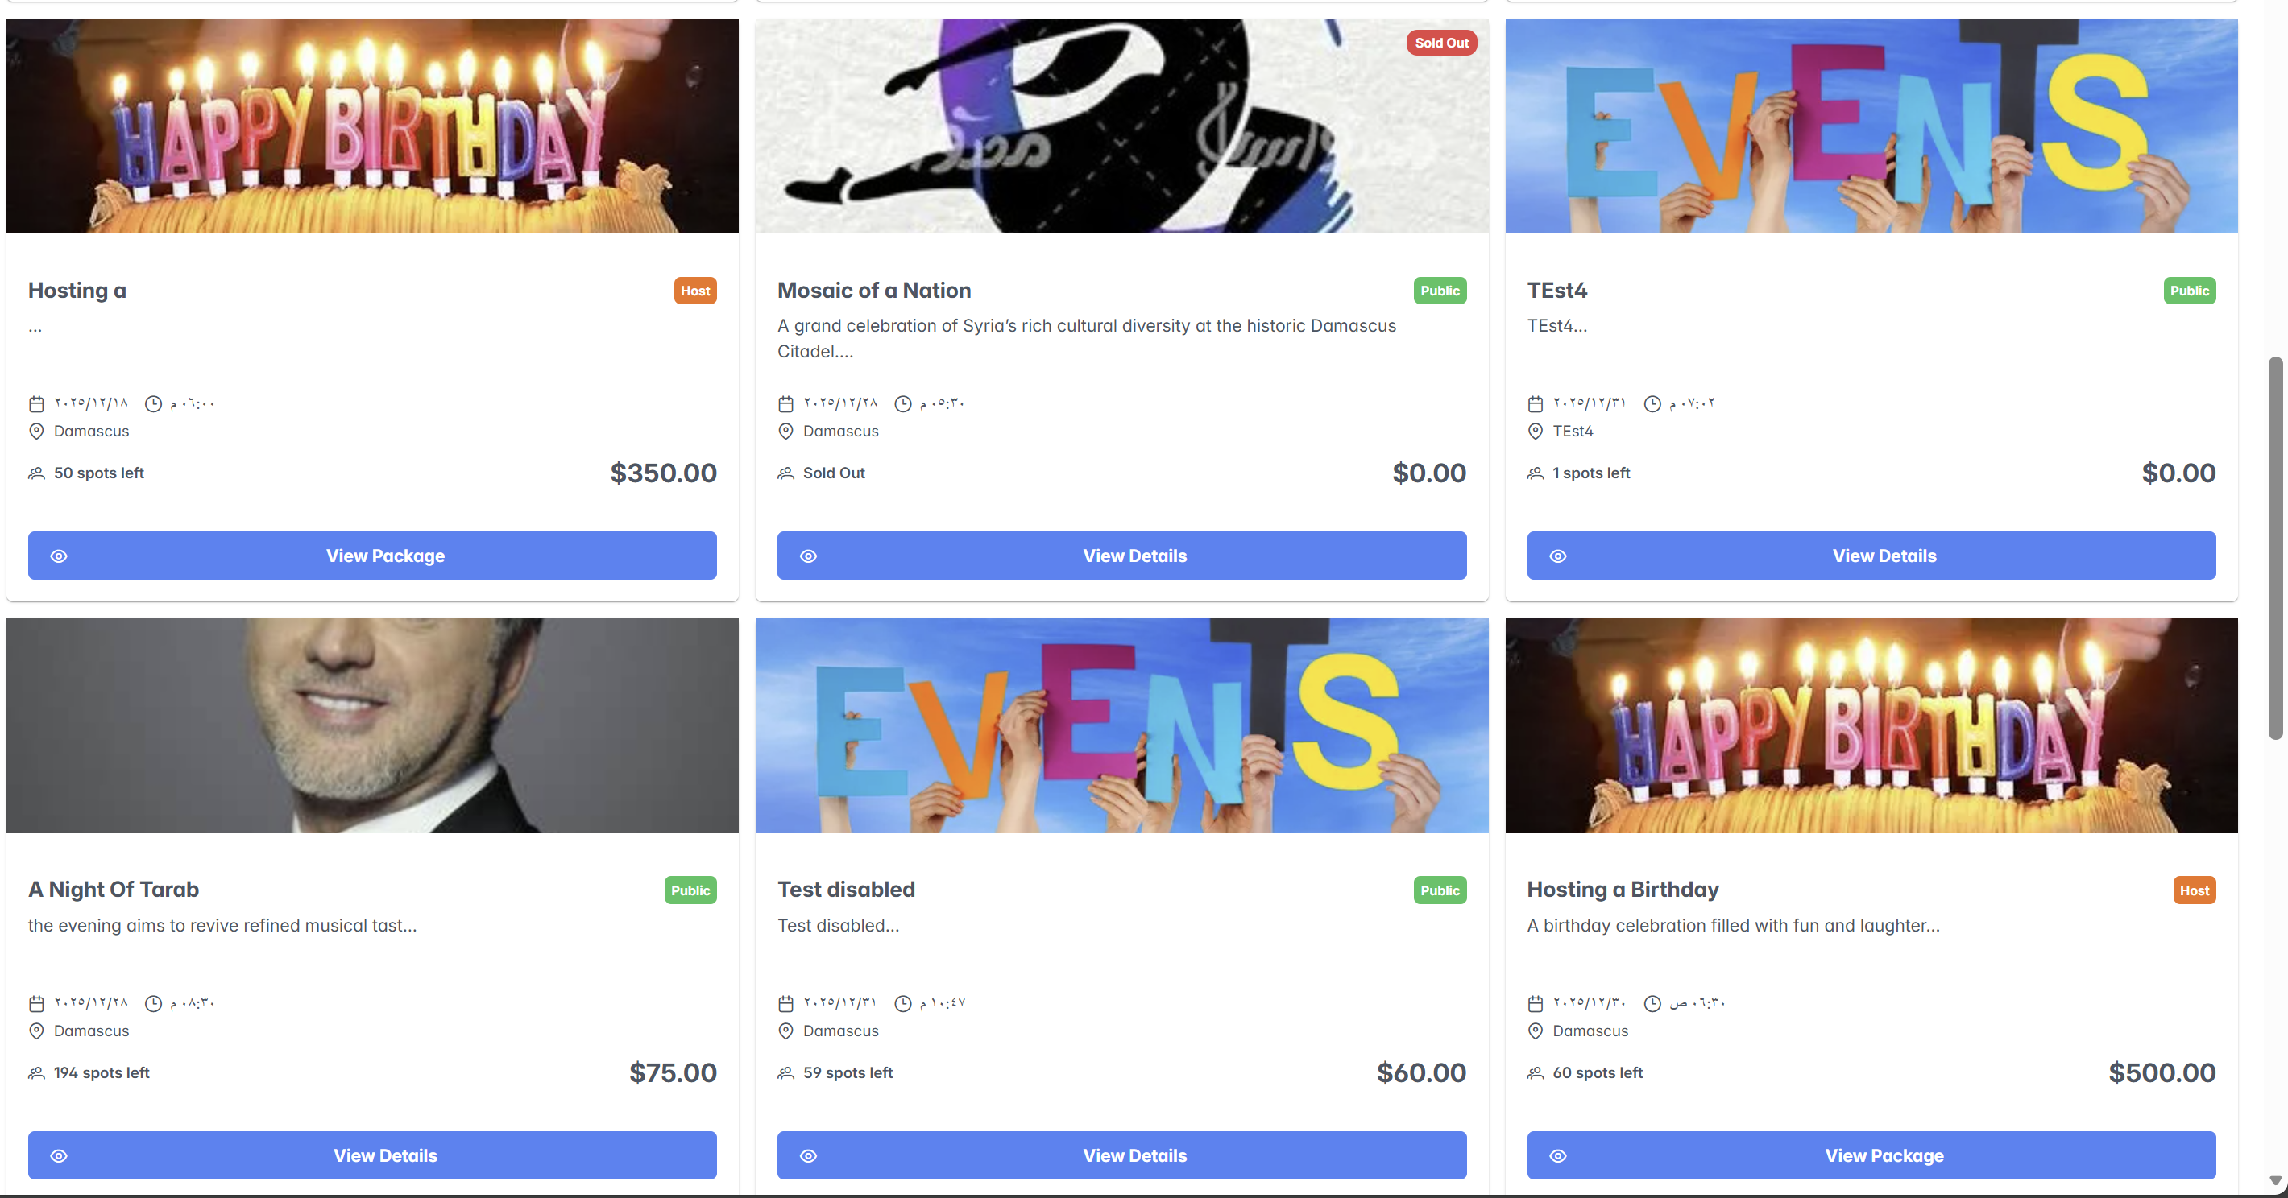

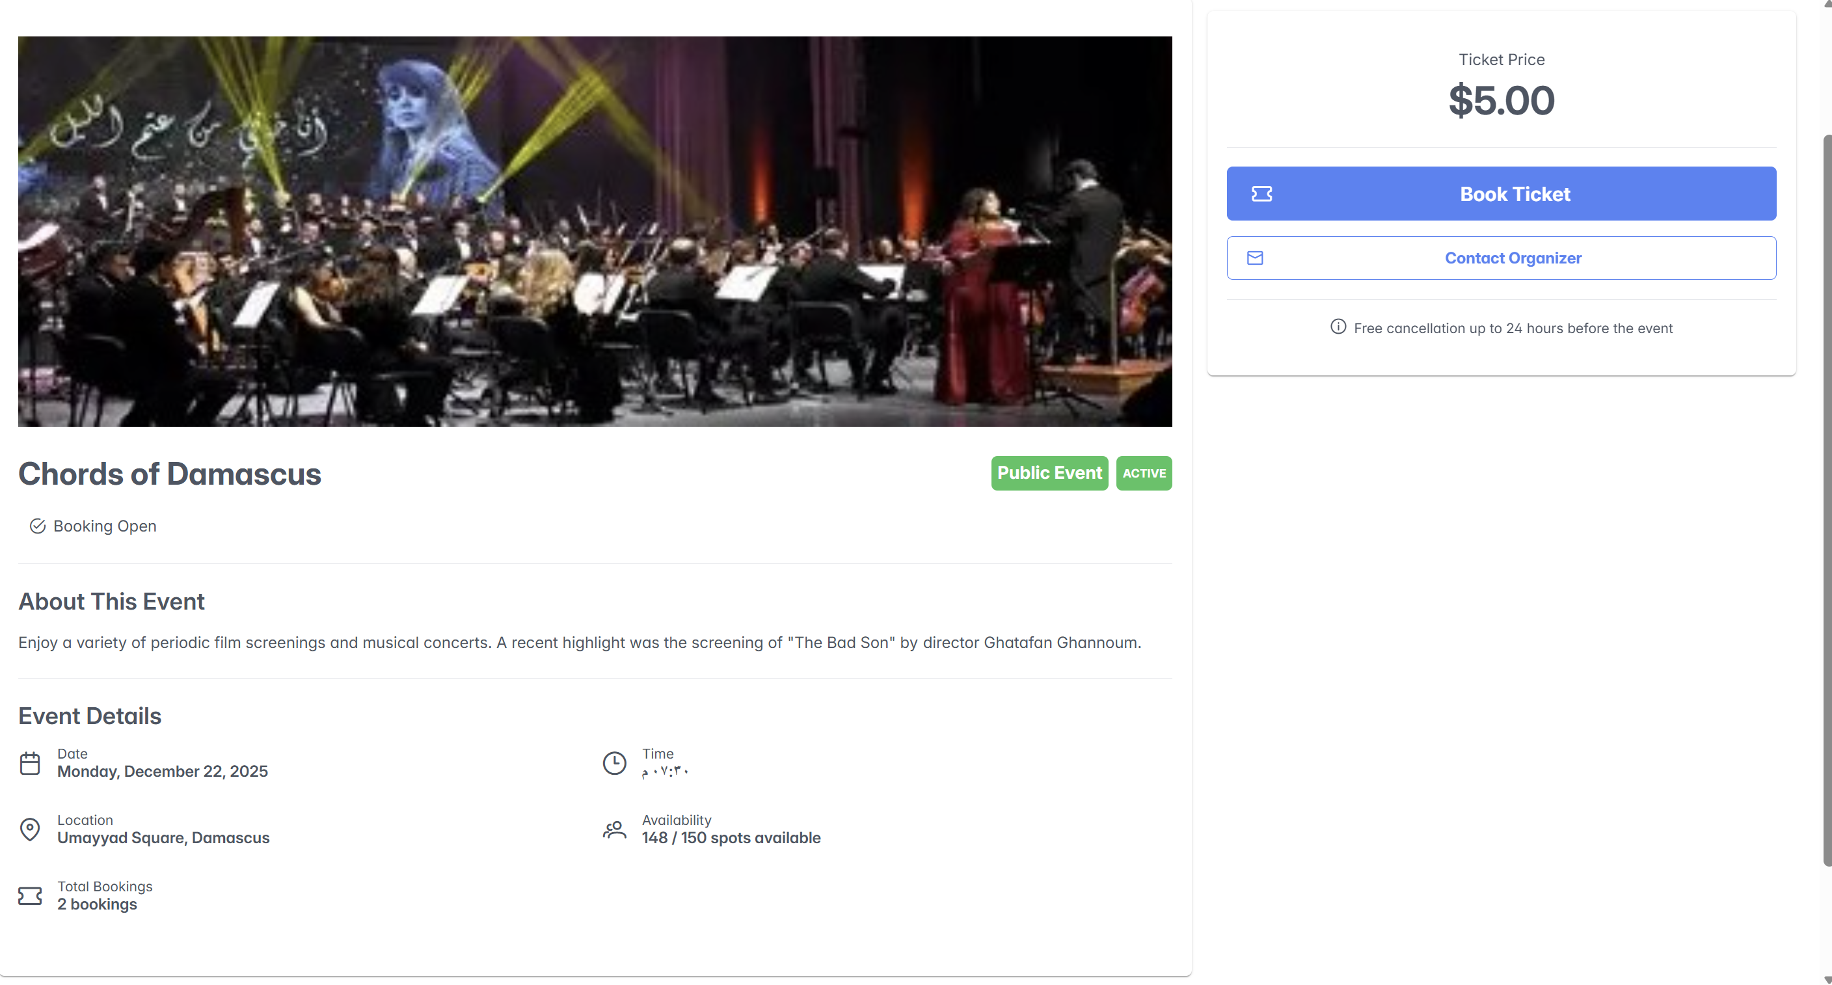

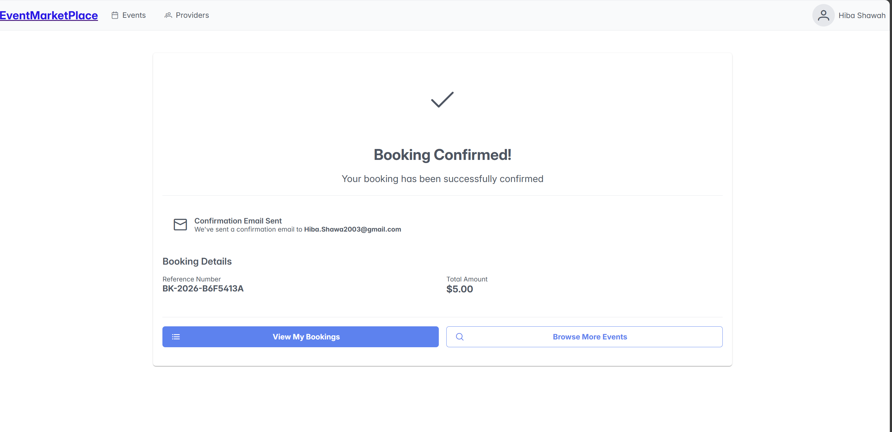

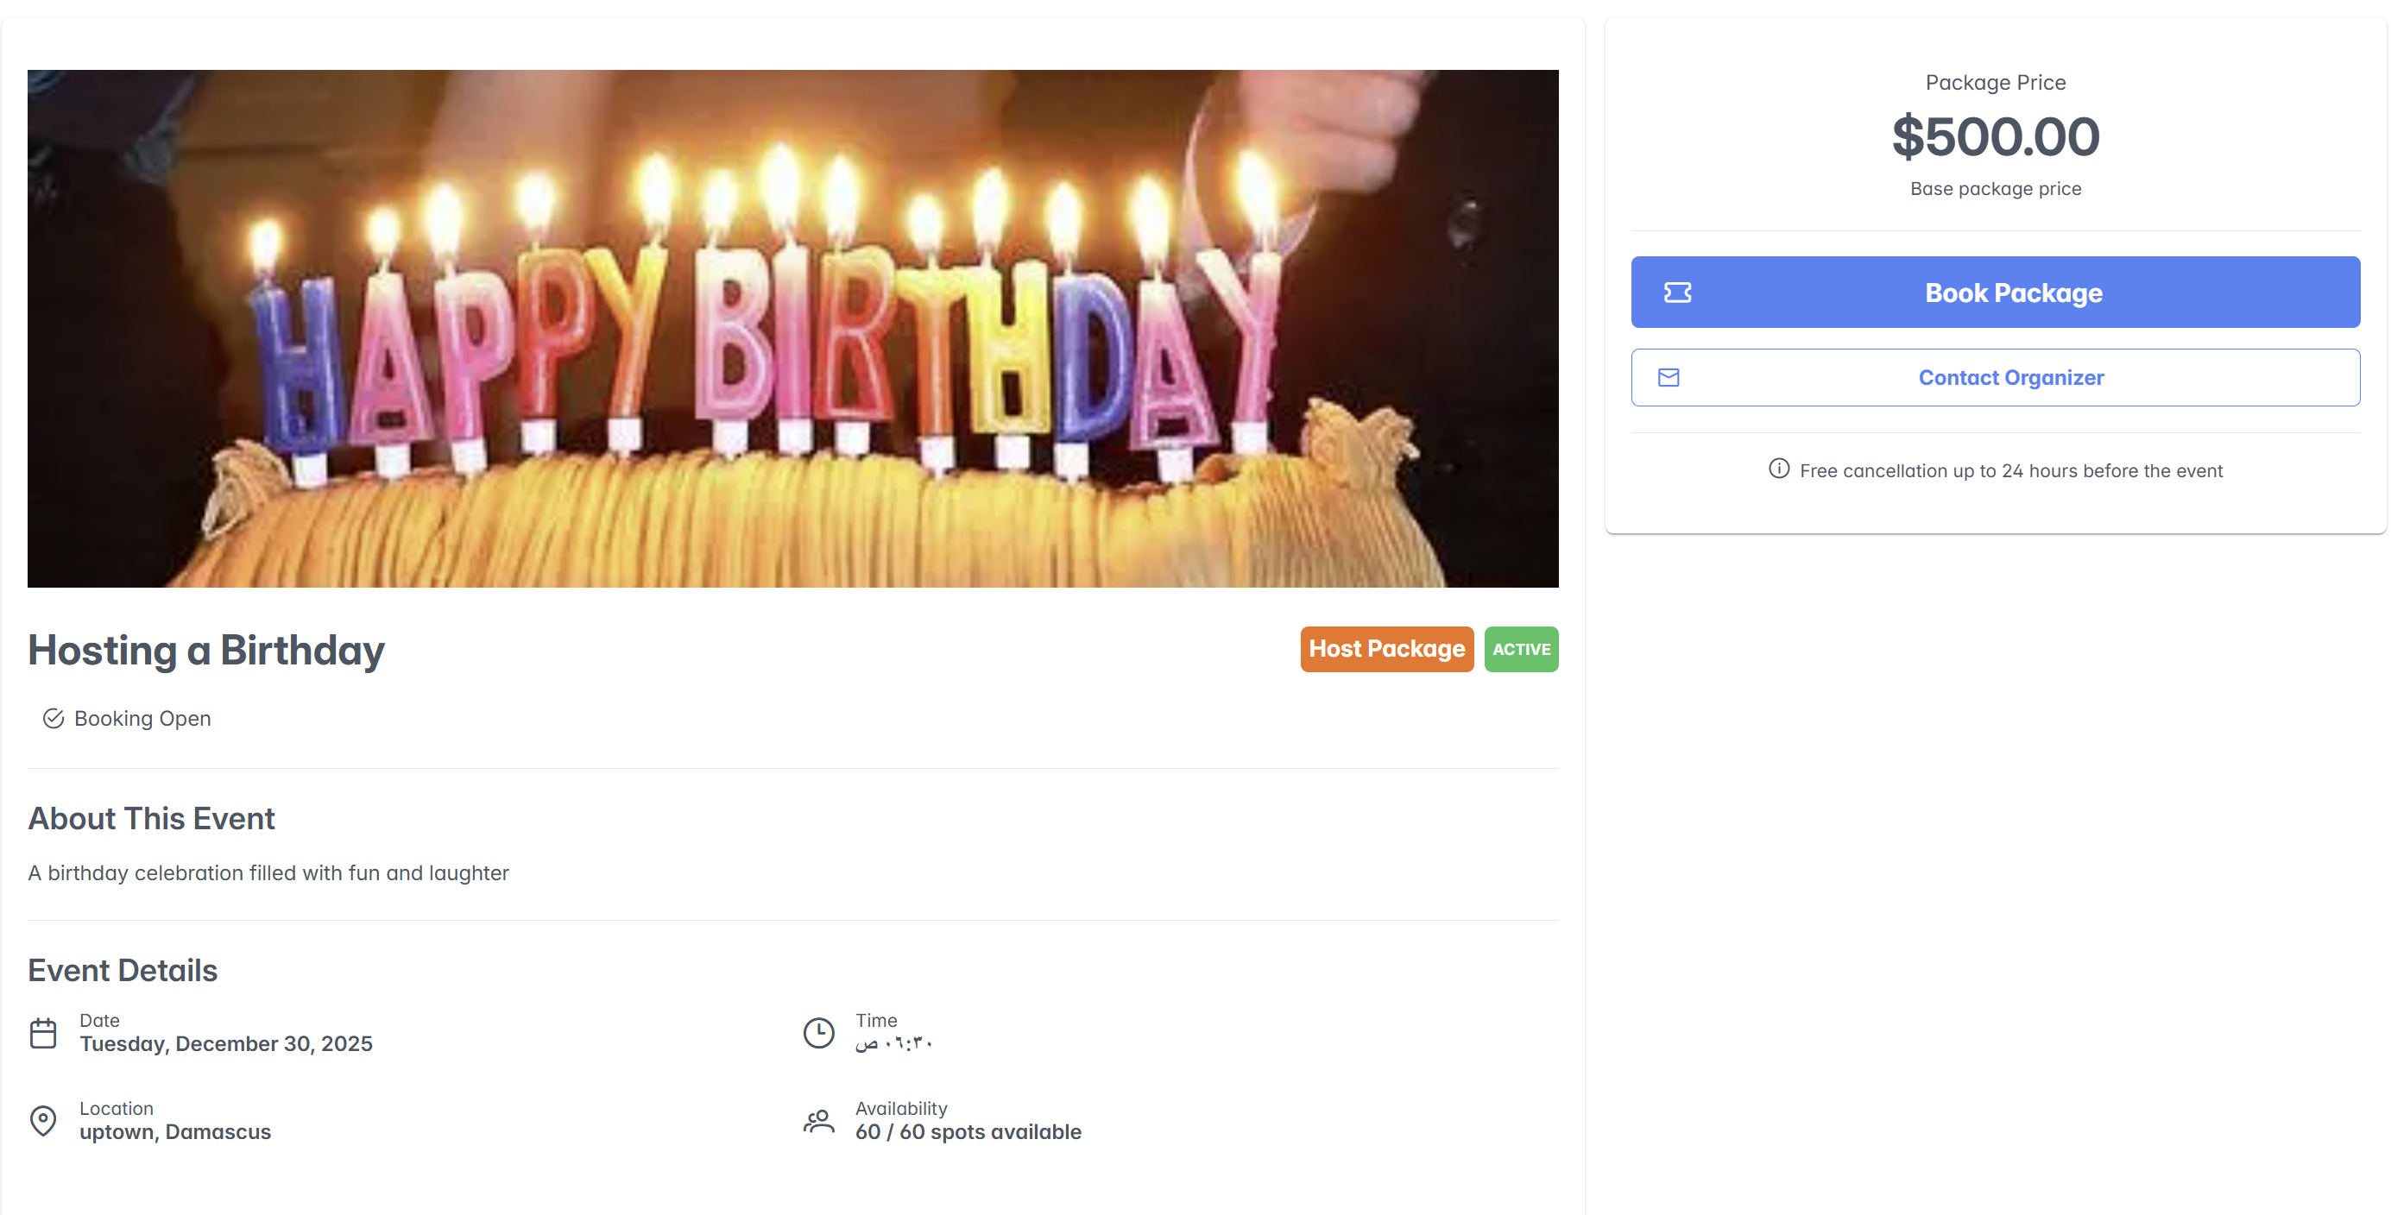

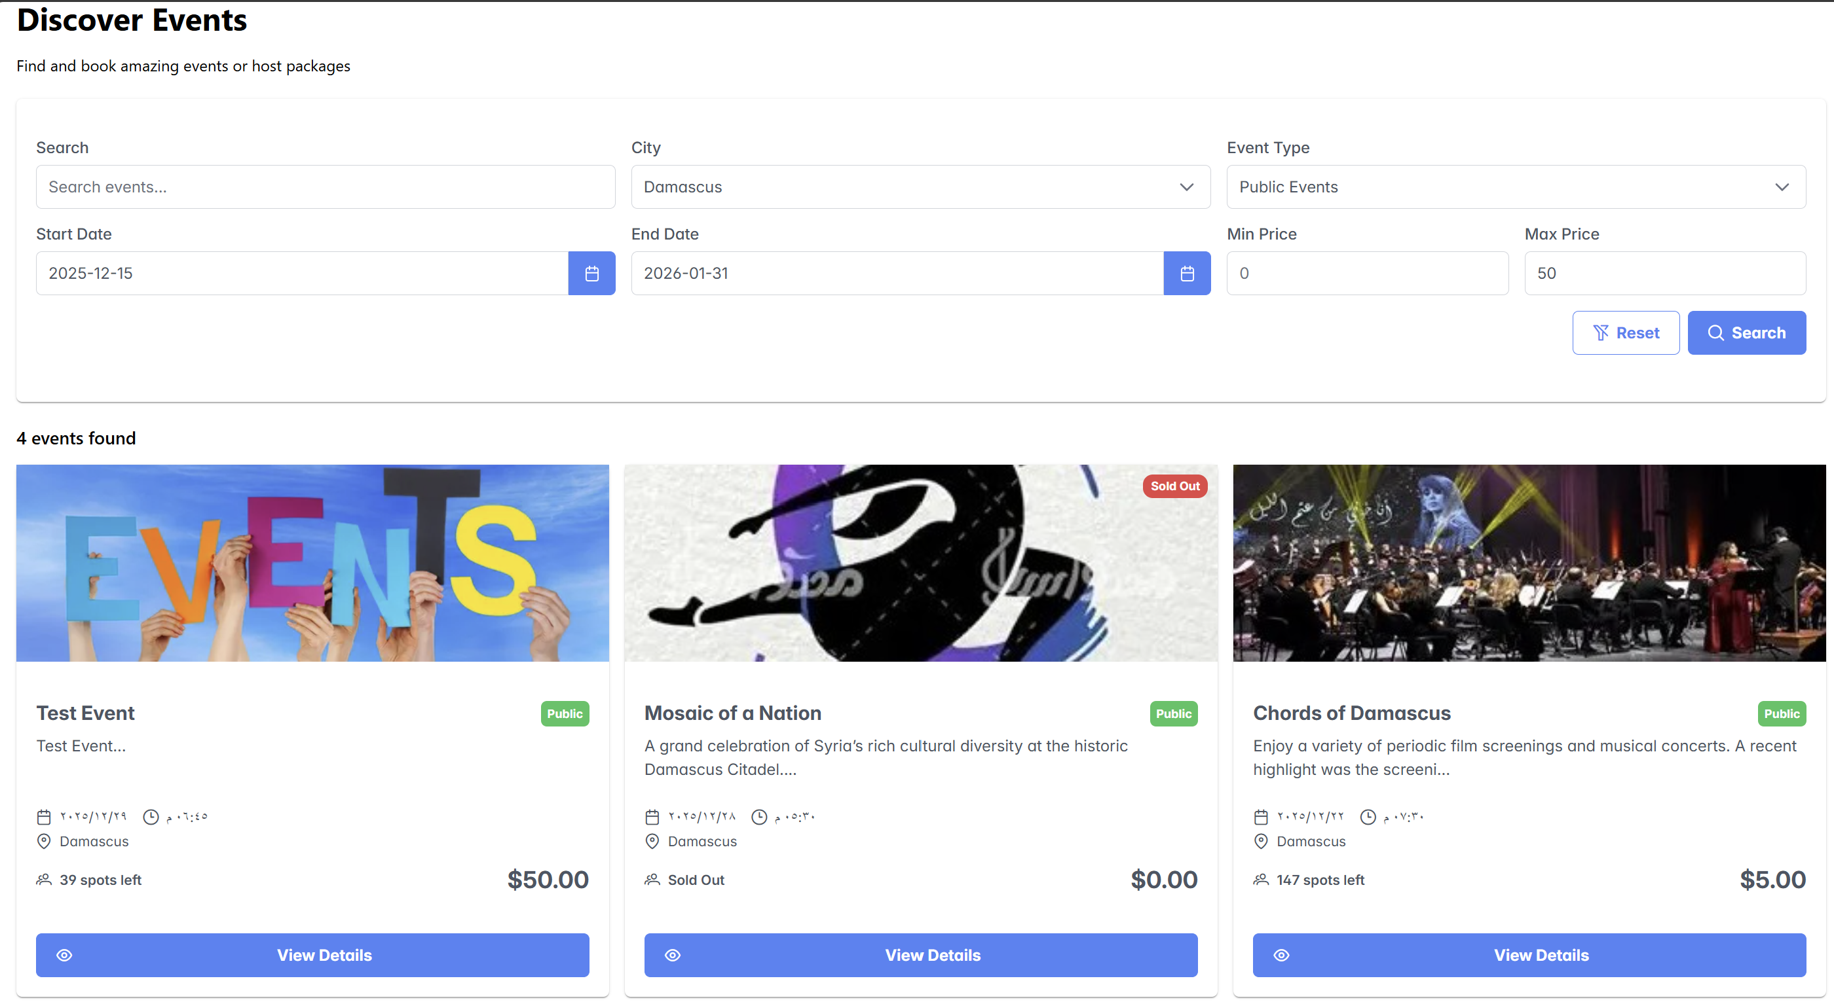

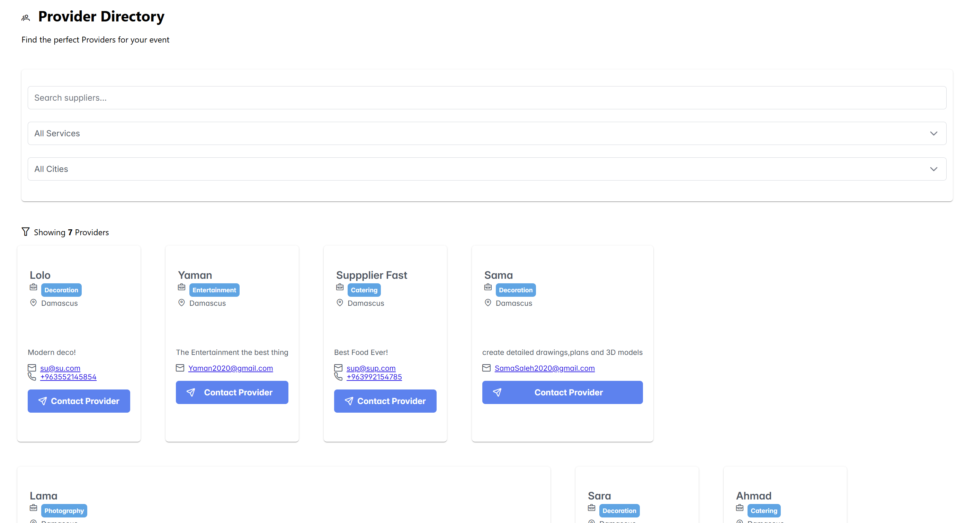

**1.Sign in**

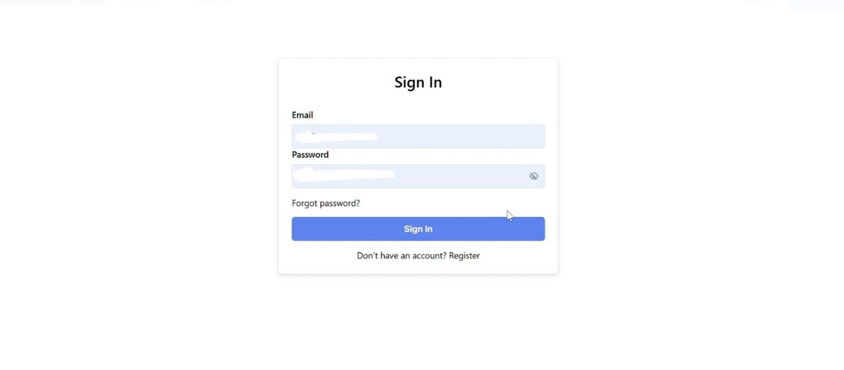

Figure 37:Sign in interface<<1>>

**2.** **New Register** **For User**

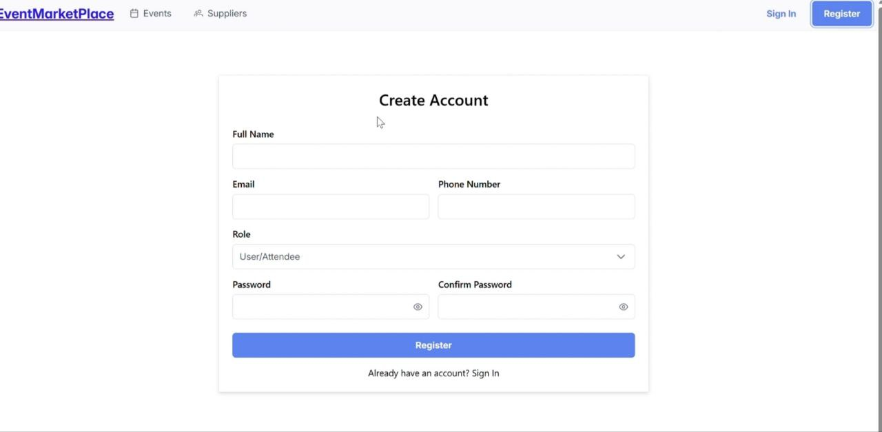

Figure 38:New Register For User <<2>>

**3.** **New Register** **For Supplier**

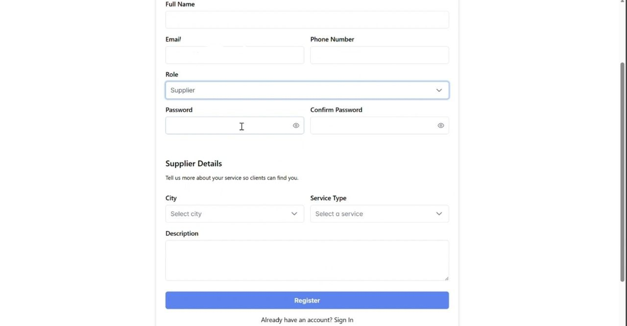

Figure 39 :New Register For Supplier<<3>>

**4. Dashboard For Organizer**

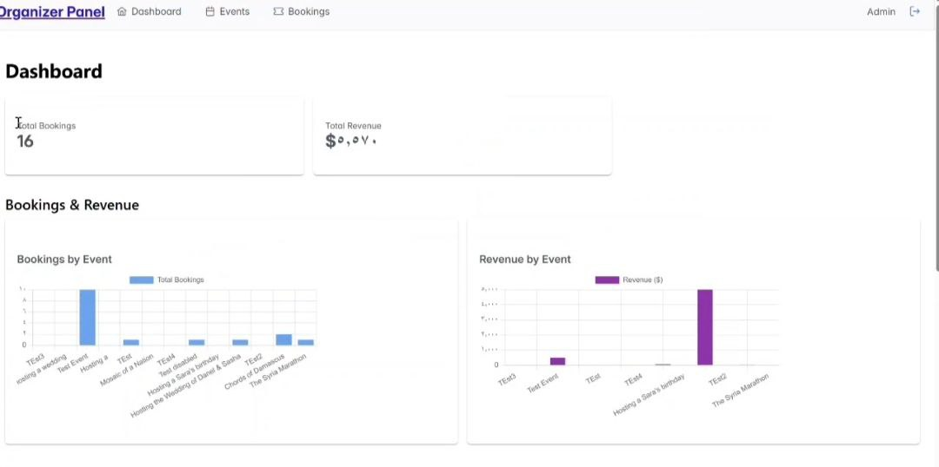

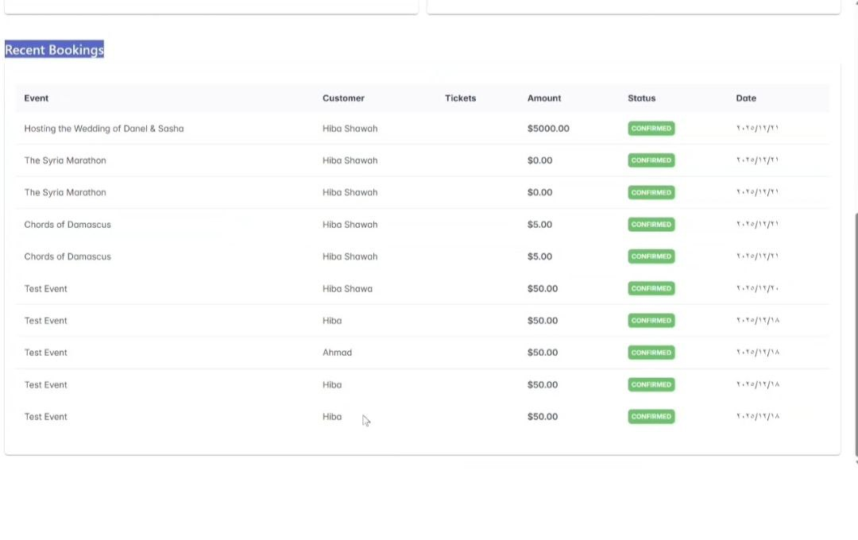

Figure 40:Dashboard For Organizer <<4>>

**5. Dashboard For Supplier**

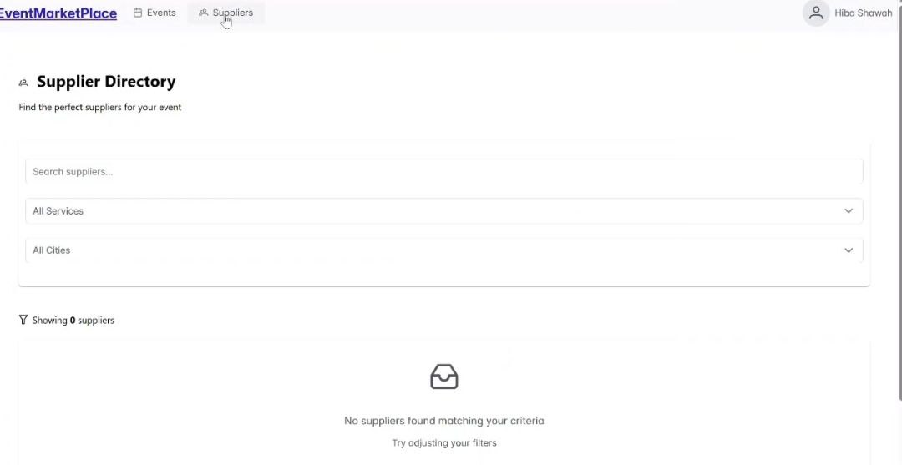

Figure 41:Dashboard For Supplier<5>>

**6.Create New Event**

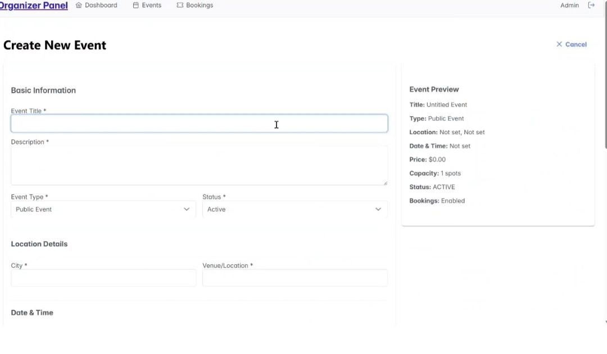

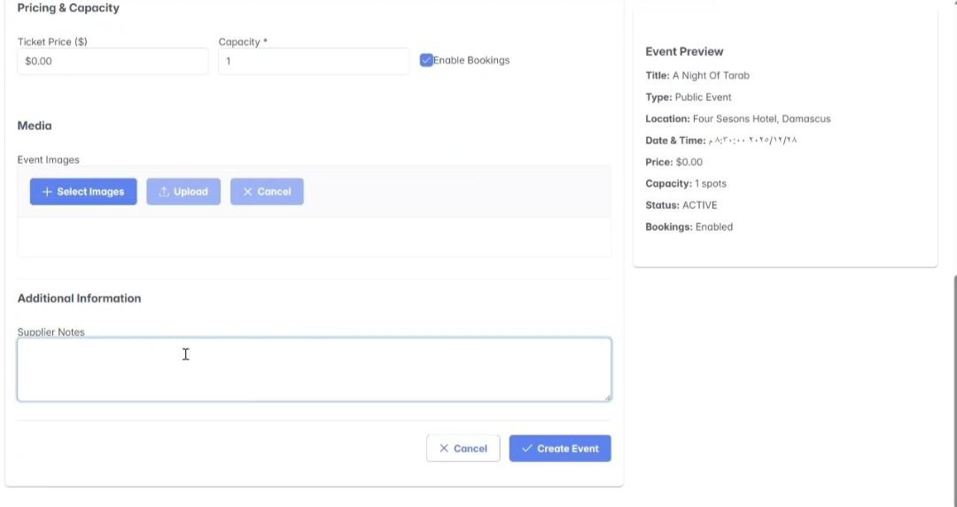

Figure 42 :Create New Event <<6>>

**7.Edit Events**

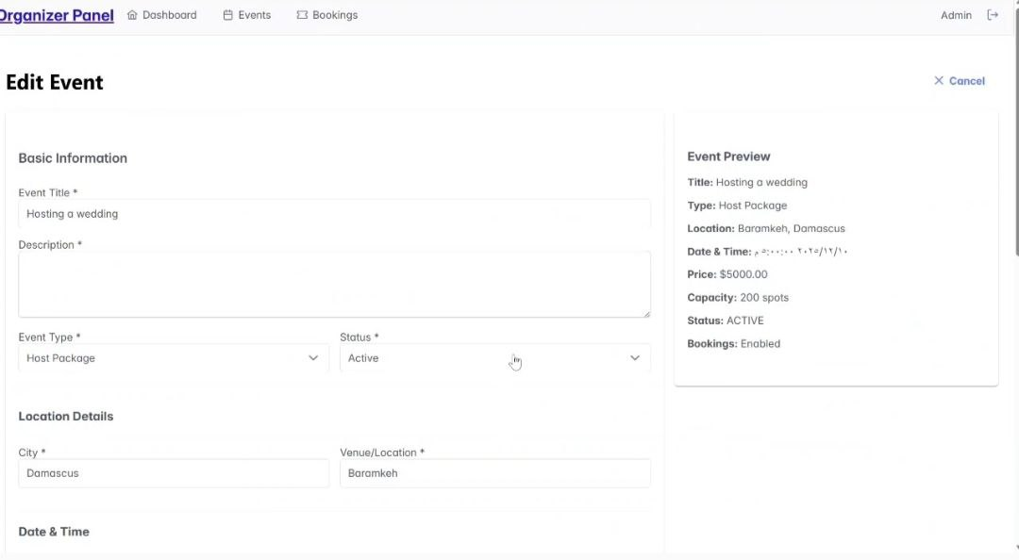

Figure 43:Edit Events <<7>>

**8.Manage Events**

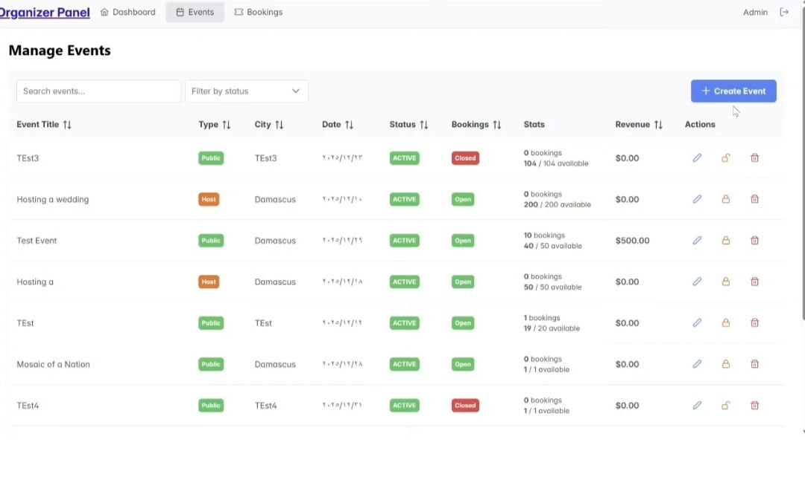

Figure 44 : Manage Events<<8>>

**9.Booking Management**

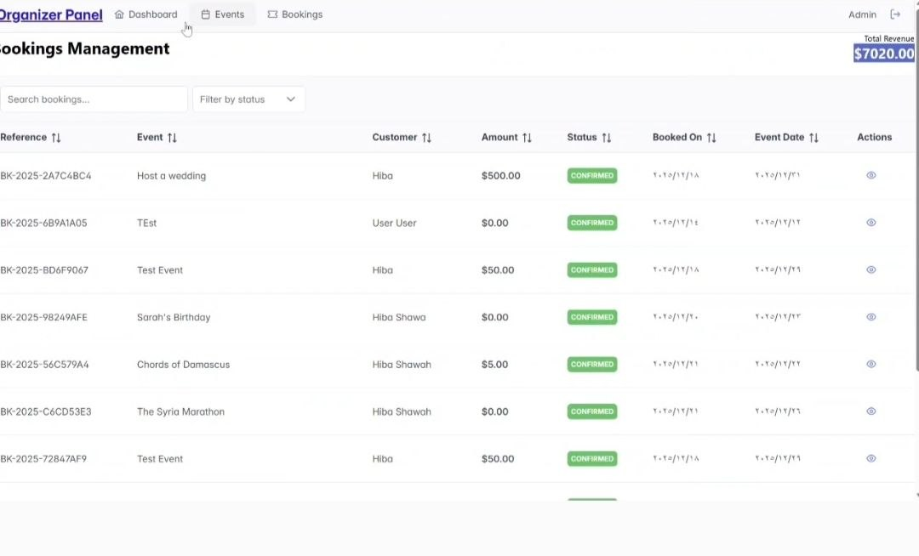

Figure 45:Booking Management <<9>>

**10.My Bookings**

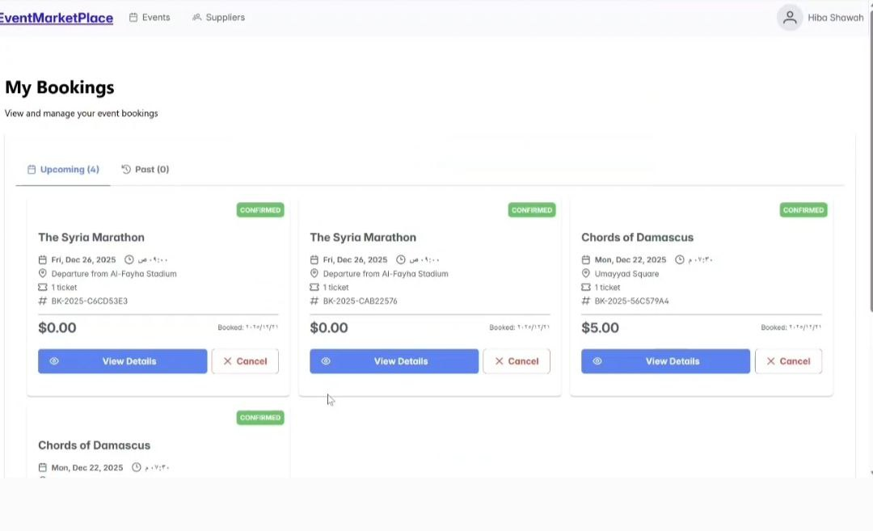

Figure 46: My Bookings <<10>>

**11.User Profile**

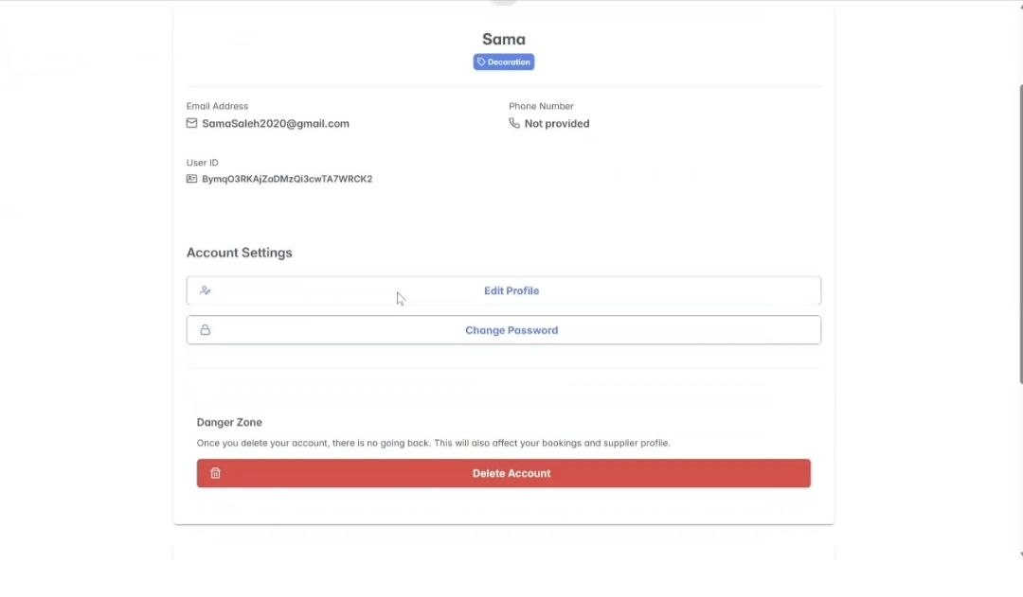

Figure 47:User Profile<<11>>

**4. REST API Documentation –** **Events and Activities Planning Platform System System**

**4.1.Introduction**

**4.1. Introduction**

This document provides a comprehensive reference for the RESTful APIs of the Events and Activities Planning Platform. This platform is designed to support efficient event management and organization by enabling event organizers to create public invitations, organize public and private events, and manage associated bookings. Service providers, on the other hand, are limited to creating a profile to showcase their information and services within the platform, without managing events or other content. These APIs allow third-party applications, such as web or mobile apps, to interact with the system to perform a range of essential tasks, including registering users, organizers, and providers; creating and managing invitations and events of various types; and processing bookings. The platform also provides visual graphs illustrating booking and revenue metrics for each event, supporting an understanding of event performance without relying on detailed analytical reports.

**4.2.Purpose**

The purpose of this documentation is to explain how to use each API endpoint in the system, including their paths, HTTP methods, required parameters, and the structure of both requests and responses. This aims to make integration easier and to ensure that the system is used properly and efficiently by developers and technical teams.

**4.3.API Structure Overview**

The APIs in this system are systematically categorized into four main sections. Each section is responsible for a specific component of Events and Activities Planning Platform System. This modular organization makes it easier for developers to navigate and utilize the APIs based on their intended functionality:

|  |  |
| --- | --- |
| **Section** | **Primary Function** |
| **SupplierController** | Manages supplier profiles linked to existing users, including operations to register a new supplier, retrieve supplier information by user ID, update supplier details, and delete supplier profiles. |
| **EventController** | Manages event operations, including creation, retrieval, updating, deletion, and booking management, providing full event lifecycle control. |
| **BookingController** | Handles event bookings by allowing users to create, view, and cancel bookings, while managing booking and payment information. |
| **DashboardController** | Aggregates event and booking data to provide dashboard statistics, including bookings, capacity, revenue, and recent booking activity. |
| **AuthenticationController** | Manages user authentication and profile operations, including user registration, identity verification via Firebase, profile updates with optional profile picture upload, and permanent account deletion. |

Table 27:API Structure

**1. SupplierController API Documentation:**

**1.1. Register New Supplier**

- **Endpoint:** /api/Supplier

- **Method:** POST

- **Description**: Registers a new supplier profile. The supplier information is linked to an existing user account.

- **Parameters:** None

- **Request Body**:{

"userId": "string",

"description": "string",

"serviceType": "enum",

"city": " string ",}

In addition: The name, email, and phoneNumber fields are automatically populated from the associated user profile.

**-Response:**

200 OK with the created Supplier object.

400 Bad Request with error message.

**1.2. Get Supplier by User ID**

**- Endpoint:** /api/suppliers/user/{userId}

**- Method:** GET

**- Description:** Retrieves a supplier profile associated with a specific user ID.

**- Parameters:**

userId (path, string, required): The ID of the user linked to the supplier profile.

**- Request Body:** None

**- Response:**

200 OK with the Supplier object.

404 Not Found if no supplier exists for the user.

400 Bad Request with error message.

**1.3. Get All Suppliers**

**- Endpoint:** /api/suppliers

**- Method:** GET

- **Description:** Retrieves a list of all registered suppliers.

**- Parameters:** None

**- Request Body:** None

**- Response:**

200 OK with a list of Supplier objects.

400 Bad Request with error message.

**1.4. Update Suppliers**

**- Endpoint:** /api/suppliers/{id}

**- Method:** PUT

**- Description:** Updates an existing supplier profile. Preserves the original createdAt timestamp.

**- Parameters:**

id (path, string, required): The ID of the supplier to update.

**- Request Body:**

"userId": "string",

"name": "string",

"email": "string",

"phonenumber": "string",

"description": "string",

"serviceType": "enum",

"city": " string ",

"createdAt": " Instant ",

"updateAt": "Instant",}

**- Response:**

200 OK with the updated Supplier object.

400 Bad Request if the update fails.

500 Internal Server Error.

**1.5. Delete Supplier**

**- Endpoint:** /api/suppliers/{id}

**- Method:** DELETE

**- Description:** Deletes a supplier profile by ID.

**- Parameters:**

id (path, string, required): The ID of the supplier to delete.

- **Request Body:** None

- **Response:**

200 OK with confirmation message "Supplier deleted".

400 Bad Request with error message.

**2. EventController API Documentation:**

**2.1. Create Event**

**- Endpoint:** /api/events

**- Method:** POST

**- Description:** Creates a new event in the system.

**- Parameters:** None

**- Request Body:** Event object containing the event details (title, description, type, location, date/time, capacity, ticket price, etc.)

**- Response:**

200 OK with the created Event object

400 Bad Request with error message if creation fails

**2.2. Get Event by ID**

**- Endpoint:** /api/events/{id}

**-** **Method:** GET

**- Description:** Retrieves the details of a specific event by its ID.

**- Parameters:**

id (path, string, required): The ID of the event

**- Request Body:** None

**- Response:**

200 OK with the Event object

404 Not Found if event does not exist

400 Bad Request if there is an error

**2.3. Get All Events**

**- Endpoint:** /api/events

**- Method:** GET

**- Description:** Retrieves a list of all events.

**- Parameters:** None

**- Request Body**: None

**- Response:**

200 OK with a list of Event objects

400 Bad Request if there is an error

**2.4. Update Event**

**- Endpoint:** /api/events/{id}

**- Method:** PUT

**- Description:** Updates the details of an existing event.

**- Parameters:**

id (path, string, required): The ID of the event to update

**- Request Body:** Event object containing updated event details

**- Response:**

200 OK with the updated Event object

400 Bad Request with error message if update fails

**2.5. Toggle Event Booking**

**- Endpoint:** /api/events/{id}/toggle-booking

**- Method:** PUT

**- Description:** Toggles the booking availability of an event (enabled/disabled).

**- Parameters:**

id (path, string, required): The ID of the event

**- Request Body:** None

**- Response:**

200 OK with the updated Event object showing new booking status

400 Bad Request with error message if toggle fails

**2.6. Delete Event**

**- Endpoint:** /api/events/{id}

**- Method:** DELETE

**- Description:** Deletes an event by its ID.

**- Parameters:**

id (path, string, required): The ID of the event to delete

**- Request Body:** None

**- Response:**

200 OK with confirmation message "Event deleted"

400 Bad Request with error message if deletion fails

**3. BookingController API Documentation**

**3.1. Create Booking**

- **Endpoint:** /api/bookings

- **Method:** POST

- **Description:** Creates a new booking for a specific event.

- **Parameters:** None

- **Request Body:**

{

"eventId": "string",

"numberOfSeats": "integer",

"paymentMethod": "string"

}

- **Response:**

201 Created with the created Booking object and associated Payment object, or 400 Bad Request / 500 Internal Server Error.

**3.2. Get Booking by ID**

- **Endpoint:** /api/bookings/{id}

- **Method:** GET

- **Description:** Retrieves a booking by its ID.

- **Parameters:**

id (path, string, required): The ID of the booking.

- **Request Body:** None

- **Response:**

200 OK with the Booking object, or 404 Not Found, or 500 Internal Server Error.

**3.3. Get All Bookings**

- **Endpoint:** /api/bookings

- **Method:** GET

- **Description:** Retrieves all bookings in the system.

- **Parameters:** None

- **Request Body:** None

- **Response:**

200 OK with a list of Booking objects, or 500 Internal Server Error.

**3.4. Get Bookings by User ID**

- **Endpoint:** /api/bookings/user/{userId}

- **Method:** GET

- **Description:** Retrieves all bookings for a specific user.

- **Parameters:**

userId (path, string, required): The ID of the user.

- **Request Body:** None

- **Response:**

200 OK with a list of Booking objects, or 500 Internal Server Error.

**3.5. Get Upcoming Bookings for User**

- **Endpoint:** /api/bookings/user/{userId}/upcoming

- **Method:** GET

- **Description:** Retrieves upcoming bookings for a specific user (events not yet occurred and not canceled).

- **Parameters:**

userId (path, string, required): The ID of the user.

- **Request Body:** None

- **Response:**

200 OK with a list of upcoming Booking objects, or 500 Internal Server Error.

**3.6. Get Past Bookings for User**

- **Endpoint:** /api/bookings/user/{userId}/past

- **Method:** GET

- **Description:** Retrieves past bookings for a specific user (events already occurred and not canceled).

- **Parameters:**

userId (path, string, required): The ID of the user.

- **Request Body:** None

- **Response:**

200 OK with a list of past Booking objects, or 500 Internal Server Error.

**3.7. Cancel Booking**

- **Endpoint:** /api/bookings/{id}/cancel

- **Method:** PUT

- **Description:** Cancels a booking by ID, only allowed by the booking owner. Payment status is set to refunded.

- **Parameters:**

id (path, string, required): The ID of the booking.

- **Request Body:** None

- **Response:**

200 OK with the updated Booking object, or 403 Forbidden if user not allowed, or 404 Not Found, or 500 Internal Server Error.

**4. AuthController API Documentation**

**4.1 Register New User**

- **Endpoint:** /api/auth/register

- **Method:** POST

- **Description:** Registers a new user account using Firebase Authentication and stores the user profile data in Firestore. Upon successful registration, a welcome email is sent to the user.

- **Parameters:** None

- **Request Body:**{

"name": "string",

"email": "string",

"password": "string",

"phoneNumber": "string (optional)", }

- **Response:**

200 OK with the created User object

400 Bad Request if registration fails

**4.2 Verify User Token (Login Verification)**

- **Endpoint:** /api/auth/verify

- **Method:** POST

- **Description:** Verifies a Firebase authentication token and retrieves the corresponding user profile from the database.

- **Parameters:**

Authorization (header, string, required): Bearer Firebase ID Token

- **Request Body:** None

- **Response:**

200 OK with a LoginResponse object containing the Firebase token and User data

401 Unauthorized if the token is invalid

**4.3 Update User Profile**

- **Endpoint:** /api/auth/user/{uid}

- **Method:** PUT

- **Description:** Updates user profile information, including optional profile picture upload. If a new email is provided, it is also updated in Firebase Authentication.

- **Parameters:**

uid (path, string, required): The unique ID of the user

- **Request Body (Multipart):**

user (User object, required)

file (MultipartFile, optional): Profile picture

- **Response:**

200 OK with the updated User object

400 Bad Request if update fails

**4.4 Delete User Profile Picture**

- **Endpoint:** /api/auth/user/{uid}/profile-picture

- **Method:** DELETE

- **Description:** Deletes the user’s profile picture from Firebase Storage and updates the user profile accordingly.

- **Parameters:**

uid (path, string, required): The unique ID of the user

- **Request Body:** None

- **Response:**

200 OK with the updated User object

400 Bad Request if no profile picture exists or deletion fails

**4.5 Delete User Account**

- **Endpoint:** /api/auth/user/{uid}

- **Method:** DELETE

- **Description:** Permanently deletes a user account from Firebase Authentication and removes the corresponding user record from Firestore.

- **Parameters:**

uid (path, string, required): The unique ID of the user

- **Request Body:** None

- **Response:**

200 OK with confirmation message.

400 Bad Request if deletion fails.

**5. DashboardController API Documentation**

**5.1. Get** **Organization Dashboard Statistics**

- **Endpoint:** /api/dashboard/organization

- **Method:** GET

- **Description:** Retrieves aggregated dashboard statistics for the organization. This endpoint provides an overview of all events, including booking statistics, capacity information, revenue details, and a list of the most recent bookings.

- **Parameters:** None

- **Request Body:** None

- **Response:**

200 OK Returns a DashboardStats object containing:

A list of event-level statistics (EventStatsDTO) including total bookings, total capacity, available seats, and total revenue per event.

The overall number of bookings across all events.

The overall revenue generated from all events.

A list of the most recent bookings, sorted by booking date in descending order (limited to the latest 10 bookings).

500 Internal Server Error: If an unexpected server-side error occurs during data retrieval or processing.

**4.4.Detailed Table of REST API Endpoints**

This table presents all the REST API endpoints used in the System, organized into four main categories based on the system’s core functionalities: SupplierController,EventController, BookingController, DashboardController, AuthController. Each entry includes the HTTP method, full endpoint path, and a brief description to facilitate understanding of how each API function operates and connects to system tasks.

|  |  |  |  |
| --- | --- | --- | --- |
| Controller | Endpoint | Method | Description |
| Supplier | /api/Supplier | POST | Registers a new supplier profile. The supplier information is linked to an existing user account. |
|  | /api/suppliers/user/{userId} | GET | Retrieves a supplier profile associated with a specific user ID. |
|  | /api/suppliers | GET | Retrieves a list of all registered suppliers. |
|  | /api/suppliers/{id} | PUT | Updates an existing supplier profile. Preserves the original createdAt timestamp. |
|  | /api/suppliers/{id} | DELETE | Deletes a supplier profile by ID. |
| EventController | /api/events | POST | Creates a new event in the system. |
|  | /api/events/{id} | GET | Retrieves the details of a specific event by its ID. |
|  | /api/events | GET | Retrieves a list of all events. |
|  | /api/events/{id} | PUT | Updates the details of an existing event. |
|  | /api/events/{id}/toggle-booking | PUT | Toggles the booking availability of an event (enabled/disabled). |
|  | /api/events/{id} | DELETE | Deletes an event by its ID. |
| BookingController | /api/bookings | POST | Creates a new booking for a specific event. |
|  | /api/bookings/{id} | GET | Retrieves a booking by its ID. |
|  | /api/bookings | GET | Retrieves all bookings in the system. |
|  | /api/bookings/user/{userId} | GET | Retrieves all bookings for a specific user. |
|  | /api/bookings/user/{userId}/upcoming | GET | Retrieves upcoming bookings for a specific user (events not yet occurred and not canceled). |
|  | /api/bookings/user/{userId}/past | GET | Retrieves past bookings for a specific user (events already occurred and not canceled). |
|  | /api/bookings/{id}/cancel | PUT | Cancels a booking by ID, only allowed by the booking owner. Payment status is set to refunded. |
| AuthController | /api/auth/register | POST | Registers a new user account using Firebase Authentication and stores the user profile data in Firestore. Upon successful registration, a welcome email is sent to the user. |
|  | /api/auth/verify | POST | Verifies a Firebase authentication token and retrieves the corresponding user profile from the database. |
|  | /api/auth/user/{uid} | PUT | Updates user profile information, including optional profile picture upload. If a new email is provided, it is also updated in Firebase Authentication. |
|  | /api/auth/user/{uid}/profile-picture | DELETE | Deletes the user’s profile picture from Firebase Storage and updates the user profile accordingly. |
|  | /api/auth/user/{uid} | DELETE | Permanently deletes a user account from Firebase Authentication and removes the corresponding user record from Firestore. |
| DashboardController | /api/dashboard/organization | GET | Retrieves aggregated dashboard statistics for the organization. This endpoint provides an overview of all events, including booking statistics, capacity information, revenue details, and a list of the most recent bookings |

Table 28:API

**5.Execution Test case**

|  |  |  |  |  |  |
| --- | --- | --- | --- | --- | --- |
| **TC ID** | **Req ID** | **Title** | **Preconditions** | **Test Steps** | **Expected Result** |
| TC-01 | FR-01 ,FR-46 | User Registration & Notification | User on registration page | 1. Open registration page 2. Enter valid data 3. Submit form | Account is created and success email is received |
| TC-02 | FR-02 | Registration Validation | User on registration page | 1. Enter invalid email/phone/password 2. Submit form | Validation error message is displayed |
| TC-03 | FR-03 | Login & Logout | User account exists | 1. Login with valid credentials 2. Logout | User logs in and out successfully |
| TC-04 | FR-04 ,FR-47 | Password Recovery & Notification | Email registered in system | 1. Click “Forgot Password” 2. Enter email | Password reset link sent and reset email received |
| TC-05 | FR-07 | Change Password | User logged in | 1. Enter old password 2. Enter new password | Password changed successfully |
| TC-06 | FR-05 | View User Profile | User logged in | Open profile page | User profile information displayed |
| TC-07 | FR-06 | Edit User Profile | User logged in | Edit profile data and save | Profile updated successfully |
| TC-08 | FR-08 | Delete User Account | User logged in | Enter password and confirm deletion | Account deleted |
| TC-09 | FR09,  FR-50 | View Events (User & Guest) | Published events exist | Open events page | Events list displayed |
| TC-10 | FR10  ,FR-51 | Search & Filter Events | Published events exist | Apply filters or search keyword | Correct results displayed |
| TC-11 | FR11,  FR-12 | Event Cards & Details | Published events exist | Open event cards and details | Correct info displayed |
| TC-12 | FR-13 ,FR-14 , FR-15 | Event Capacity & Booking Status | Event published | Open event page | Available seats and booking status shown |
| TC-13 | FR-16 | View Vendor Info | Event linked to resource | View event details | Vendor info displayed |
| TC-14 | FR-17 ,FR-18 , FR-53 , FR-54 | Booking Flow & Restrictions | Event fully booked / user not logged in | Attempt to book event | Booking blocked if full or guest redirected |
| TC-15 | FR-19 ,FR-20, FR-27 | Booking Processing & Capacity Update | User logged in, event available | Complete booking, cancel, or repeat | Booking reference generated, capacity updated/restored |
| TC-16 | FR-21,  FR-48, FR-49 | Booking & Event Notifications | Booking or event updated | Trigger booking/event changes | Notifications sent on time |
| TC-17 | FR-22, FR-23 | View & Book Hosting Packages | Packages available | Open packages, select & confirm booking | Packages displayed and booking successful |
| TC-18 | FR-24 , FR-25 | View Bookings (Upcoming & Past) | User has bookings | Open bookings page/history | Bookings displayed |
| TC-19 | FR-26 | Cancel Booking | User has confirmed booking | Cancel booking | Booking canceled successfully |
| TC-20 | FR-33 , FR-36 | Create & Edit Hosting Package | Organizer logged in | Enter/edit package details and save | Package created/updated |
| TC-21 | FR-34 | Validate Mandatory Package Fields | Organizer on package creation page | Submit incomplete package form | Validation error displayed |
| TC-22 | FR-35 | Customize Package Elements | Package supports customization | Select customization options | Custom options applied |
| TC-23 | FR-37 | Delete Hosting Package | Package exists | Delete package | Package deleted |
| TC-24 | FR-28 ,FR-30, FR-31 , FR-32 | Event Management (Create/Edit/Delete/Enable Booking) | Organizer logged in | Create, edit, delete, toggle booking | Events updated correctly |
| TC-25 | FR-38, FR-39, FR-40 | Dashboard & Event Search | Organizer has events | Open dashboard and search/filter events | Correct events & dashboard data displayed |
| TC-26 | FR-41  ,FR-42 | Event & General Statistics | Events have bookings | View analytics | Event/general statistics displayed |
| TC-27 | FR-43 | Vendor Registration | Vendor not registered | Register vendor | Vendor account created |
| TC-28 | FR-44,  FR-45, FR-55 | Search & Filter Vendors | Providers exist | Search/filter vendors page | Correct vendors displayed |
| TC-29 | FR-46,  FR-47 | Registration & Password Notifications | Vendor registered or requesting reset | Complete action | Notification email received |
| TC-30 | NFR-01 | Usability | User logged in | Navigate through main pages | User can use all features easily |
| TC-31 | NFR-02 | Performance | System under normal load | Load Home, Events, Booking pages | Pages load <3 sec |
| TC-32 | NFR-03 | Availability | System deployed | Monitor uptime | ≥99% uptime |
| TC-33 | NFR-04 | Data Protection | User account exists | Attempt to access data | Data protected |
| TC-34 | NFR-05 | Compatibility | Modern browsers installed | Open system in Chrome/Firefox/Edge | Works correctly |
| TC-35 | NFR-06 | Scalability | System under load | Simulate many users/events | System handles load |
| TC-36 | NFR-07 | Reliability | Existing bookings present | Make booking/repeat | Booking not lost/duplicated |
| TC-37 | NFR-08 | Notifications | Notifications enabled | Trigger system notifications | Notifications delivered on time |

Table 29:execution test cases

**6. Requirement Trackability Matrix (RTM) (V.4)**

|  |  |  |  |  |  |  |  |  |
| --- | --- | --- | --- | --- | --- | --- | --- | --- |
| **Requirement Id** | **Title** | **Use Case** | **System**  **Design** | **Analysis** | **Detailed Design** | **Coding** | | **Test Cases** |
| **Frontend** | **Backend** |
| REQ-01 | The system should allow the creation of an account for a new user. | [UC-01](https://github.com/Hiba2003-cmd/Alternative-Energy-Management-System/blob/main/design/UC-01.png) | [Interface <1>](https://github.com/Hiba2003-cmd/Alternative-Energy-Management-System/blob/main/design/interface(1).png) | [seq.1](https://github.com/Hiba2003-cmd/Alternative-Energy-Management-System/blob/main/design/seq.1.png) | [class diagram](https://github.com/Hiba2003-cmd/Alternative-Energy-Management-System/blob/main/design/Class%20diagram.png) | [Authentication.jsx](https://github.com/Hiba2003-cmd/Alternative-Energy-Management-System/blob/main/alternative-energy-management-system/frontend/src/pages/Authentication.jsx) | [UserController.java#L24](https://github.com/Hiba2003-cmd/Alternative-Energy-Management-System/blob/af9d187d52e86f862dd47aa472e69d70abbe9888/alternative-energy-management-system/backend/src/main/java/com/backend/alternativeenergymanagementsystem/controller/UserController.java#L24) | [manual test cases](https://view.officeapps.live.com/op/view.aspx?src=https%3A%2F%2Fraw.githubusercontent.com%2FHiba2003-cmd%2FAlternative-Energy-Management-System%2Frefs%2Fheads%2Fmain%2Ftest%2Fmanual%2520test%2520cases.docx&wdOrigin=BROWSELINK) |
| REQ-02 | The system should allow the user to log in. | [UC-01](https://github.com/Hiba2003-cmd/Alternative-Energy-Management-System/blob/main/design/UC-01.png) | [Interface<2>](https://github.com/Hiba2003-cmd/Alternative-Energy-Management-System/blob/main/design/interface(2).png) | [seq.1](https://github.com/Hiba2003-cmd/Alternative-Energy-Management-System/blob/main/design/seq.1.png) | [class diagram](https://github.com/Hiba2003-cmd/Alternative-Energy-Management-System/blob/main/design/Class%20diagram.png) | [Authentication.jsx](https://github.com/Hiba2003-cmd/Alternative-Energy-Management-System/blob/main/alternative-energy-management-system/frontend/src/pages/Authentication.jsx) | [firebaseService.js#L2](https://github.com/Hiba2003-cmd/Alternative-Energy-Management-System/blob/af9d187d52e86f862dd47aa472e69d70abbe9888/alternative-energy-management-system/frontend/src/services/firebaseService.js#L2) | [manual test cases](https://view.officeapps.live.com/op/view.aspx?src=https%3A%2F%2Fraw.githubusercontent.com%2FHiba2003-cmd%2FAlternative-Energy-Management-System%2Frefs%2Fheads%2Fmain%2Ftest%2Fmanual%2520test%2520cases.docx&wdOrigin=BROWSELINK) |
| REQ-03 | The system should allow the user to reset their password in case they forget it. | [UC-01](https://github.com/Hiba2003-cmd/Alternative-Energy-Management-System/blob/main/design/UC-01.png) | [Interface<3>](https://github.com/Hiba2003-cmd/Alternative-Energy-Management-System/blob/main/design/interface(3).png) | [seq.1](https://github.com/Hiba2003-cmd/Alternative-Energy-Management-System/blob/main/design/seq.1.png) | [class diagram](https://github.com/Hiba2003-cmd/Alternative-Energy-Management-System/blob/main/design/Class%20diagram.png) | [Authentication.jsx](https://github.com/Hiba2003-cmd/Alternative-Energy-Management-System/blob/main/alternative-energy-management-system/frontend/src/pages/Authentication.jsx) | [authService.js#L47](https://github.com/Hiba2003-cmd/Alternative-Energy-Management-System/blob/af9d187d52e86f862dd47aa472e69d70abbe9888/alternative-energy-management-system/frontend/src/services/authService.js#L47) | [manual test cases](https://view.officeapps.live.com/op/view.aspx?src=https%3A%2F%2Fraw.githubusercontent.com%2FHiba2003-cmd%2FAlternative-Energy-Management-System%2Frefs%2Fheads%2Fmain%2Ftest%2Fmanual%2520test%2520cases.docx&wdOrigin=BROWSELINK) |
| REQ-04 | The system should enforce secure authentication and require users to log in with passwords. | [UC-01](https://github.com/Hiba2003-cmd/Alternative-Energy-Management-System/blob/main/design/UC-01.png) | [Interface<2>](https://github.com/Hiba2003-cmd/Alternative-Energy-Management-System/blob/main/design/interface(2).png) | [seq.1](https://github.com/Hiba2003-cmd/Alternative-Energy-Management-System/blob/main/design/seq.1.png) | [class diagram](https://github.com/Hiba2003-cmd/Alternative-Energy-Management-System/blob/main/design/Class%20diagram.png) | [Authentication.jsx](https://github.com/Hiba2003-cmd/Alternative-Energy-Management-System/blob/main/alternative-energy-management-system/frontend/src/pages/Authentication.jsx) | [UserService.java#L30](https://github.com/Hiba2003-cmd/Alternative-Energy-Management-System/blob/af9d187d52e86f862dd47aa472e69d70abbe9888/alternative-energy-management-system/backend/src/main/java/com/backend/alternativeenergymanagementsystem/service/UserService.java#L30) | [manual test cases](https://view.officeapps.live.com/op/view.aspx?src=https%3A%2F%2Fraw.githubusercontent.com%2FHiba2003-cmd%2FAlternative-Energy-Management-System%2Frefs%2Fheads%2Fmain%2Ftest%2Fmanual%2520test%2520cases.docx&wdOrigin=BROWSELINK) |
| REQ-05 | The system should allow the user to update their password. | [UC-05](https://github.com/Hiba2003-cmd/Alternative-Energy-Management-System/blob/main/design/UC-05.png) | [Interface<16>](https://github.com/Hiba2003-cmd/Alternative-Energy-Management-System/blob/main/design/interface(16).png) | [seq.5](https://github.com/Hiba2003-cmd/Alternative-Energy-Management-System/blob/main/design/seq.5.png) | [class diagram](https://github.com/Hiba2003-cmd/Alternative-Energy-Management-System/blob/main/design/Class%20diagram.png) | [UserProfile.jsx](https://github.com/Hiba2003-cmd/Alternative-Energy-Management-System/blob/main/alternative-energy-management-system/frontend/src/pages/UserProfile.jsx) | [userService.js#L59](https://github.com/Hiba2003-cmd/Alternative-Energy-Management-System/blob/af9d187d52e86f862dd47aa472e69d70abbe9888/alternative-energy-management-system/frontend/src/services/userService.js#L59) | [manual test cases](https://view.officeapps.live.com/op/view.aspx?src=https%3A%2F%2Fraw.githubusercontent.com%2FHiba2003-cmd%2FAlternative-Energy-Management-System%2Frefs%2Fheads%2Fmain%2Ftest%2Fmanual%2520test%2520cases.docx&wdOrigin=BROWSELINK) |
| REQ-06 | The system should allow the user to update personal information. | [UC-05](https://github.com/Hiba2003-cmd/Alternative-Energy-Management-System/blob/main/design/UC-05.png) | [Interface<16>](https://github.com/Hiba2003-cmd/Alternative-Energy-Management-System/blob/main/design/interface(16).png) | [seq.5](https://github.com/Hiba2003-cmd/Alternative-Energy-Management-System/blob/main/design/seq.5.png) | [class diagram](https://github.com/Hiba2003-cmd/Alternative-Energy-Management-System/blob/main/design/Class%20diagram.png) | [UserProfile.jsx](https://github.com/Hiba2003-cmd/Alternative-Energy-Management-System/blob/main/alternative-energy-management-system/frontend/src/pages/UserProfile.jsx) | [UserController.java#L73](https://github.com/Hiba2003-cmd/Alternative-Energy-Management-System/blob/af9d187d52e86f862dd47aa472e69d70abbe9888/alternative-energy-management-system/backend/src/main/java/com/backend/alternativeenergymanagementsystem/controller/UserController.java#L73) | [manual test cases](https://view.officeapps.live.com/op/view.aspx?src=https%3A%2F%2Fraw.githubusercontent.com%2FHiba2003-cmd%2FAlternative-Energy-Management-System%2Frefs%2Fheads%2Fmain%2Ftest%2Fmanual%2520test%2520cases.docx&wdOrigin=BROWSELINK) |

|  |  |  |  |  |  |  |  |  |
| --- | --- | --- | --- | --- | --- | --- | --- | --- |
| REQ-07 | The system should allow the user to view their profile dashboard. | [UC-05](https://github.com/Hiba2003-cmd/Alternative-Energy-Management-System/blob/main/design/UC-05.png) | [Interface<16>](https://github.com/Hiba2003-cmd/Alternative-Energy-Management-System/blob/main/design/interface(16).png) | [seq.5](https://github.com/Hiba2003-cmd/Alternative-Energy-Management-System/blob/main/design/seq.5.png) | [class diagram](https://github.com/Hiba2003-cmd/Alternative-Energy-Management-System/blob/main/design/Class%20diagram.png) | [UserProfile.jsx](https://github.com/Hiba2003-cmd/Alternative-Energy-Management-System/blob/main/alternative-energy-management-system/frontend/src/pages/UserProfile.jsx) | [UserController.java#L51](https://github.com/Hiba2003-cmd/Alternative-Energy-Management-System/blob/af9d187d52e86f862dd47aa472e69d70abbe9888/alternative-energy-management-system/backend/src/main/java/com/backend/alternativeenergymanagementsystem/controller/UserController.java#L51) | [manual test cases](https://view.officeapps.live.com/op/view.aspx?src=https%3A%2F%2Fraw.githubusercontent.com%2FHiba2003-cmd%2FAlternative-Energy-Management-System%2Frefs%2Fheads%2Fmain%2Ftest%2Fmanual%2520test%2520cases.docx&wdOrigin=BROWSELINK) |
| REQ-08 | The system should allow the user to manage notification preferences. | [UC-05](https://github.com/Hiba2003-cmd/Alternative-Energy-Management-System/blob/main/design/UC-05.png) | [Interface<16>](https://github.com/Hiba2003-cmd/Alternative-Energy-Management-System/blob/main/design/interface(16).png) | [seq.5](https://github.com/Hiba2003-cmd/Alternative-Energy-Management-System/blob/main/design/seq.5.png) | [class diagram](https://github.com/Hiba2003-cmd/Alternative-Energy-Management-System/blob/main/design/Class%20diagram.png) | [UserProfile.jsx](https://github.com/Hiba2003-cmd/Alternative-Energy-Management-System/blob/main/alternative-energy-management-system/frontend/src/pages/UserProfile.jsx) | [User.java#L25](https://github.com/Hiba2003-cmd/Alternative-Energy-Management-System/blob/af9d187d52e86f862dd47aa472e69d70abbe9888/alternative-energy-management-system/backend/src/main/java/com/backend/alternativeenergymanagementsystem/model/User.java#L25) | [manual test cases](https://view.officeapps.live.com/op/view.aspx?src=https%3A%2F%2Fraw.githubusercontent.com%2FHiba2003-cmd%2FAlternative-Energy-Management-System%2Frefs%2Fheads%2Fmain%2Ftest%2Fmanual%2520test%2520cases.docx&wdOrigin=BROWSELINK) |
| REQ-09 | The system should display the main dashboard for the user. | [UC-04](https://github.com/Hiba2003-cmd/Alternative-Energy-Management-System/blob/main/design/UC-04.png) | [Interface<4>](https://github.com/Hiba2003-cmd/Alternative-Energy-Management-System/blob/main/design/interface(4).png) | [seq.4](https://github.com/Hiba2003-cmd/Alternative-Energy-Management-System/blob/main/design/seq.4.png) | [class diagram](https://github.com/Hiba2003-cmd/Alternative-Energy-Management-System/blob/main/design/Class%20diagram.png) | [Dashboard.jsx](https://github.com/Hiba2003-cmd/Alternative-Energy-Management-System/blob/af9d187d52e86f862dd47aa472e69d70abbe9888/alternative-energy-management-system/frontend/src/pages/Dashboard.jsx) | [EnergyAnalysisController.java](https://github.com/Hiba2003-cmd/Alternative-Energy-Management-System/blob/af9d187d52e86f862dd47aa472e69d70abbe9888/alternative-energy-management-system/backend/src/main/java/com/backend/alternativeenergymanagementsystem/controller/EnergyAnalysisController.java) | [manual test cases](https://view.officeapps.live.com/op/view.aspx?src=https%3A%2F%2Fraw.githubusercontent.com%2FHiba2003-cmd%2FAlternative-Energy-Management-System%2Frefs%2Fheads%2Fmain%2Ftest%2Fmanual%2520test%2520cases.docx&wdOrigin=BROWSELINK) |
| REQ-10 | The system should display the top energy consuming devices. | [UC-04](https://github.com/Hiba2003-cmd/Alternative-Energy-Management-System/blob/main/design/UC-04.png) | [Interface<5>](https://github.com/Hiba2003-cmd/Alternative-Energy-Management-System/blob/main/design/interface(5).png) |  | [class diagram](https://github.com/Hiba2003-cmd/Alternative-Energy-Management-System/blob/main/design/Class%20diagram.png) | [TopConsumingDevicesTable.jsx](https://github.com/Hiba2003-cmd/Alternative-Energy-Management-System/blob/af9d187d52e86f862dd47aa472e69d70abbe9888/alternative-energy-management-system/frontend/src/components/TopConsumingDevicesTable.jsx) |  | [manual test cases](https://view.officeapps.live.com/op/view.aspx?src=https%3A%2F%2Fraw.githubusercontent.com%2FHiba2003-cmd%2FAlternative-Energy-Management-System%2Frefs%2Fheads%2Fmain%2Ftest%2Fmanual%2520test%2520cases.docx&wdOrigin=BROWSELINK) |
| REQ-11 | The system should allow the user to add new solar panels. | [UC-02](https://github.com/Hiba2003-cmd/Alternative-Energy-Management-System/blob/main/design/UC-02.png) | [Interface<9>](https://github.com/Hiba2003-cmd/Alternative-Energy-Management-System/blob/main/design/interface(9).png) | [seq.2](https://github.com/Hiba2003-cmd/Alternative-Energy-Management-System/blob/main/design/seq.2.png) | [class diagram](https://github.com/Hiba2003-cmd/Alternative-Energy-Management-System/blob/main/design/Class%20diagram.png) | SolarPanelManagement.jsx | [SolarPanelController.java#L22](https://github.com/Hiba2003-cmd/Alternative-Energy-Management-System/blob/af9d187d52e86f862dd47aa472e69d70abbe9888/alternative-energy-management-system/backend/src/main/java/com/backend/alternativeenergymanagementsystem/controller/SolarPanelController.java#L22) | [manual test cases](https://view.officeapps.live.com/op/view.aspx?src=https%3A%2F%2Fraw.githubusercontent.com%2FHiba2003-cmd%2FAlternative-Energy-Management-System%2Frefs%2Fheads%2Fmain%2Ftest%2Fmanual%2520test%2520cases.docx&wdOrigin=BROWSELINK) |
| REQ-12 | The system should allow the user to modify solar panel data. | [UC-02](https://github.com/Hiba2003-cmd/Alternative-Energy-Management-System/blob/main/design/UC-02.png) | [Interface<10>](https://github.com/Hiba2003-cmd/Alternative-Energy-Management-System/blob/main/design/interface(10).png) | [seq.2](https://github.com/Hiba2003-cmd/Alternative-Energy-Management-System/blob/main/design/seq.2.png) | [class diagram](https://github.com/Hiba2003-cmd/Alternative-Energy-Management-System/blob/main/design/Class%20diagram.png) | SolarPanelManagement.jsx | [SolarPanelController.java#L66](https://github.com/Hiba2003-cmd/Alternative-Energy-Management-System/blob/af9d187d52e86f862dd47aa472e69d70abbe9888/alternative-energy-management-system/backend/src/main/java/com/backend/alternativeenergymanagementsystem/controller/SolarPanelController.java#L66) | [manual test cases](https://view.officeapps.live.com/op/view.aspx?src=https%3A%2F%2Fraw.githubusercontent.com%2FHiba2003-cmd%2FAlternative-Energy-Management-System%2Frefs%2Fheads%2Fmain%2Ftest%2Fmanual%2520test%2520cases.docx&wdOrigin=BROWSELINK) |
| REQ-13 | The system should allow the user to delete a solar panel. | [UC-02](https://github.com/Hiba2003-cmd/Alternative-Energy-Management-System/blob/main/design/UC-02.png) | [Interface<11>](https://github.com/Hiba2003-cmd/Alternative-Energy-Management-System/blob/main/design/interface(11).png) | [seq.2](https://github.com/Hiba2003-cmd/Alternative-Energy-Management-System/blob/main/design/seq.2.png) | [class diagram](https://github.com/Hiba2003-cmd/Alternative-Energy-Management-System/blob/main/design/Class%20diagram.png) | SolarPanelManagement.jsx | [SolarPanelController.java#L83](https://github.com/Hiba2003-cmd/Alternative-Energy-Management-System/blob/af9d187d52e86f862dd47aa472e69d70abbe9888/alternative-energy-management-system/backend/src/main/java/com/backend/alternativeenergymanagementsystem/controller/SolarPanelController.java#L83) | [manual test cases](https://view.officeapps.live.com/op/view.aspx?src=https%3A%2F%2Fraw.githubusercontent.com%2FHiba2003-cmd%2FAlternative-Energy-Management-System%2Frefs%2Fheads%2Fmain%2Ftest%2Fmanual%2520test%2520cases.docx&wdOrigin=BROWSELINK) |

|  |  |  |  |  |  |  |  |  |
| --- | --- | --- | --- | --- | --- | --- | --- | --- |
| REQ-14 | The system should automatically update the solar energy production chart after any changes | [UC-02](https://github.com/Hiba2003-cmd/Alternative-Energy-Management-System/blob/main/design/UC-02.png) | [interface<8>](https://github.com/Hiba2003-cmd/Alternative-Energy-Management-System/blob/main/design/interface(8).png) | [seq.2](https://github.com/Hiba2003-cmd/Alternative-Energy-Management-System/blob/main/design/seq.2.png) | [class diagram](https://github.com/Hiba2003-cmd/Alternative-Energy-Management-System/blob/main/design/Class%20diagram.png) | [SolarProductionCharts.jsx](https://github.com/Hiba2003-cmd/Alternative-Energy-Management-System/blob/af9d187d52e86f862dd47aa472e69d70abbe9888/alternative-energy-management-system/frontend/src/components/SolarProductionCharts.jsx) |  | [manual test cases](https://view.officeapps.live.com/op/view.aspx?src=https%3A%2F%2Fraw.githubusercontent.com%2FHiba2003-cmd%2FAlternative-Energy-Management-System%2Frefs%2Fheads%2Fmain%2Ftest%2Fmanual%2520test%2520cases.docx&wdOrigin=BROWSELINK) |
| REQ-15 | The system should allow the user to add new electrical devices. | [UC-03](https://github.com/Hiba2003-cmd/Alternative-Energy-Management-System/blob/main/design/UC-03.png) | [Interface<13>](https://github.com/Hiba2003-cmd/Alternative-Energy-Management-System/blob/main/design/interface(13).png) | [seq.3](https://github.com/Hiba2003-cmd/Alternative-Energy-Management-System/blob/main/design/seq.3.png) | [class diagram](https://github.com/Hiba2003-cmd/Alternative-Energy-Management-System/blob/main/design/Class%20diagram.png) | [ElectricalDeviceManagement.jsx](https://github.com/Hiba2003-cmd/Alternative-Energy-Management-System/blob/af9d187d52e86f862dd47aa472e69d70abbe9888/alternative-energy-management-system/frontend/src/pages/ElectricalDeviceManagement.jsx) | [DeviceService.java#L23](https://github.com/Hiba2003-cmd/Alternative-Energy-Management-System/blob/af9d187d52e86f862dd47aa472e69d70abbe9888/alternative-energy-management-system/backend/src/main/java/com/backend/alternativeenergymanagementsystem/service/DeviceService.java#L22) | [manual test cases](https://view.officeapps.live.com/op/view.aspx?src=https%3A%2F%2Fraw.githubusercontent.com%2FHiba2003-cmd%2FAlternative-Energy-Management-System%2Frefs%2Fheads%2Fmain%2Ftest%2Fmanual%2520test%2520cases.docx&wdOrigin=BROWSELINK) |
| REQ-16 | The system should allow the user to modify device data. | [UC-03](https://github.com/Hiba2003-cmd/Alternative-Energy-Management-System/blob/main/design/UC-03.png) | [Interface<14>](https://github.com/Hiba2003-cmd/Alternative-Energy-Management-System/blob/main/design/interface(14).png) | [seq.3](https://github.com/Hiba2003-cmd/Alternative-Energy-Management-System/blob/main/design/seq.3.png) | [class diagram](https://github.com/Hiba2003-cmd/Alternative-Energy-Management-System/blob/main/design/Class%20diagram.png) | [ElectricalDeviceManagement.jsx](https://github.com/Hiba2003-cmd/Alternative-Energy-Management-System/blob/af9d187d52e86f862dd47aa472e69d70abbe9888/alternative-energy-management-system/frontend/src/pages/ElectricalDeviceManagement.jsx) | [DeviceService.java#L56](https://github.com/Hiba2003-cmd/Alternative-Energy-Management-System/blob/af9d187d52e86f862dd47aa472e69d70abbe9888/alternative-energy-management-system/backend/src/main/java/com/backend/alternativeenergymanagementsystem/service/DeviceService.java#L56) | [manual test cases](https://view.officeapps.live.com/op/view.aspx?src=https%3A%2F%2Fraw.githubusercontent.com%2FHiba2003-cmd%2FAlternative-Energy-Management-System%2Frefs%2Fheads%2Fmain%2Ftest%2Fmanual%2520test%2520cases.docx&wdOrigin=BROWSELINK) |
| REQ-17 | The system should allow the user to delete an electrical device. | [UC-03](https://github.com/Hiba2003-cmd/Alternative-Energy-Management-System/blob/main/design/UC-03.png) | [Interface<15>](https://github.com/Hiba2003-cmd/Alternative-Energy-Management-System/blob/main/design/interface(15).png) | [seq.3](https://github.com/Hiba2003-cmd/Alternative-Energy-Management-System/blob/main/design/seq.3.png) | [class diagram](https://github.com/Hiba2003-cmd/Alternative-Energy-Management-System/blob/main/design/Class%20diagram.png) | [ElectricalDeviceManagement.jsx](https://github.com/Hiba2003-cmd/Alternative-Energy-Management-System/blob/af9d187d52e86f862dd47aa472e69d70abbe9888/alternative-energy-management-system/frontend/src/pages/ElectricalDeviceManagement.jsx) | [DeviceService.java#L66](https://github.com/Hiba2003-cmd/Alternative-Energy-Management-System/blob/af9d187d52e86f862dd47aa472e69d70abbe9888/alternative-energy-management-system/backend/src/main/java/com/backend/alternativeenergymanagementsystem/service/DeviceService.java#L66) | [manual test cases](https://view.officeapps.live.com/op/view.aspx?src=https%3A%2F%2Fraw.githubusercontent.com%2FHiba2003-cmd%2FAlternative-Energy-Management-System%2Frefs%2Fheads%2Fmain%2Ftest%2Fmanual%2520test%2520cases.docx&wdOrigin=BROWSELINK) |
| REQ-18 | The system should automatically update the electricity consumption chart after any changes. | [UC-03](https://github.com/Hiba2003-cmd/Alternative-Energy-Management-System/blob/main/design/UC-03.png) | [Interface<12>](https://github.com/Hiba2003-cmd/Alternative-Energy-Management-System/blob/main/design/interface(12).png) | [seq.3](https://github.com/Hiba2003-cmd/Alternative-Energy-Management-System/blob/main/design/seq.3.png) | [class diagram](https://github.com/Hiba2003-cmd/Alternative-Energy-Management-System/blob/main/design/Class%20diagram.png) | [ConsumptionCharts.jsx](https://github.com/Hiba2003-cmd/Alternative-Energy-Management-System/blob/af9d187d52e86f862dd47aa472e69d70abbe9888/alternative-energy-management-system/frontend/src/components/ConsumptionCharts.jsx) |  | [manual test cases](https://view.officeapps.live.com/op/view.aspx?src=https%3A%2F%2Fraw.githubusercontent.com%2FHiba2003-cmd%2FAlternative-Energy-Management-System%2Frefs%2Fheads%2Fmain%2Ftest%2Fmanual%2520test%2520cases.docx&wdOrigin=BROWSELINK) |
| REQ-19 | The system should calculate the user’s solar energy production. | [UC-02](https://github.com/Hiba2003-cmd/Alternative-Energy-Management-System/blob/main/design/UC-02.png) | [Interface<4>](https://github.com/Hiba2003-cmd/Alternative-Energy-Management-System/blob/main/design/interface(4).png) | [seq.2](https://github.com/Hiba2003-cmd/Alternative-Energy-Management-System/blob/main/design/seq.2.png) | [class diagram](https://github.com/Hiba2003-cmd/Alternative-Energy-Management-System/blob/main/design/Class%20diagram.png) | [SolarPanelManagement.jsx](https://github.com/Hiba2003-cmd/Alternative-Energy-Management-System/blob/af9d187d52e86f862dd47aa472e69d70abbe9888/alternative-energy-management-system/frontend/src/pages/SolarPanelManagement.jsx) | [SolarPanelService.java#L75](https://github.com/Hiba2003-cmd/Alternative-Energy-Management-System/blob/af9d187d52e86f862dd47aa472e69d70abbe9888/alternative-energy-management-system/backend/src/main/java/com/backend/alternativeenergymanagementsystem/service/SolarPanelService.java#L75) | [manual test cases](https://view.officeapps.live.com/op/view.aspx?src=https%3A%2F%2Fraw.githubusercontent.com%2FHiba2003-cmd%2FAlternative-Energy-Management-System%2Frefs%2Fheads%2Fmain%2Ftest%2Fmanual%2520test%2520cases.docx&wdOrigin=BROWSELINK) |

|  |  |  |  |  |  |  |  |  |
| --- | --- | --- | --- | --- | --- | --- | --- | --- |
| REQ-20 | The system should calculate total energy consumption. | [UC-03](https://github.com/Hiba2003-cmd/Alternative-Energy-Management-System/blob/main/design/UC-03.png) |  | [seq.3](https://github.com/Hiba2003-cmd/Alternative-Energy-Management-System/blob/main/design/seq.3.png) | [class diagram](https://github.com/Hiba2003-cmd/Alternative-Energy-Management-System/blob/main/design/Class%20diagram.png) | [ElectricalDeviceManagement.jsx](https://github.com/Hiba2003-cmd/Alternative-Energy-Management-System/blob/af9d187d52e86f862dd47aa472e69d70abbe9888/alternative-energy-management-system/frontend/src/pages/ElectricalDeviceManagement.jsx) | [DeviceService.java#L80](https://github.com/Hiba2003-cmd/Alternative-Energy-Management-System/blob/af9d187d52e86f862dd47aa472e69d70abbe9888/alternative-energy-management-system/backend/src/main/java/com/backend/alternativeenergymanagementsystem/service/DeviceService.java#L80) | [manual test cases](https://view.officeapps.live.com/op/view.aspx?src=https%3A%2F%2Fraw.githubusercontent.com%2FHiba2003-cmd%2FAlternative-Energy-Management-System%2Frefs%2Fheads%2Fmain%2Ftest%2Fmanual%2520test%2520cases.docx&wdOrigin=BROWSELINK) |
| REQ-21 | The system should compare production/consumption and display it to the user. | [UC-04](https://github.com/Hiba2003-cmd/Alternative-Energy-Management-System/blob/main/design/UC-04.png) | [Interface<4>](https://github.com/Hiba2003-cmd/Alternative-Energy-Management-System/blob/main/design/interface(4).png) | [seq.4](https://github.com/Hiba2003-cmd/Alternative-Energy-Management-System/blob/main/design/seq.4.png) | [class diagram](https://github.com/Hiba2003-cmd/Alternative-Energy-Management-System/blob/main/design/Class%20diagram.png) | [Dashboard.jsx](https://github.com/Hiba2003-cmd/Alternative-Energy-Management-System/blob/af9d187d52e86f862dd47aa472e69d70abbe9888/alternative-energy-management-system/frontend/src/pages/Dashboard.jsx) | [Dashboard.jsx#L68](https://github.com/Hiba2003-cmd/Alternative-Energy-Management-System/blob/af9d187d52e86f862dd47aa472e69d70abbe9888/alternative-energy-management-system/frontend/src/pages/Dashboard.jsx#L68) | [manual test cases](https://view.officeapps.live.com/op/view.aspx?src=https%3A%2F%2Fraw.githubusercontent.com%2FHiba2003-cmd%2FAlternative-Energy-Management-System%2Frefs%2Fheads%2Fmain%2Ftest%2Fmanual%2520test%2520cases.docx&wdOrigin=BROWSELINK) |
| REQ-22 | The system should display an energy production vs consumption chart. | [UC-04](https://github.com/Hiba2003-cmd/Alternative-Energy-Management-System/blob/main/design/UC-04.png) | [Interface<4>](https://github.com/Hiba2003-cmd/Alternative-Energy-Management-System/blob/main/design/interface(4).png) | [seq.4](https://github.com/Hiba2003-cmd/Alternative-Energy-Management-System/blob/main/design/seq.4.png) | [class diagram](https://github.com/Hiba2003-cmd/Alternative-Energy-Management-System/blob/main/design/Class%20diagram.png) | [EnergyProductionConsumptionChart.jsx](https://github.com/Hiba2003-cmd/Alternative-Energy-Management-System/blob/af9d187d52e86f862dd47aa472e69d70abbe9888/alternative-energy-management-system/frontend/src/components/EnergyProductionConsumptionChart.jsx) | [EnergyAnalysisController.java](https://github.com/Hiba2003-cmd/Alternative-Energy-Management-System/blob/af9d187d52e86f862dd47aa472e69d70abbe9888/alternative-energy-management-system/backend/src/main/java/com/backend/alternativeenergymanagementsystem/controller/EnergyAnalysisController.java) | [manual test cases](https://view.officeapps.live.com/op/view.aspx?src=https%3A%2F%2Fraw.githubusercontent.com%2FHiba2003-cmd%2FAlternative-Energy-Management-System%2Frefs%2Fheads%2Fmain%2Ftest%2Fmanual%2520test%2520cases.docx&wdOrigin=BROWSELINK) |
| REQ-23 | The system should allow the user to select a time filter for the energy chart (daily, weekly, monthly | [UC-04](https://github.com/Hiba2003-cmd/Alternative-Energy-Management-System/blob/main/design/UC-04.png) | [Interface<4>](https://github.com/Hiba2003-cmd/Alternative-Energy-Management-System/blob/main/design/interface(4).png) | [seq.4](https://github.com/Hiba2003-cmd/Alternative-Energy-Management-System/blob/main/design/seq.4.png) | [class diagram](https://github.com/Hiba2003-cmd/Alternative-Energy-Management-System/blob/main/design/Class%20diagram.png) | [Dashboard.jsx](https://github.com/Hiba2003-cmd/Alternative-Energy-Management-System/blob/af9d187d52e86f862dd47aa472e69d70abbe9888/alternative-energy-management-system/frontend/src/pages/Dashboard.jsx) | [EnergyAnalysisController.java](https://github.com/Hiba2003-cmd/Alternative-Energy-Management-System/blob/af9d187d52e86f862dd47aa472e69d70abbe9888/alternative-energy-management-system/backend/src/main/java/com/backend/alternativeenergymanagementsystem/controller/EnergyAnalysisController.java) | [manual test cases](https://view.officeapps.live.com/op/view.aspx?src=https%3A%2F%2Fraw.githubusercontent.com%2FHiba2003-cmd%2FAlternative-Energy-Management-System%2Frefs%2Fheads%2Fmain%2Ftest%2Fmanual%2520test%2520cases.docx&wdOrigin=BROWSELINK) |
| REQ-24 | The system should generate detailed daily/weekly/monthly reports. | [UC-04](https://github.com/Hiba2003-cmd/Alternative-Energy-Management-System/blob/main/design/UC-04.png) | [interface 6](https://github.com/Hiba2003-cmd/Alternative-Energy-Management-System/blob/main/design/interface(6).png) | [seq.4](https://github.com/Hiba2003-cmd/Alternative-Energy-Management-System/blob/main/design/seq.4.png) | [class diagram](https://github.com/Hiba2003-cmd/Alternative-Energy-Management-System/blob/main/design/Class%20diagram.png) | [Dashboard.jsx](https://github.com/Hiba2003-cmd/Alternative-Energy-Management-System/blob/af9d187d52e86f862dd47aa472e69d70abbe9888/alternative-energy-management-system/frontend/src/pages/Dashboard.jsx) | [EnergyAnalysisController.java](https://github.com/Hiba2003-cmd/Alternative-Energy-Management-System/blob/af9d187d52e86f862dd47aa472e69d70abbe9888/alternative-energy-management-system/backend/src/main/java/com/backend/alternativeenergymanagementsystem/controller/EnergyAnalysisController.java) | [manual test cases](https://view.officeapps.live.com/op/view.aspx?src=https%3A%2F%2Fraw.githubusercontent.com%2FHiba2003-cmd%2FAlternative-Energy-Management-System%2Frefs%2Fheads%2Fmain%2Ftest%2Fmanual%2520test%2520cases.docx&wdOrigin=BROWSELINK) |
| REQ-25 | The system should allow the user to view consumption reports. | [UC-04](https://github.com/Hiba2003-cmd/Alternative-Energy-Management-System/blob/main/design/UC-04.png) | [interface 6](https://github.com/Hiba2003-cmd/Alternative-Energy-Management-System/blob/main/design/interface(6).png) | [seq.5](https://github.com/Hiba2003-cmd/Alternative-Energy-Management-System/blob/main/design/seq.5.png) | [class diagram](https://github.com/Hiba2003-cmd/Alternative-Energy-Management-System/blob/main/design/Class%20diagram.png) | [Dashboard.jsx](https://github.com/Hiba2003-cmd/Alternative-Energy-Management-System/blob/af9d187d52e86f862dd47aa472e69d70abbe9888/alternative-energy-management-system/frontend/src/pages/Dashboard.jsx) | [EnergyAnalysisController.java](https://github.com/Hiba2003-cmd/Alternative-Energy-Management-System/blob/af9d187d52e86f862dd47aa472e69d70abbe9888/alternative-energy-management-system/backend/src/main/java/com/backend/alternativeenergymanagementsystem/controller/EnergyAnalysisController.java) | [manual test cases](https://view.officeapps.live.com/op/view.aspx?src=https%3A%2F%2Fraw.githubusercontent.com%2FHiba2003-cmd%2FAlternative-Energy-Management-System%2Frefs%2Fheads%2Fmain%2Ftest%2Fmanual%2520test%2520cases.docx&wdOrigin=BROWSELINK) |

|  |  |  |  |  |  |  |  |  |
| --- | --- | --- | --- | --- | --- | --- | --- | --- |
| REQ-26 | The system should provide the user with recommendations and tips for saving energy. | [UC-04](https://github.com/Hiba2003-cmd/Alternative-Energy-Management-System/blob/main/design/UC-04.png) | [interface <7>](https://github.com/Hiba2003-cmd/Alternative-Energy-Management-System/blob/main/design/interface(7).png) | [seq.4](https://github.com/Hiba2003-cmd/Alternative-Energy-Management-System/blob/main/design/seq.4.png) | [class diagram](https://github.com/Hiba2003-cmd/Alternative-Energy-Management-System/blob/main/design/Class%20diagram.png) | [Dashboard.jsx](https://github.com/Hiba2003-cmd/Alternative-Energy-Management-System/blob/af9d187d52e86f862dd47aa472e69d70abbe9888/alternative-energy-management-system/frontend/src/pages/Dashboard.jsx) | [EnergyAnalysisController.java](https://github.com/Hiba2003-cmd/Alternative-Energy-Management-System/blob/af9d187d52e86f862dd47aa472e69d70abbe9888/alternative-energy-management-system/backend/src/main/java/com/backend/alternativeenergymanagementsystem/controller/EnergyAnalysisController.java) | [manual test cases](https://view.officeapps.live.com/op/view.aspx?src=https%3A%2F%2Fraw.githubusercontent.com%2FHiba2003-cmd%2FAlternative-Energy-Management-System%2Frefs%2Fheads%2Fmain%2Ftest%2Fmanual%2520test%2520cases.docx&wdOrigin=BROWSELINK) |
| REQ-27 | The system should be capable of processing requests quickly. |  |  |  |  |  |  | [manual test cases](https://view.officeapps.live.com/op/view.aspx?src=https%3A%2F%2Fraw.githubusercontent.com%2FHiba2003-cmd%2FAlternative-Energy-Management-System%2Frefs%2Fheads%2Fmain%2Ftest%2Fmanual%2520test%2520cases.docx&wdOrigin=BROWSELINK) |
| REQ-28 | The system should encrypt sensitive information such as passwords and user data. |  |  |  |  |  |  | [manual test cases](https://view.officeapps.live.com/op/view.aspx?src=https%3A%2F%2Fraw.githubusercontent.com%2FHiba2003-cmd%2FAlternative-Energy-Management-System%2Frefs%2Fheads%2Fmain%2Ftest%2Fmanual%2520test%2520cases.docx&wdOrigin=BROWSELINK) |
| REQ-29 | The system should be capable of handling an increasing number of users and events without affecting performance. |  |  |  |  |  |  | [manual test cases](https://view.officeapps.live.com/op/view.aspx?src=https%3A%2F%2Fraw.githubusercontent.com%2FHiba2003-cmd%2FAlternative-Energy-Management-System%2Frefs%2Fheads%2Fmain%2Ftest%2Fmanual%2520test%2520cases.docx&wdOrigin=BROWSELINK) |
| REQ-30 | The system should be allow Continuous Operations without Interruptions |  |  |  |  |  |  | [manual test cases](https://view.officeapps.live.com/op/view.aspx?src=https%3A%2F%2Fraw.githubusercontent.com%2FHiba2003-cmd%2FAlternative-Energy-Management-System%2Frefs%2Fheads%2Fmain%2Ftest%2Fmanual%2520test%2520cases.docx&wdOrigin=BROWSELINK) |
| REQ-31 | The website should be available 24/7. |  |  |  |  |  |  | [manual test cases](https://view.officeapps.live.com/op/view.aspx?src=https%3A%2F%2Fraw.githubusercontent.com%2FHiba2003-cmd%2FAlternative-Energy-Management-System%2Frefs%2Fheads%2Fmain%2Ftest%2Fmanual%2520test%2520cases.docx&wdOrigin=BROWSELINK) |
| REQ-32 | Secure authentication must be enforced for users |  |  |  |  |  |  | [manual test cases](https://view.officeapps.live.com/op/view.aspx?src=https%3A%2F%2Fraw.githubusercontent.com%2FHiba2003-cmd%2FAlternative-Energy-Management-System%2Frefs%2Fheads%2Fmain%2Ftest%2Fmanual%2520test%2520cases.docx&wdOrigin=BROWSELINK) |

Table 30:RTM V.4

**7.Summary:**

In this chapter, we reviewed the user interfaces (UI) that allow users to interact with the system easily, through screens like login, panel management, electrical devices, and report viewing. These interfaces were designed to be intuitive and smooth, providing a comfortable and efficient user experience. We presented a comprehensive overview of the solar energy management system by thoroughly explaining four main components: APIs, solar panel management, user management, and electrical devices, in addition to the user interfaces (UI) that users interact with.

We started by explaining how to retrieve weekly and monthly energy reports to track energy consumption and production over time. Then, we moved on to solar panel management, where we detailed adding, updating, deleting, and retrieving panel data, with a focus on calculating each user’s daily energy production. We also provided a detailed table of all API endpoints, which makes it easier to understand how the system operates and how its components communicate with each other.

The chapter concluded with a series of test cases covering all requirements to ensure the system’s quality and stability. It also included a Requirements Traceability Matrix (RTM) that links requirements, use cases, design, coding, and test cases to ensure comprehensive coverage and continuous monitoring of the project’s progress.

Overall, this chapter illustrates how the system integrates to provide a complete environment for managing solar energy and electrical devices, with easy-to-use and secure user interfaces that meet users’ needs.